REPUBLIC OF UZBEKISTAN
MINISTRY OF HIGHER AND SECONDARY SPECIAL EDUCATION

ANDIJAN INSTITUTE OF MECHANICAL ENGINEERING

"TECHNOLOGICAL PROCESS MANAGEMENT AND
FACULTY OF COMPUTER SYSTEMS

"INFORMATION TECHNOLOGY"
DEPARTMENT

"Cloud technologies and database"
from science

EDUCATIONAL METHODOLOGY COMPLEX

5330200 – Information systems and technologies (by industries and sectors)

Andijan 2022
The educational methodical complex was registered with the number "_____" in 2022 "____" ____________ of the Andijan Mechanical Engineering Institute Educational Methodical Council and approved in "____" ____________ 2022It was developed on the basis of the "Cloud technologies and database" science program.

Developers:
1. M. Yuldashev - trainee teacher of the "Information Technologies" department

Reviewers:
- M. Yusupov - "Information technologies»associate professor of the department, ifn
- G'. Tojiboyev - head of the "Information Technologies" department of ASU, fm.fn

The teaching methodology complex of the subject was reviewed and recommended for use by the Scientific Methodology Council of the Andijan Mechanical Engineering Institute (Report No. "___" dated "___" ___________, 2022)

Chairman of the educational and methodical council of the institute: ____________ ____________________

CONTENTS OF THE CURRICULUM COMPLEX

1. | Study materials:
1.1 | Lecture course.
1.2 | Methodical instructions for practical training
1.3 | Methodical instructions for performing laboratory exercises
2. | Applications
2.1 | Science program
2.2 | Work study program
2.3 | Handouts
2.4 | Test and questions
2.5 | Methodological instruction on the application of assessment criteria in accordance with the working curriculum
3. | Glossary
4. | Books

LECTURE
EXERCISES

LECTURE 1:Organization of cloud technologies

Plan:
- Development of cloud technologies in Uzbekistan.
- Services provided by cloud infrastructure.
- The process of emergence of cloud technologies.
1.1 Development of cloud technologies in Uzbekistan.
Every day, information and communication technologies (ICT) are introduced into every sphere of our life, increasing the efficiency of our professional activities. Today, we could not live without modern devices such as television, radio, mobile phones, computers, tablets, using them, we enrich the content of our lives, and ease our tasks in work and education. Currently, the introduction of ICT capabilities in the teaching of various subjects in the education system, as well as in all other fields, is an urgent issue.
In recent times, in many psychological and advanced pedagogic fields, we are witnessing that the ideas about ICT development of students' knowledge and creative thinking are emphasized.
UNESCO believes that ICT can contribute to ensuring openness and authenticity of education, improving the quality of teaching and learning and professional development of teachers. In addition, with appropriate policies, technologies and capabilities, ICT can help improve educational management, leadership and administration.
Today, the eyes of all countries of the world are focused on our country, because our country is rapidly developing in all areas. If we take the higher education system as an example, very large reforms are being carried out in this regard, according to the Decree of the President of the Republic of Uzbekistan dated October 8, 2019 No. PF-5847, the concept of the development of the higher education system of the Republic of Uzbekistan until 2030 is higher education is a clear example of the development of the lim system.
"Cloud technologies" allows students to use computing resources more efficiently in organization management; Improving IT infrastructure management (including geographically); continuous simplification and facilitation of work management, system concept backup and virtual machine migration; IT covered issues such as reducing the cost of infrastructure, providing information about saving computing resources, electricity, storing information in electronic form and using them in any conditions, if necessary, to improve the quality of education.
The subject "Cloud technologies" is included in the group of specialized subjects, and it is taught in the 3rd year of undergraduate education of the Faculty of Vocational Education in the field of ICT of the Tashkent University of Information Technologies named after Muhammad al-Khorazmi. The training manual prepared on the subject of "Cloud technologies" is used to conduct lectures, improve the effectiveness of classes, acquire knowledge in the field of specialization, introduce engineers-pedagogues to cloud computing software tools, and introduce them to the educational process. to demonstrate the ways of application, to master the teaching methodology based on cloud technologies in the teaching of telecommunications, informatics and information technologies, to apply cloud technologies in the disciplines of telecommunications, informatics and information technologies knowledge,
The topics presented in the training manual are the introduction of education and training methods and the ability to effectively use the Internet and cloud technologies of future personnel and the formation of skills, telecommunications, informatics for students in higher and secondary special educational institutions. and teaching the subjects of information technology with the help of modern educational technical tools, introduces the specific features of distance education. It contributes to the improvement of students' skills and abilities and is effective in practical use.
The concept of "cloud technologies" (English "cloud computing") is widely used in English and Russian sources.
The author used the translation of this term in Uzbek. TNNishonboyev's monograph "Service-Oriented Architecture" also used this term a lot.[6]
Today, the computing network, which we call cloud computing, is developing rapidly. Today, Google (GoogleDrive), Yandex (Yandex disk), Microsoft (OneDrive), Apple (iCloud), DropboxInc, Cisco, Oracle and many other large companies in the field of information technology are paying great attention to expanding the spectrum of their cloud services. Many services are being introduced into the cloud network, and users have the opportunity to get the services they need from the cloud. Cloud computing systems, which are widely developed and continue to develop in the world, continue to develop in Uzbekistan today. For example, The launch of the Data Processing Center (DPC), created in cooperation with Huawei, shows that great work is being done to develop cloud services in Uzbekistan. Today, the field of cloud computing and the range of services they provide are also expanding. Due to the increase and convenience of services, the number of its consumers is also increasing. With the increase in requests and requests for cloud services, the amount of download to the system is also increasing. Cloud providers aim to: With the increase in requests and requests for cloud services, the amount of download to the system is also increasing. Cloud providers aim to: With the increase in requests and requests for cloud services, the amount of download to the system is also increasing. Cloud providers aim to:
- Ensuring continuous operation of the network;
- QoSto provide etc
The development of cloud technologies in Uzbekistan. Today
Today, along with many countries in the world, cloud technology has started to be used in Uzbekistan. "Uzbektelecom" JSC "UZCLOUD" data processing center has been launched in Uzbekistan.
Data processing center "UZCLOUD" launched by JSC "Uzbektelecom" was implemented by the first President of the Republic of Uzbekistan on March 6, 2015 "Program for the modernization and development of road transport infrastructure and engineering communications in 2015-2019" "About" Decision No. PQ-2313 and the Decision of the President of the Republic of Uzbekistan "On additional measures related to the further development of information and communication technologies". 19.02.2018. It was carried out in accordance with the Decision No. Pq-5349.
The project envisages the creation of Data Processing and Storage Centers in the cities of Tashkent, Bukhara and Kokan.
At present, the establishment of the Data Processing and Storage Center has been carried out in Tashkent. The purpose of this project is to meet the growing demand for the resources of the Data Processing and Storage Center, expand technical capabilities, and provide new services in the cloud computing base.
As part of the project, the ActivePlatfom software platform designed for cloud business management has been introduced.
The innovative design of ActivePlatform enables management of services in the field of IT services and Internet products. The introduction of a single platform for the provision of all types of cloud service services with advanced technologies opens the new data processing center to the possibilities of diversification of the product portfolio and wide opportunities that ensure the unquestionable superiority of the Uzbektelecom company in the market.
The current configuration of the data center is 160 blade servers, with a storage capacity of 1 petabyte, with the possibility of expanding the number of servers up to 10 petabytes in the future.
The level of reliability of MQIM (data processing center) corresponds to the Tier III international system according to the Uptime Institute classification, that is, the reservation of MQIM infrastructure is ensured according to the "N+1" formula, with a reliability coefficient of 99.982(%) is a percentage. This means that the data center has the possibility of reservation from all engineering systems and allows to carry out maintenance and preventive works without stopping the work of MQIM.
New Uzbektelecom is ready to offer VPS "Virtual server" service among cloud services to MQIM customers. Customers can rent MQIM computing power using the cloud platform to create a private infrastructure "in the cloud" and be able to connect to a fully isolated autonomous infrastructure anywhere in the world 24/7.
In addition, UZCLOUD customers can use the web hosting service, which allows entrepreneurs to develop their business through the Internet.
For "UZBEKTELEKOM" JSC, the project of building a data center in Uzbekistan is considered to be the first cloud data center implemented in full cooperation with Huawei company (infrastructure, server equipment, virtualization system).
After the implementation of the project, JSC "Uzbektelecom" will have the opportunity to provide services for state organizations and large corporate clients, as well as private individuals, as well as expand the scope of business and provide modern ICT services.
In addition to data storage devices - diskette, compact disk, flash drive and external hard drives, storage of necessary files in "cloud" services is becoming more widespread. You know about such common services as Yandex.Disk, Google Drive, Dropbox. Uzbek versions of such services are also developed by local programmers, and it is the FileCloud.uz service.
Services provided by cloud infrastructure
When the word "cloud" is used by information technologies, it means the technology and infrastructure that provides services via the Internet. When data is sent from one computer to another in another country, it travels through many networks to get there. In this case, the information goes from the sender's computer to his provider, from the provider through his networks, through other networks, through the vast Internet network and reaches the intended computer.
A cloud infrastructure consists of many interconnected network devices, such as switches, routers, servers, and various other devices. This entire infrastructure is collectively called the cloud. The cloud is not only used to send information, but the exchange of information is only one of the possibilities of using the cloud. In addition, there will be special programs running in the cloud, that is, on servers located in the infrastructure. They offer cloud-based application services. The most common cloud services are Dropbox - file storage service, GoogleDocs - office applications, SalesForce - CRM and ERP systems. To use cloud services, in most cases, the user only needs an internet connection and a browser. sometimes, special software applications are installed on the user's device to facilitate the use of this service. For example, the work done in Word, Excel programs can be easily done through GoogleDocs, for which there is no need to have office applications on the computer.
Another service provided by cloud infrastructure is data storage. Examples of such services are Dropbox, Microsoft's Skydrive, and Google Drive. In addition to these services, for example, the computer's resources may be insufficient to perform some complex process. In this case, the cloud can be used. If complex processes use cloud resources, there is also the possibility of execution in the cloud.
Obvibase makes this very easy when it integrates with Google Drive and Dropbox. For example, the file icons in the "Browse" column above represent PDF files stored in Google Drive, and clicking on them will open a preview in a new nested window.
This is cool for several reasons. First, there is the division of labor: we can never do file storage like specialized services. Second, like Obvibase, Google Drive and Dropbox have very powerful free plans. And finally, there is no dependency: if you decide to stop using Obvibase, you must export the data in CSV format and this data in Google Drive
or contain permalinks attached to Dropbox. to database records

Figure 1.1. Merging Google Drive and Dropbox.
Today, the world leaders in providing cloud services are Google (GoogleDrive), Yandex (Yandex disk), Microsoft (OneDrive), Apple (iCloud), DropboxInc, Cisco, Oracle, and others in the field of information and communication.
In our republic, the main focus is on the development of cloud hosting, for example, UZDisk can be cited. UZDisk is our own Dropbox analogue. UZDisk is a cloud service for storing files located in the TAS-IX region. An important factor is that traffic for this service is completely free. Another similar cloud service located in the TAS-IX area is filecloud.uz. This type of cloud service also has the ability to store data and work with office programs.
There are also firms that provide these types of services for a certain period of time; Among them are "AtiveCloud" TM, which provides services such as VDS hosting, VPS hosting, virtual hosting, and cloud hosting, and "SHARKTELECOM" LLC, which provides VDS hosting, VPS hosting, virtual hosting, cloud hosting, and cloud hosting services [6].
The market share of cloud services and platforms is steadily growing, because the cloud has a number of advantages for users and organizations, among which the following can be listed first: it selects the most optimal of all resources available in the system for data processing; the speed of searching and processing data is high, because everything is located on one platform; In cloud systems, the number of processors, RAM and disk space are theoretically unlimited; users do not need to install and configure software; a simple web browser is enough to access cloud services; taking into account the system deployment time, the cost of providing technical support to organizations and the modernization of selected systems, as well as high-speed implementation; the need for training is significant - most users already know how to use a web browser and Internet services as classes of service; usually, cloud systems are maintained by highly qualified professionals, which ensures high quality of software storage. And most importantly, all the data in the hands of the provider cannot be deleted for malicious purposes.
From the above, it is known that the study of computing systems using cloud computing technology is of great importance in the development of scientific and technological activities and convergence to the cloud. Based on all the above information, this direction is one of the most relevant directions, which means that the growth rate of cloud technologies will only increase.
The process of emergence of cloud technologies.
Cloud technologies - this model presents IT as a service to the consumer over the Internet. The importance of "virtualization" technologies in the emergence of cloud computing is very great. Virtualization technologies were first proposed by IBM in 1960, but the term virtualization was forgotten for a long time after the transition from expensive mainframe computer technologies to inexpensive x86 processor computer servers. Starting from 2000, the situation started to change, until these years, WMware won the monopoly in x86 discharge virtualization. In 2005, Wmware released virtual machines for free using DT. In 2006, Microsoft launched the Windows version of Microsoft virtual PC...
The cloud is considered an innovative model (concept) of IT-infrastructure organizations, which is separately allocated and configured
consists of hardware and network resources, software, and they are at the heart of remote service providers.

Figure 1.2. Schematic view of cloud computing.

The following are the main rules presented in the concept of cloud computing.
The user chooses the computing needs at will;
-resources are combined into a single currency with the possibility of rapid redistribution;
- access through the data network is universal;
- services can be automatically provided, extended or contracted almost without spending time;
- consumed resources are calculated automatically.
Otherwise, the essence of cloud technologies can be expressed as follows: they are created to provide computing power, software, platforms - as a service. Based on this principle, the main business models of cloud computing are: Software as a Service (SaaS), Platform as a Service (PaaS), Infrastructure as a Service (IaaS), Desktop as a Service (DaaS), etc. Each of them, of course, is aimed at different categories of users (and therefore market segments).
The user no longer pays for the equipment or software - he only pays for its use, renting it in his own way. And this is done immediately and remotely using the Internet or another data network. Of course, such a revolutionary business model will change a lot in the market.
The idea of ​​using remote resources to calculate and store information is never new (in one form or another, this question was raised several times until the 80s and 90s of the XX century), but its implementation in the form of large, successful projects is relatively something new.
In 2006, Amazon launched its Web Services project; his product, among other things, provided the user with remote computing power. This idea has also been adopted by companies such as IBM and Google (Google, which is rapidly developing Google App Engine).
Today, a service like Google Docs is familiar to the mass consumer, and it is the most common cloud technology products, together with Apple's iCloud. But the most ambitious, of course, was the Microsoft project - the company decided to offer not only a place to store software and processed data, but also a platform and infrastructure as a service. Although the project called Windows Azure is already something like a cloud-based operating system, it is not intended for the user to work directly in his environment. This is a product that uses the IaaS and PaaS models (discussed above).
Google is also thinking in the same direction, its future development Chrome OS is also a cloud-based operating system, but very different from Microsoft's product. If Azure was created to provide various services (in particular, another well-known cloud service - iCloud), then Chrome OS is a user operating system focused on using low-power equipment. From the previous principle of SaaS cloud computing, due to the emergence of this OS, a new one - DaaS has been separated (desktop as a service). So both x86-based and ARM-based systems can work. Laptops equipped with Chrome OS went on sale in the fall of 2012.
On the one hand, cloud technologies are still in their early stages of development. Many ambitious projects are still far from the final versions, and users and developers are not used to believing in the new possibilities that lie ahead. In addition, cloud technologies face a large-scale and very important task - to achieve certain standardization and universality among various services.
On the other hand, interest in these technologies is approaching its peak, and almost all major players in the global IT market are trying to find their place in this field by investing in "cloud" projects. This happens despite the fact that it is not clear which areas of development of this technology are the most promising and from a commercial point of view.
Research company Gartner introduced the concept of "technology maturity" in 2011 to study the development of cloud technologies, for which it created a graph:
At the same time, experts predicted a slight decrease in interest in cloud computing by the end of 2012 due to the revision of certain experience. However, this decline has not been observed so far.
According to experts of Forrester Research, a huge breakthrough in the new market (the company was valued at $ 42 billion in 2011) is already accompanying manufacturers in several categories, and only companies like Google are joining the companies that are listened to by a wide range of users.
The highest rates are shown by large enterprises - first of all, companies that produce IBM. Successful companies that create ready-made hardware and software systems for cloud computing are Hewlett-Packard and Dell. Those with extensive experience in working with distributed computers have a good place in the market: for example, the Canadian company "Platform Computing" was able to adapt the existing experience and quickly learn to cloud technologies.
Many potential industry leaders have not yet had time to fully enter the new market - for example, much can be expected from Cisco and Citrix.
As for our country, it will not be left out. By 2016, the Russian cloud technology market is estimated to grow to $5 billion. However, Russia ranks only 34th in the world in the adoption of cloud technologies. In addition to non-technical ones, there are many reasons for this, which will be discussed below. For example, the territory of the Russian Federation is still not sufficiently provided with high-speed Internet - an indispensable condition for the full use of cloud technologies. Many experts also emphasize the peculiarities of the mentality of Russian business - a tendency not to trust new technical solutions that have not been confirmed by long practice.
  - Services provided by cloud infrastructure.
When using cloud computing concept application scenarios, it is important in the applied technologies, in difficult and problematic issues, and in the advantages that are clarified and justified during the process of active discussion in the public and commercial sectors during the gradual development. At the same time, the definition, properties, characteristics and their compatibility will change and develop over time [30], therefore it is appropriate to refer to the concept of the so-called cloud computing ecosystem (cloud ecosystem), because recently it 1.6 - managed to get the appearance presented in the picture.
A cloud ecosystem is a term used to describe a complex system of interrelated components that work together and enable cloud services. According to the recommendations of the ITU target groups (FG Cloud TR, Part 1:Introduction to the cloud ecosystem: definitions, taxonomies, usecases and high-level requirements)), there are several actors that shape the ecosystem:
- Cloud service user (CSU):cloud service users;
- Cloud service provider (CSP):cloud service providers;
- Cloud service partner (CSN):cloud service partners.
Add user to range of users
may add, they implement cloud services for end users of cloud services provided by cloud service providers (CSPs). End users include individuals, machines or applications. A cloud service provider is an organization that provides and continuously delivers services in the cloud. Service Partner: A person or organization that supports the cloud service provider's service delivery process (eg service integration). Figure 1.6 shows these participants of the cloud ecosystem.

1,6- picture The role of participants in the cloud ecosystem.
CSU-cloud service users, CSP-cloud service providers, CSN-cloud service partners. Based on these principles, we will consider the scenario of interactions of participants in the cloud ecosystem (inter-cloud scenarios).
1. Intercloud hidden scenario.
The two providers can interact directly with each other. Each CSP (provider) can offer its own API for cloud cross-network collaboration, and providers can collaborate with each other using another provider's API.
2. Joint scenario with inter-cloud federation.
Two providers can join together in an alliance based on mutual trust. General for cloud cross-network interoperability in an alliance
An API is defined and each CSP interacts with the others together through a common API.
3. A scenario for working with an inter-cloud services broker
In this scenario, the CSP (provider) plays the role of a service broker (broker) between clouds, receiving a cloud service request from a cloud service provider or a cloud service user through its API. Provider interactions between cloud services and other providers acting as brokers are defined by a cloud federation or federation.
Multifunctional user portal
The first step in moving to a cloud computing organization is usually collocation. In this case, the company places its equipment in the data processing center of the provider, and the provider ensures the operation of communication channels with the data processing center, energy supply, ventilation, fire safety, temperature in the rooms in the data processing center. mode, resolves issues related to the physical security of the customer's equipment; For this, the SLA should include the requirement for access to the data processing center through communication channels, for sudden changes in voltage and lack of power supply, and for maintaining the temperature regime.
SLA-based cloud computing organization features.
Based on the principles of implementation of cloud accounts, the state of the technical and technological structure of the infrastructure, we will consider the step-by-step scenario of the cloud accounts system (Service Level Agreement, SLA) taking into account the concept of service level, because today it is is playing an important role in managing the various players in the cloud computing ecosystem.
The next step is IaaS, where the customer does not need to purchase equipment for himself. It buys server time, channel bandwidth, disk space from the provider, not hardware. That is, servers, data storage and virtualization systems are added to the responsibility of the provider, and the SLA should reflect indicators that determine the ease of access to servers and data.
PaaS is a logical continuation of outsourcing IT systems: everything except applications is outsourced to the provider. Platform developers do not need to think only about the hardware part, but also about the operating system, in MBBT (database management systems) and information security issues, they have the necessary environment and code development tools, accordingly, in SLA, also the issues of platform accessibility must find its reflection.
Cloud pyramid, in fact, the only difference lies in the method of data storage and processing. If all operations (using its power) occur on your computer, it is not a "cloud", and if the process is formed on a server on the network, this is a trend, and it is called "cloud computing". In other words, cloud computing is a variety of tools available to the user, such as hardware, software, methodology, and Internet services to achieve their goals, tasks, and projects. Practice shows that the concepts of "cloud technologies" and "cloud services" , in the form of "clouds", is calculated with a generally accepted graphic image. just confuses the users, in fact their structure is expressed in the form of the following pyramid.
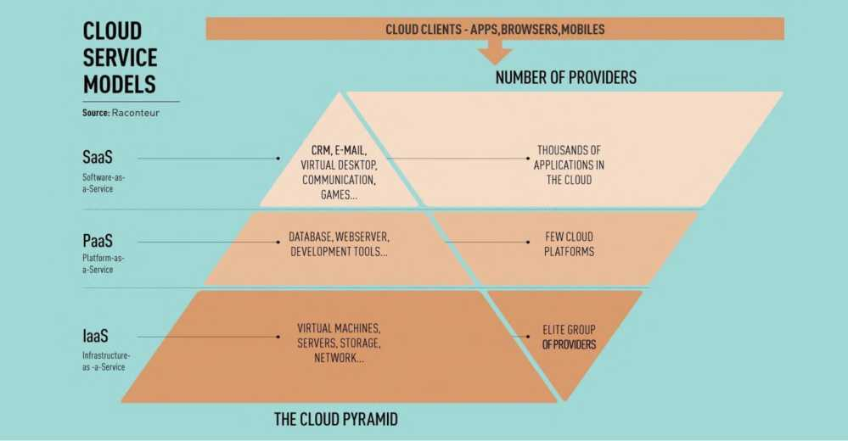

  - The process of emergence of cloud technologies
Consumers do not look at the performance characteristics of computers. Computers do not need to have large memory and large disk drives to work at high power. Because all data and all programs are stored on cloud servers. Consumers can access the cloud through personal desktops, laptops, and netbooks with large capacity.
Improving the performance of computers for consumers. Consumers should use fewer applications to make computer programs, files, and remote operations less burdensome. For example, Panda Cloud Antivirus is an antivirus program that can be used as a web service. Panda Cloud Antivirus allows you to remotely scan for viruses on powerful server data. Running this program on a consumer computer doubles the performance load.
The efficiency of using the IT infrastructure increases and the number of outputs decreases. If we take the average server load estimate for the company, it is 13%. In some cases, the company has to use its additional resource power, but in some cases, the computing resources are idle and not used. In this case, the spending of money will be invalid. If the company uses remote cloud servers for computing resources, then the company's expenses will be reduced by half. Due to this, the flexibility of unstable economic production increases. When the reliability of storing its data in other organizations is lost, the company itself can create a private cloud and fully use all the capabilities of virtualization infrastructures.
Reduction of costs in service provision and purchase of DT. The application of cloud computing technologies on personal servers is considered small in scale of the company, so they are easy to maintain. By avoiding a large number of physical servers, the problems of purchasing DT are reduced. Because the service and applications are in the cloud, consumers will not need to purchase DT.
Increase in computing power. Comparing cloud computing resources with personal computers, cloud computing resources have great potential.
Cloud computing power is measured by the number of its servers. It allows the consumer to use a supercomputer remotely, which of course is not possible to solve problems on a regular personal computer.
Unlimited volumes of data storage. Depending on the size of the data storage, cloud technologies place it conveniently and automatically (depending on the user's wishes). This is not the case with cloud computing clients when there is not enough storage space for a typical personal computer client.
Compatibility with the operating system. Cloud technologies do not care about the operating system that consumers have. A client using a Microsoft Windows operating system can seamlessly share data with Unix clients. When using services, each operating system standardizes depending on the browser.
Compatibility with document formats. If the file on the personal computer is executed on the basis of the Microsoft Word 2007 program, it is not possible to open it in older versions, that is, in Microsoft Word 2003. In cloud computing, there is no problem of opening incorrect documents.
Convenience of consumers working in a group. In cloud computing systems, several users can work at the same time. There will be no need to transfer documents from one computer to another. Document editing is reflected quickly, in addition, consumers have the option of updating the document.
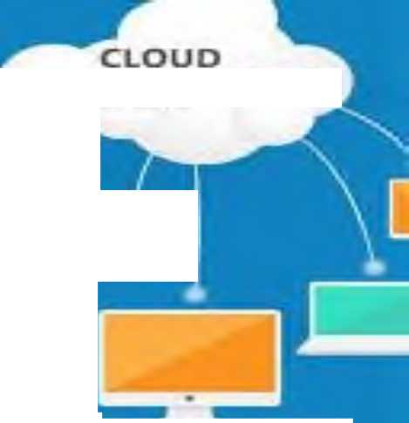
- Availability of free access to files in cloud computing. If data is stored in the cloud, this data can be accessed by consumers at any time, as long as there is an Internet connection. For consumers to access the Internet from a wide range of devices
possible Cloud client PC, tablet, netbook, smartphone,they can use laptops.

ADVANTAGES OF CLOUD COMPUTING
COMPUTING
E
4
i.e
Figure 1.11 Advantages of using cloud technologies.
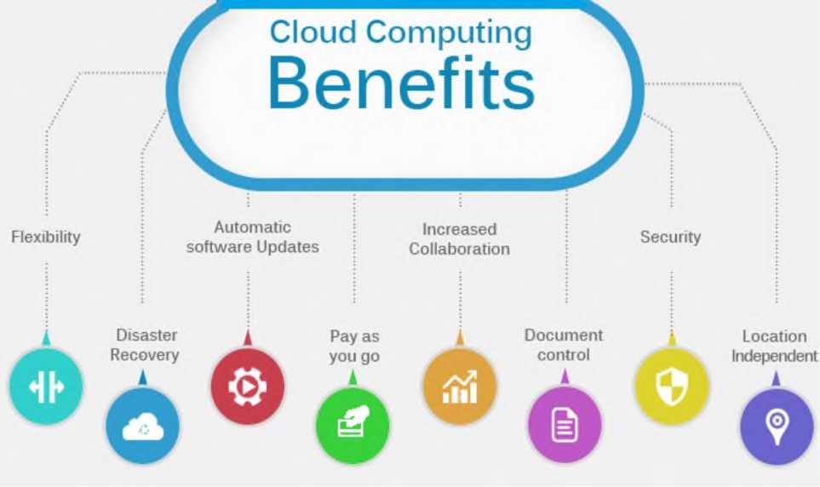

- picture Cloud computing functions.
-Reducing the use of natural resources. In cloud computing technologies, it is possible to save computing power not only in terms of electricity, but also to reduce physical space and natural resources. The Data Processing Center (DCP) also has the option of storing in known cool areas. Data-capable devices are now considered very compact and require less material to manufacture.
-Data loss tolerance. Data stored in the cloud places its copies on several servers. Therefore, data stored in the cloud is much less likely to be lost compared to a consumer's personal computer.
Disadvantages of using cloud technologies
Must be in constant connection with the Internet. When using cloud computing technologies, the network must always be connected to the Internet. In addition, there are several applications that can be downloaded to computers and can be used for long periods of time. In other cases, it is considered as simple as always and there is no work if there is no connection. Many consider this to be the biggest drawback of cloud computing. Taking into account the development of information technology, we can say that the Internet is now everywhere. Therefore, these problematic views will soon disappear altogether.
Slow performance. Many cloud services require a normal Internet connection for their full operation. Measures are being taken to prevent this problem from occurring, and we are confident that this problem will be resolved soon.
Programs running slowly and without full functionality. Several programs may run slower on cloud systems than on a local computer system. This may be due to loading difficulties of remote servers.
Risks to data security. The security of every piece of data placed by consumers on cloud technologies can be at risk. But the first issue is the consumer's trust in the provider. If the cloud technology provider reliably encrypts data exchange, backs up and has sufficient experience in the cloud technology market, then there are no security problems. It is a fact that data lost in the cloud cannot be recovered.
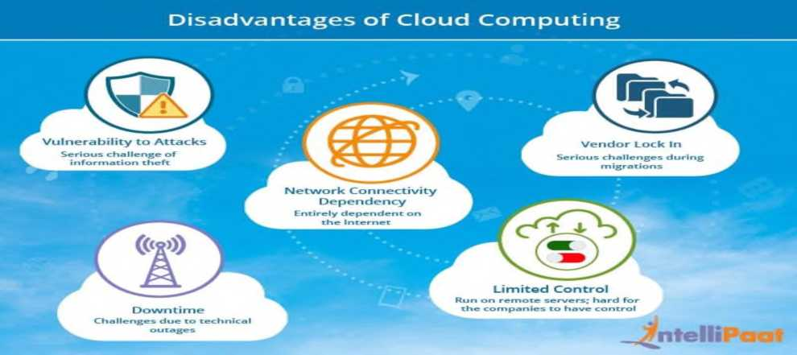
List of used literature:
1. Cloud technologies. Study guide. TEDelov. -Tashkent: 2020 -217 p.
2. Patrick Niemeyer, Daniel Lake Learning Java / 2014.
3. Cruz Zapata. Android Studio Essentials Belén 2013.
4. Ted Hagos. "Learn Android Studio 3 with Kotlin" 2015.
5. J. Zdziarski. "iPhone SDK Application Development". Saint Petersburg. 2010.
List of Internet sources:
1.https://intuit.ru/studies/courses/493/349/lecture/8337?page=3
2. https://developer.apple.com/ios/download/
3.http://www.iphonedevforums.com/forum/
4. https://flatironschool.com/free-courses/coding-bootcamp-prep

LECTURE 2:Creation and models of cloud technology

Plan:
- ActivePlatfom innovative design IT services and service management in the field of Internet products
- Introduction of a single platform for providing all cloud service services
Every day, information and communication technologies (ICT) are introduced into every sphere of our life, increasing the efficiency of our professional activities. Today, we could not live without modern devices such as television, radio, mobile phones, computers, tablets, using them, we enrich the content of our lives, and ease our tasks in work and education. Currently, the introduction of ICT capabilities in the teaching of various subjects in the education system, as well as in all other fields, is an urgent issue.
In recent times, in many psychological and advanced pedagogic fields, we are witnessing that the ideas about ICT development of students' knowledge and creative thinking are emphasized.
UNESCOIt believes that ICT can contribute to ensuring the openness and authenticity of education, improving the quality of teaching and learning, and the professional development of teachers. In addition, with appropriate policies, technologies and capabilities, ICT can help improve educational management, leadership and administration.
Today, the eyes of all countries of the world are focused on our country, because our country is rapidly developing in all areas. If we take the higher education system as an example, very large reforms are being carried out in this regard, according to the Decree of the President of the Republic of Uzbekistan dated October 8, 2019 No. PF-5847, the concept of the development of the higher education system of the Republic of Uzbekistan until 2030 is higher education is a clear example of the development of the lim system.
"Cloud technologies" allows students to use computing resources more efficiently in organization management; Improving IT infrastructure management (including geographically); continuous simplification and facilitation of work management, system concept backup and virtual machine migration; IT covered issues such as reducing the cost of infrastructure, providing information about saving computing resources, electricity, storing information in electronic form and using them in any conditions, if necessary, to improve the quality of education.
The subject "Cloud technologies" is included in the group of specialized subjects, and it is taught in the 3rd year of undergraduate education of the Faculty of Vocational Education in the field of ICT of the Tashkent University of Information Technologies named after Muhammad al-Khorazmi.
The training manual prepared on the subject of "Cloud technologies" is used to conduct lectures, improve the effectiveness of classes, acquire knowledge in the field of specialization, introduce engineers-pedagogues to cloud computing software tools, and introduce them to the educational process. to demonstrate the ways of application, to master the teaching methodology based on cloud technologies in the teaching of telecommunications, informatics and information technologies, to apply cloud technologies in the disciplines of telecommunications, informatics and information technologies serves to improve knowledge, skills and abilities.
The topics presented in the training manual are the introduction of education and training methods and the ability to effectively use the Internet and cloud technologies of future personnel and the formation of skills, telecommunications, informatics for students in higher and secondary special educational institutions. and teaching the subjects of information technology with the help of modern educational technical tools, introduces the specific features of distance education. It contributes to the improvement of students' skills and abilities and is effective in practical use.
- ActivePlatfom innovative design IT services and service management in the field of Internet products
The concept of "cloud technologies" (English "cloud computing") is widely used in English and Russian sources.
The author used the translation of this term in Uzbek. TNNishonboyev's monograph "Service-Oriented Architecture" also used this term a lot.[6]
Today, the computing network, which we call cloud computing, is developing rapidly. Today, Google (GoogleDrive), Yandex (Yandex disk), Microsoft (OneDrive), Apple (iCloud), DropboxInc, Cisco, Oracle and many other large companies in the field of information technology are paying great attention to expanding the spectrum of their cloud services. Many services are being introduced into the cloud network, and users have the opportunity to get the services they need from the cloud. Cloud computing systems, which are widely developed and continue to develop in the world, continue to develop in Uzbekistan today. For example, The launch of the Data Processing Center (DPC), created in cooperation with Huawei, shows that great work is being done to develop cloud services in Uzbekistan. Today, the field of cloud computing and the range of services they provide are also expanding. Due to the increase and convenience of services, the number of its consumers is also increasing. With the increase in requests and requests for cloud services, the amount of download to the system is also increasing. Cloud providers aim to: With the increase in requests and requests for cloud services, the amount of download to the system is also increasing. Cloud providers aim to: With the increase in requests and requests for cloud services, the amount of download to the system is also increasing. Cloud providers aim to:
- Ensuring continuous operation of the network;
- QoS provisioning etc
The development of cloud technologies in Uzbekistan. Today
Today, along with many countries in the world, cloud technology has started to be used in Uzbekistan. "Uzbektelecom" JSC "UZCLOUD" data processing center has been launched in Uzbekistan.
Data processing center "UZCLOUD" launched by JSC "Uzbektelecom" was implemented by the first President of the Republic of Uzbekistan on March 6, 2015 "Program for the modernization and development of road transport infrastructure and engineering communications in 2015-2019" "About" Decision No. PQ-2313 and the Decision of the President of the Republic of Uzbekistan "On additional measures related to the further development of information and communication technologies". 19.02.2018. It was carried out in accordance with the Decision No. Pq-5349.
The project envisages the creation of Data Processing and Storage Centers in the cities of Tashkent, Bukhara and Kokan.
At present, the establishment of the Data Processing and Storage Center has been carried out in Tashkent. The purpose of this project is to meet the growing demand for the resources of the Data Processing and Storage Center, expand technical capabilities, and provide new services in the cloud computing base.
As part of the project, the ActivePlatfom software platform designed for cloud business management has been introduced.
The innovative design of ActivePlatform enables management of services in the field of IT services and Internet products. The introduction of a single platform for the provision of all types of cloud service services with advanced technologies opens the new data processing center to the possibilities of diversification of the product portfolio and wide opportunities that ensure the unquestionable superiority of the Uzbektelecom company in the market.
The current configuration of the data center is 160 blade servers, with a storage capacity of 1 petabyte, with the possibility of expanding the number of servers up to 10 petabytes in the future.
The level of reliability of MQIM (data processing center) corresponds to the Tier III international system according to the Uptime Institute classification, that is, the reservation of MQIM infrastructure is ensured according to the "N+1" formula, with a reliability coefficient of 99.982(%) is a percentage. This means that the data center has the possibility of reservation from all engineering systems and allows to carry out maintenance and preventive works without stopping the work of MQIM.
New Uzbektelecom is ready to offer VPS "Virtual server" service among cloud services to MQIM customers. Customers can rent MQIM computing power using the cloud platform to create a private infrastructure "in the cloud" and be able to connect to a fully isolated autonomous infrastructure anywhere in the world 24/7.
In addition, UZCLOUD customers can use the web hosting service, which allows entrepreneurs to develop their business through the Internet.
For "UZBEKTELEKOM" JSC, the project of building a data center in Uzbekistan is considered to be the first cloud data center implemented in full cooperation with Huawei company (infrastructure, server equipment, virtualization system).
After the implementation of the project, JSC "Uzbektelecom" will have the opportunity to provide services for state organizations and large corporate clients, as well as private individuals, as well as expand the scope of business and provide modern ICT services.
In addition to data storage devices - diskette, compact disk, flash drive and external hard drives, storage of necessary files in "cloud" services is becoming more widespread. You know about such common services as Yandex.Disk, Google Drive, Dropbox. Uzbek versions of such services are also developed by local programmers, and it is the FileCloud.uz service.
Services provided by cloud infrastructure
When the word "cloud" is used by information technologies, it means the technology and infrastructure that provides services via the Internet. When data is sent from one computer to another in another country, it travels through many networks to get there. In this case, the information goes from the sender's computer to his provider, from the provider through his networks, through other networks, through the vast Internet network and reaches the intended computer.
A cloud infrastructure consists of many interconnected network devices, such as switches, routers, servers, and various other devices. This entire infrastructure is collectively called the cloud. The cloud is not only used to send information, but the exchange of information is only one of the possibilities of using the cloud. In addition, there will be special programs running in the cloud, that is, on servers located in the infrastructure. They offer cloud-based application services. The most common cloud services are Dropbox - file storage service, GoogleDocs - office applications, SalesForce - CRM and ERP systems. To use cloud services, in most cases, the user only needs an internet connection and a browser. sometimes, special software applications are installed on the user's device to facilitate the use of this service. For example, the work done in Word, Excel programs can be easily done through GoogleDocs, for which there is no need to have office applications on the computer.
Another service provided by cloud infrastructure is data storage. Examples of such services are Dropbox, Microsoft's Skydrive, and Google Drive. In addition to these services, for example, the computer's resources may be insufficient to perform some complex process. In this case, the cloud can be used. If complex processes use cloud resources, there is also the possibility of execution in the cloud.
Obvibase makes this very easy when it integrates with Google Drive and Dropbox. For example, the file icons in the "Browse" column above represent PDF files stored in Google Drive, and clicking on them will open a preview in a new nested window.
This is cool for several reasons. First, there is the division of labor: we can never do file storage like specialized services. Second, like Obvibase, Google Drive and Dropbox have very powerful free plans. And finally, there is no dependency: if you decide to stop using Obvibase, you must export the data in CSV format and this data in Google Drive
or contain permalinks attached to Dropbox. to database records
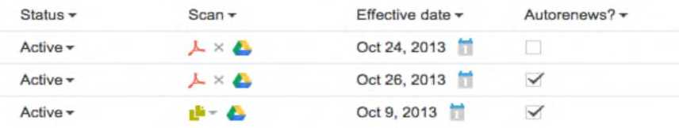

Figure 1.1. Merging Google Drive and Dropbox.
Today, the world leaders in providing cloud services are Google (GoogleDrive), Yandex (Yandex disk), Microsoft (OneDrive), Apple (iCloud), DropboxInc, Cisco, Oracle, and others in the field of information and communication.
In our republic, the main focus is on the development of cloud hosting, for example, UZDisk can be cited. UZDisk is our own Dropbox analogue. UZDisk is a cloud service for storing files located in the TAS-IX region. An important factor is that traffic for this service is completely free. Another similar cloud service located in the TAS-IX area is filecloud.uz. This type of cloud service also has the ability to store data and work with office programs.
There are also firms that provide these types of services for a certain period of time; Among them are "AtiveCloud" TM, which provides services such as VDS hosting, VPS hosting, virtual hosting, and cloud hosting, and "SHARKTELECOM" LLC, which provides VDS hosting, VPS hosting, virtual hosting, cloud hosting, and cloud hosting services [6].
The market share of cloud services and platforms is steadily growing, because the cloud has a number of advantages for users and organizations, among which the following can be listed first: it selects the most optimal of all resources available in the system for data processing; the speed of searching and processing data is high, because everything is located on one platform; In cloud systems, the number of processors, RAM and disk space are theoretically unlimited; users do not need to install and configure software; a simple web browser is enough to access cloud services; taking into account the system deployment time, the cost of providing technical support to organizations and the modernization of selected systems, as well as high-speed implementation; the need for training is significant - most users already know how to use a web browser and Internet services as classes of service; usually, cloud systems are maintained by highly qualified professionals, which ensures high quality of software storage. And most importantly, all the data in the hands of the provider cannot be deleted for malicious purposes.
From the above, it is known that the study of computing systems using cloud computing technology is of great importance in the development of scientific and technological activities and convergence to the cloud. Based on all the above information, this direction is one of the most relevant directions, which means that the growth rate of cloud technologies will only increase.
The process of emergence of cloud technologies.
Cloud technologies - this model presents IT as a service to the consumer over the Internet. The importance of "virtualization" technologies in the emergence of cloud computing is very great. Virtualization technologies were first proposed by IBM in 1960, but the term virtualization was forgotten for a long time after the transition from expensive mainframe computer technologies to inexpensive x86 processor computer servers. Starting from 2000, the situation started to change, until these years, WMware won the monopoly in x86 discharge virtualization. In 2005, Wmware released virtual machines for free using DT. In 2006, Microsoft launched the Windows version of Microsoft virtual PC...
The cloud is considered an innovative model (concept) of IT-infrastructure organizations, which is separately allocated and configured
consists of hardware and network resources, software, and they are at the heart of remote service providers.
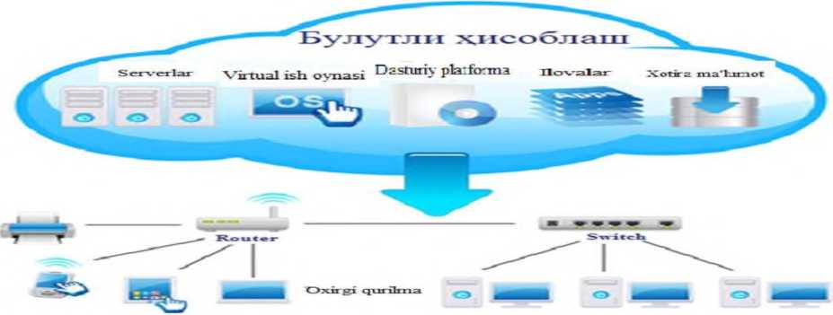
Figure 1.2. Schematic view of cloud computing.

The following are the main rules presented in the concept of cloud computing.
The user chooses the computing needs at will;
-resources are combined into a single currency with the possibility of rapid redistribution;
- access through the data network is universal;
- services can be automatically provided, extended or contracted almost without spending time;
- consumed resources are calculated automatically.
Otherwise, the essence of cloud technologies can be expressed as follows: they are created to provide computing power, software, platforms - as a service. Based on this principle, the main business models of cloud computing are: Software as a Service (SaaS), Platform as a Service (PaaS), Infrastructure as a Service (IaaS), Desktop as a Service (DaaS), etc. Each of them, of course, is aimed at different categories of users (and therefore market segments).
The user no longer pays for the equipment or software - he only pays for its use, renting it in his own way. And this is done immediately and remotely using the Internet or another data network. Of course, such a revolutionary business model will change a lot in the market.
The idea of ​​using remote resources to calculate and store information is never new (in one form or another, this question was raised several times until the 80s and 90s of the XX century), but its implementation in the form of large, successful projects is relatively something new.
In 2006, Amazon launched its Web Services project; his product, among other things, provided the user with remote computing power. This idea has also been adopted by companies such as IBM and Google (Google, which is rapidly developing Google App Engine).
Today, a service like Google Docs is familiar to the mass consumer, and it is the most common cloud technology products, together with Apple's iCloud. But the most ambitious, of course, was the Microsoft project - the company decided to offer not only a place to store software and processed data, but also a platform and infrastructure as a service. Although the project called Windows Azure is already something like a cloud-based operating system, it is not intended for the user to work directly in his environment. This is a product that uses the IaaS and PaaS models (discussed above).
Google is also thinking in the same direction, its future development Chrome OS is also a cloud-based operating system, but very different from Microsoft's product. If Azure was created to provide various services (in particular, another well-known cloud service - iCloud), then Chrome OS is a user operating system focused on using low-power equipment. From the previous principle of SaaS cloud computing, due to the emergence of this OS, a new one - DaaS has been separated (desktop as a service). So both x86-based and ARM-based systems can work. Laptops equipped with Chrome OS went on sale in the fall of 2012.
On the one hand, cloud technologies are still in their early stages of development. Many ambitious projects are still far from the final versions, and users and developers are not used to believing in the new possibilities that lie ahead. In addition, cloud technologies face a large-scale and very important task - to achieve certain standardization and universality among various services.
On the other hand, interest in these technologies is approaching its peak, and almost all major players in the global IT market are trying to find their place in this field by investing in "cloud" projects. This happens despite the fact that it is not clear which areas of development of this technology are the most promising and from a commercial point of view.
Research company Gartner introduced the concept of "technology maturity" in 2011 to study the development of cloud technologies, for which it created a graph:
At the same time, experts predicted a slight decrease in interest in cloud computing by the end of 2012 due to the revision of certain experience. However, this decline has not been observed so far.
According to experts of Forrester Research, a huge breakthrough in the new market (the company was valued at $ 42 billion in 2011) is already accompanying manufacturers in several categories, and only companies like Google are joining the companies that are listened to by a wide range of users.
The highest rates are shown by large enterprises - first of all, companies that produce IBM. Successful companies that create ready-made hardware and software systems for cloud computing are Hewlett-Packard and Dell. Those with extensive experience in working with distributed computers have a good place in the market: for example, the Canadian company "Platform Computing" was able to adapt the existing experience and quickly learn to cloud technologies.
Many potential industry leaders have not yet had time to fully enter the new market - for example, much can be expected from Cisco and Citrix.
As for our country, it will not be left out. By 2016, the Russian cloud technology market is estimated to grow to $5 billion. However, Russia ranks only 34th in the world in the adoption of cloud technologies. In addition to non-technical ones, there are many reasons for this, which will be discussed below. For example, the territory of the Russian Federation is still not sufficiently provided with high-speed Internet - an indispensable condition for the full use of cloud technologies. Many experts also emphasize the peculiarities of the mentality of Russian business - a tendency not to trust new technical solutions that have not been confirmed by long practice.
Basic literature

- Cloud technologies. Study guide. TEDelov. -Tashkent: 2020 -217 p.
2. Patrick Niemeyer, Daniel Lake Learning Java / 2014.
3. Cruz Zapata. Android Studio Essentials Belén 2013.
4.Ted Hagos."Learn Android Studio 3 with Kotlin" 2015.
5. J. Zdziarski. "iPhone SDK Application Development". Saint Petersburg. 2010.

Additional literature

- Android Programming Tutorials2013.
- Adam Sinicki. Learn Unity for Android Game Development 245 pages
- Matt Neuburg. iOS 12 Programming Fundamentals with Swift

Internet sites

1.https://intuit.ru/studies/courses/493/349/lecture/8337
2. https://www.fandroid.info/
3.https://developer.android.com/
- https://covde.oksei.ru/user/view.php?id=5&course=167 – for Android
- https://www.w3schools.com/java/default.asp– on website programming languages
- https://udacity.com. - online platform

LECTURE 3: Cloud computing
PLAN
3.1. | Cloud computing
3.2. | The development of cloud computing on a global scale

Cloud computing refers to the delivery of electronic computing services through computer networks. Computer resources are provided to the user in the form of an Internet service. Cloud services platforms such as Amazon Web Services have networked hardware that uses Internet resources to distribute and use the necessary resources while performing the necessary maintenance from such software services.
Cloud computing (English cloud computing) is a distributed computing technology in which computer resources are provided to the user as an Internet service.
Cloud computing systems primarily work in the client-server mode: the client uses the resources of a group of servers in the network - processor time, RAM, disk space, network channels, specialized controllers, software, etc. However, this group appears to the client as a single virtual server. The user has the opportunity to change the amount of consumed resources according to his needs. For example, it can expand the disk space it occupies for a certain fee.
Rather than building and maintaining an on-premises computing infrastructure, cloud computing provides utility tools such as virtual machines (VMs), storage or applications, and power savings.
Cloud computing as a concept is highly controversial. When asked to define cloud computing, it is difficult to come up with a clear general definition. Let's look at some definitions of cloud computing to find out:
- The practice of using a network of remote servers hosted on the internet to store, manage, and process data instead of a local server or personal computer. This is one of the definitions of cloud computing.
- Cloud computing is a computing term or metaphor coined in the late 2000s to account for the use and consumption of computing resources. Cloud computing involves distributing groups of remote servers and software networks that provide centralized data storage and online access to computer services or resources.
- Cloud computing is one of the common definitions of cloud computing. These services fall into three categories: Infrastructure-as-a-Service (IaaS), Platform-a-Service (PaaS), and Software-as-a-Service (SaaS).
- Some define cloud computing as a method of computing that provides scalability and elasticity of IT capabilities using Internet technology.
- The National Institute of Standards and Technology (NIST), which sets the standard, defines cloud computing as: a shared set of configurable computing resources that can be quickly provisioned with minimal management complexity or distributed in partnership with service providers. model for quick connection and convenient use of plami on demand.
- The IEEE Standards Association (IEEE-SA) defines cloud computing in two ways. The P2302 (Cloud Profiles) project highlights the different ecosystems of the cloud, such as cloud vendors, service providers, and users. The P2302 (Intercloud) project defines the topology, functions and management for cloud-to-cloud collaboration.
- From all the concepts below and above, a short and quick definition of cloud computing is: A computing method with a virtual network of remote servers that allows users to store, process and access data, flexibility, scale of on-demand computing services , security and redundancy is cloud computing.
The development of cloud computing on a global scale. Today, cloud services are provided by companies such as Google (GoogleDrive), Yandex (Yandex disk), Microsoft (OneDrive), Apple (iCloud), DropboxInc, Cisco, Oracle. Cloud applications can be accessed by any user connected to the Internet through a browser. For example, the Gmail service allows you to use e-mail or Google Docs office documents through a browser without installing any additional programs. Internet connection and a browser are enough for data storage services in the cloud. In some cases, special client software may also be required. In this, the user is provided with a location in the cloud. In this place, the user can save his files. Amazon web services, (AWS) is a cloud-based web services infrastructure provided by Amazon. This infrastructure provides various services. These include data storage, Amazon S3, virtual server rental, provision of computing resources, Amazon EC2. Amazon S3 online web service provides the ability to store data of any size and access them anytime from anywhere in the world via the Internet. Amazon EC2, that is, elastic computer cloud web service, provides computing power and resources located in the cloud. Amazon S3 online web service provides the ability to store data of any size and access them anytime from anywhere in the world via the Internet. Amazon EC2, that is, elastic computer cloud web service, provides computing power and resources located in the cloud. Amazon S3 online web service provides the ability to store data of any size and access them anytime from anywhere in the world via the Internet. Amazon EC2, that is, elastic computer cloud web service, provides computing power and resources located in the cloud.
Oracle, a company that produces software for corporate customers, is competing in all segments of the cloud services market with its competitors. A few years ago, the IT giant announced the Oracle Partner Network, its first collaborative cloud product.
Analysis of the workflow of information processing centers.
Basic services of data processing and storage center;
- Cloud computing - Cloud computing;
- Colocation - placement of equipment;
- VDI - virtual desktop;
- VPS is a virtual server.
Additional services of the data processing and storage center include:
- Video conferencing;
- Reservation of data;
- Telecommunication infrastructure;
- Development of national content;
- Web hosting.
When using cloud computing concept application scenarios, it is important in the applied technologies, in difficult and problematic issues, and in the advantages that are clarified and justified during the process of active discussion in the public and commercial sectors during the gradual development. At the same time, the definition, properties, characteristics and their compatibility evolve over time, so it is appropriate to refer to the concept of the so-called cloud computing ecosystem (cloud ecosystem), since recently it is presented in Figure 1.3 managed to have a look.
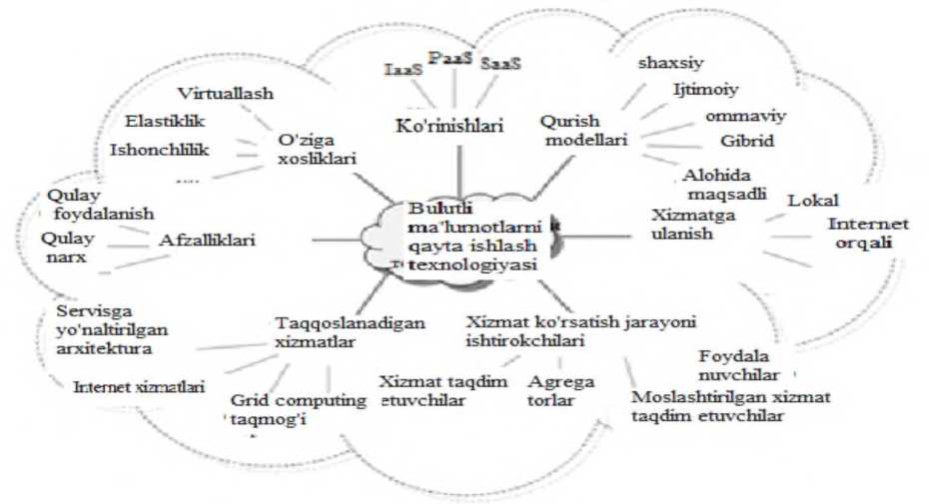

Figure 1.3. The main views of the application of data processing technology in the cloud.
Today's trends in the development of information and communication technologies (ICT) and the increasing level of automation of large companies require the creation of effective and perfect technological solutions for the implementation of large-scale data processing and storage processes.
On the other hand, the development of requirements for reducing the funds spent on the support and development of computing power, that is, ICT structures, is being observed. Optimizing IT spending is becoming an increasingly pressing issue today. This problem is being discussed by experts in the field of information technologies worldwide, and new approaches are being proposed in the direction of cost reduction.
One of the solutions to the problem is to create a single computing complex, that is, a data processing center based on distributed system methods.
Information storage and processing center (English data center) is considered a specialized architecture, consisting of server (hosting) and network tools, to which users connect using Internet channels.
The main purpose of the data processing center is to unify the distributed computing power and reduce the cost of ownership while meeting the requirements for the reliability of the information technology infrastructure, ease of access to its resources, security and management.
Information storage and processing center performs information processing, storage and distribution functions according to the interests of corporate clients. The center is focused on solving business problems by providing information services.
Consolidation of scattered computing and data storage resources within the data processing center allows efficient use of hardware, software and other technical tools, for example, distribution of loads, simplification of management, etc. This, in turn, leads to a decrease in overall costs .
The data storage and processing center consists of:
information infrastructure, including server devices, performs the main functions of the data processing center, i.e. data processing and storage functions;
telecommunication infrastructure - provides communication (communication) between the components of the data processing center, at the same time this infrastructure performs data transfer processes between the MQIM and the user;
The engineer creates an environment for the normal operation of infrastructure - MQIM systems.
In the standard model of the data processing center, the following functional subsystems are distinguished:
- server systems - provide computing resources for the operation of corporate applications;
- infrastructures for network communication - ensure the efficient transport of information flows between the components of the MQIM and the connection of the MQIM with the main data transmission network;
- information storage infrastructure;
- under the system to ensure information reliability;
- control and monitoring subsystem, it performs the functions of control, monitoring, diagnostics and localization of hardware and software complex failures.
All subsystems of MQIM regularly interact with each other using the transport network.
Engineered infrastructure consists of the following: air conditioners that ensure temperature and humidity levels in the center's rooms are within the specified parameters;
uninterruptible electrical power means that ensure autonomous operation of the MQIM in case of a shutdown of the central power supply;
fire alarm and fire extinguishing means;
remote IP control, power supply management and access control systems.
Below is a description of the server complex of the information processing system and the organization of the information storage system:
The multi-level architectural model is a relatively promising model of the MQIM server complex. In this architecture, several server groups are separated (Figure 1.4):
- resource servers or information resource servers, such as file servers - they are responsible for storing information and providing application servers with the necessary information;
- application servers - perform data processing operations related to the implementation of the business process of the company's management system, for example, servers executing data processing modules;
- information presentation servers - solve the issue of the interface between user terminals and application servers, for example, web servers;
Depending on the conditions of operation, certain group servers are subject to appropriate requirements for this group, that is, the requirements for different group servers are different.
In particular, information provision servers are characterized by a large volume of short request flows from users, therefore, this type of servers has the property of "good" scalability (possibility of increasing the number of servers) to ensure load distribution. are required
For application servers, the requirement to provide horizontal scalability is less important. Vertical scalability is important for them - increasing the number of processors, increasing the size of RAM, increasing the availability of input-output channels.
Such capabilities are essential for processing multiplexed user requests and executing the logic of the problems being solved.
A traditional three-layer (physical, channel, network layers of the seven-layer OSI model) architecture is used in the design of the data transmission network of the data processing center.
Modular switches are used at the third level of MQIM data transmission network.
On the one hand, the server-server connection, on the other hand, the interconnection of communication channels, at the same time, connections with high-speed data storage networks are performed.
Based on them, it is not difficult to conclude that the large-scale development of MQIM will lead to the intended goal of forming its data transmission network based on the idea of ​​software configurable networks covered in Chapter 1.
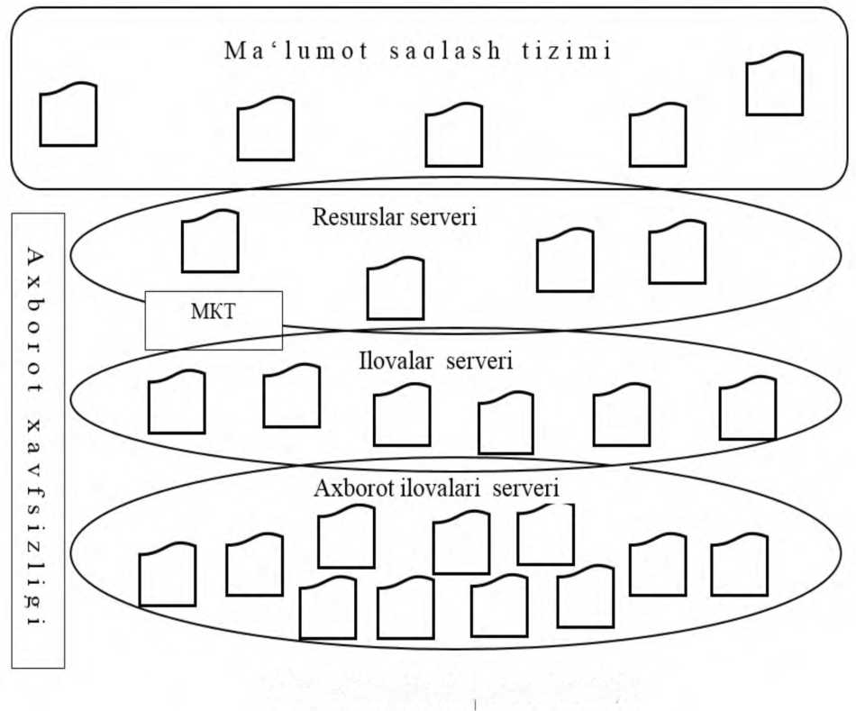
The information storage network is of particular importance in the infrastructure of MQIM. This network provides high-speed data transfer between central server computers and data storage disks. This process is based on a pattern called Fiber Channel.
MKT - local computer network
- - picture Infrastructure of MQIM server complex. The infrastructure of the data storage network (Storage Area Network - SAN) is made up of Fiber Channel switches (Fibre Channel
swirhes, FC-swithes), Fiber Channel concentrators (Fibre Channel Hub) and Fiber Channel routers (Fibre Channel - SCSI routers), as well as optical fiber communication systems that ensure their connection. The interconnection of such devices is called Fiber Channel Fabric.
Data storage networks (MST) provide reliable communication between data processing center servers and information resources stored on data storage media.
The main goal (concept) of MST is to ensure that every server of the information processing center can access all the information stored within the center. Fiber Channel (FC) protocol is used as the main protocol.
One of the main challenges in the design and development of a data processing center is to ensure that several network infrastructures can work with each other (support each other), that is, the Ethernet (LAN) network, is to ensure mutual communication
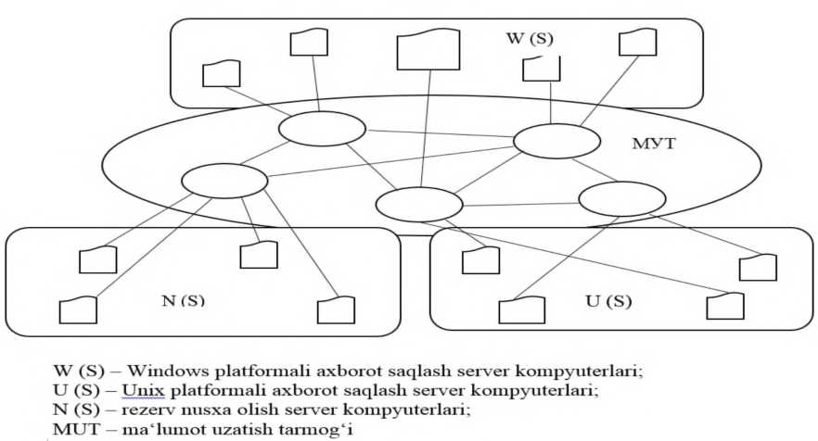

- - fig. Organize the information storage network of MQIM
achievement scheme.
The data storage network consists of data storage devices, servers, management system and communication tools that ensure communication between MST components.
This architecture ensures continuous and secure data storage and high-speed data transfer between MST devices.
The technology accepted as a universal technology is the Ethernet protocol,
and the Fiber Channel (FC) protocol perform the tasks of ensuring the transmission of blocks without loss.
Today, data processing centers are being improved based on the capabilities of cloud technologies, and "cloud" data processing centers are being created.
Improvement of the information processing center on the basis of "cloud" technologies requires the organization of virtual machines, operating systems, grid system software and other virtual tools for data storage and processing.
Virtual technologies make it possible to run several applications on a physical computer, mix data processing center server resources with each other, organize different proportions of computing resources and dramatically reduce the demand for physical resources. Information about them is provided in the second chapter of this thesis.
Axbort is a world-renowned developer of hardware-software complexes in the field of communication networks, such as Alcatel-Lucent, Juniper, Huawei, Hewlett-Packard, Cisco, and works on the creation and implementation of special network tools for cloud data processing centers. are taking.
In order to simplify the network tools, suggestions such as combining routing and switching levels, using software configurable networks are being developed.
The convergence of computing, storage, networking, and virtualization platforms is driving disparate architectures to converge. This problem is solved using a unified switching matrix created on the basis of new network technology. In this case, a single protocol called "Data Center Ethernet" is used in the data processing center.
"Data Center Ethernet" protocol is configured separately for each application, high priority is assigned to important traffic.
Such a solution provides the following advantages in the operation of data processing centers:
- It makes it possible to deploy completely different applications on a single virtualized server with a single common interface;
- Data is placed in an Ethernet packet, such a packet can be transmitted to any local "point" and can also be transmitted to an external network using the Ethernet protocol. Such a possibility is an "ideal" condition for networks based on cloud computing.
- The physical infrastructure will be transformed into a universal data transmission environment.
Creation of information processing centers, their improvement on the basis of cloud and grid technologies, conducting scientific and practical research on the development of new network solutions is one of the most urgent issues in the field of ICT today. Below is information about the advantages of data processing centers.
- The creation of data processing centers will reduce the costs of large-scale companies. 1-2 employees in the information processing center will be able to perform the activities of employees working in the offices of companies with branches located in a wide territory.
- MQIM provides integration of a large amount of information. This possibility reduces the probability of complete loss of the same important information, which leads to a decrease in the cost of information recovery. With its unique features, MQIM ensures effective continuous operation of any company.
- A user (person) or a company can "enter" the network from any point of the planet, through various terminal tools, from the resources available in MQIM, the necessary and sufficient computing power, the required memory capacity, the required software can solve problems quickly, qualitatively and at low cost using its services. He only pays for the rent of the resources. The traditional resources of MQIM include: renting server racks, hosting servers, Internet connection, renting communication channels, software configuration, installation, management, computing resources, virtual machines, disk storage for backup, rental of applications, etc
- Reliability of information storage is ensured. This is provided on the basis of the indicators provided during the design phase of the MQIM architecture.
- The costs of renting rooms will be reduced. This includes the cost of using the power source, the area of ​​the rooms dedicated to the servers "office space", the rooms dedicated to the cooling systems and uninterruptible power supplies. Virtualization technology reduces the number of physical servers, resulting in lower costs.
- The main office of the company is ensured to work continuously with its branches. It is possible to access the information in the work process from the workplace. For example, the manager is on vacation and communicates with his employees regularly.
- The cost of purchasing applications is reduced.
Basic literature

- Cloud technologies. Study guide. TEDelov. -Tashkent: 2020 -217 p.
2. Patrick Niemeyer, Daniel Lake Learning Java / 2014.
3. Cruz Zapata. Android Studio Essentials Belén 2013.
4.Ted Hagos."Learn Android Studio 3 with Kotlin" 2015.
5. J. Zdziarski. "iPhone SDK Application Development". Saint Petersburg. 2010.

Additional literature

- Android Programming Tutorials2013.
- Adam Sinicki. Learn Unity for Android Game Development 245 pages
- Matt Neuburg. iOS 12 Programming Fundamentals with Swift

Internet sites
1.https://intuit.ru/studies/courses/493/349/lecture/8337
2. https://www.fandroid.info/
3.https://developer.android.com/
- https://covde.oksei.ru/user/view.php?id=5&course=167 – for Android
- https://www.w3schools.com/java/default.asp– on website programming languages
- https://udacity.com. - online platform

LECTURE 4: Principles of cloud computing ecosystem development
Plan
4.1. | A cloud ecosystem
4.2. | SLA-based cloud computing organization features
4.3 | Cloudy pyramid
When using cloud computing concept application scenarios, it is important in the applied technologies, in difficult and problematic issues, and in the advantages that are clarified and justified during the process of active discussion in the public and commercial sectors during the gradual development. At the same time, the definition, properties, characteristics and their compatibility will change and develop over time [30], therefore it is appropriate to refer to the concept of the so-called cloud computing ecosystem (cloud ecosystem), because recently it 1.6 - managed to get the appearance presented in the picture.
A cloud ecosystem is a term used to describe a complex system of interrelated components that work together and enable cloud services. According to the recommendations of the ITU target groups (FG Cloud TR, Part 1:Introduction to the cloud ecosystem: definitions, taxonomies, usecases and high-level requirements)), there are several actors that shape the ecosystem:
- Cloud service user (CSU): cloud service users;
- Cloud service provider (CSP): cloud service providers;
- Cloud service partner (CSN): cloud service partners.
Add user to range of users
may add, they implement cloud services for end users of cloud services provided by cloud service providers (CSPs). End users include individuals, machines or applications. A cloud service provider is an organization that provides and continuously delivers services in the cloud. Service Partner: A person or organization that supports the cloud service provider's service delivery process (eg service integration). Figure 1.6 shows these participants of the cloud ecosystem.
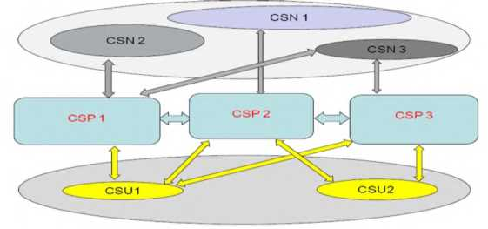

- picture The role of participants in the cloud ecosystem.
CSU-cloud service users, CSP-cloud service providers, CSN-cloud service partners. Based on these principles, we will consider the scenario of interactions of participants in the cloud ecosystem (inter-cloud scenarios).
- Intercloud hidden scenario.
The two providers can interact directly with each other. Each CSP (provider) can offer its own API for cloud cross-network collaboration, and providers can collaborate with each other using another provider's API.
- Joint scenario with inter-cloud federation.
Two providers can join together in an alliance based on mutual trust. General for cloud cross-network interoperability in an alliance
An API is defined and each CSP interacts with the others together through a common API.
- A scenario for working with an inter-cloud services broker
In this scenario, the CSP (provider) plays the role of a service broker (broker) between clouds, receiving a cloud service request from a cloud service provider or a cloud service user through its API. Provider interactions between cloud services and other providers acting as brokers are defined by a cloud federation or federation.
Multifunctional user portal

Level of service automation
SLA
apply
service
Automating the service life cycle
Service directory~
Integration with external systems (workflow, billing)

Orchestration (virtual resource management)
'S
&
O
l

external
resource
need
cent
ay-
ver
O
0
1
vv
Virtualization
mother
A
a
r
J
Hypervior + virtual network
Device management
Computational infrastructure and network (basic requirements - virtualization support)

a
V
- picture The cloud computing ecosystem.
Based on these principles, Figure 1.7 provides a schematic diagram of the cloud computing ecosystem proposed to explore various issues related to its application and implementation; it is coordinated with the conceptual models recognized above and is a methodological tool in the study of cloud computing infrastructure.
The first step in moving to a cloud computing organization is usually collocation. In this case, the company places its equipment in the data processing center of the provider, and the provider ensures the operation of communication channels with the data processing center, energy supply, ventilation, fire safety, temperature in the rooms in the data processing center. mode, resolves issues related to the physical security of the customer's equipment; For this, the SLA should include the requirement for access to the data processing center through communication channels, for sudden changes in voltage and lack of power supply, and for maintaining the temperature regime.
SLA-based cloud computing organization features.
Based on the principles of implementation of cloud accounts, the state of the technical and technological structure of the infrastructure, we will consider the step-by-step scenario of the cloud accounts system (Service Level Agreement, SLA) taking into account the concept of service level, because today it is is playing an important role in managing the various players in the cloud computing ecosystem.
The next step is IaaS, where the customer does not need to purchase equipment for himself. It buys server time, channel bandwidth, disk space from the provider, not hardware. That is, servers, data storage and virtualization systems are added to the responsibility of the provider, and the SLA should reflect indicators that determine the ease of access to servers and data.
PaaS is a logical continuation of outsourcing IT systems: everything except applications is outsourced to the provider. Platform developers do not need to think only about the hardware part, but also about the operating system, in MBBT (database management systems) and information security issues, they have the necessary environment and code development tools, accordingly, in SLA, also the issues of platform accessibility must find its reflection.
Cloud pyramid, in fact, the only difference lies in the method of data storage and processing. If all operations (using its power) occur on your computer, it is not a "cloud", and if the process is formed on a server on the network, this is a trend, and it is called "cloud computing". In other words, cloud computing is a variety of tools available to the user, such as hardware, software, methodology, and Internet services to achieve their goals, tasks, and projects. Practice shows that the concepts of "cloud technologies" and "cloud services" , in the form of "clouds", is calculated with a generally accepted graphic image. just confuses the users, in fact their structure is expressed in the form of the following pyramid.

- picture Cloud Pyramid The "infrastructure" of a pyramid is a set of physical devices (servers, hard drives, etc.). In addition, a "platform" is a collection of services and advanced software at the request of users. Also, you should know that it is the same basic vector obtained by the synthesis of cloud computing technology and approaches (confused. To show what I mean, I will give the diagram below.
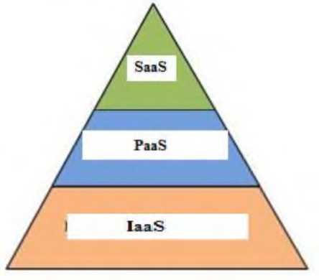
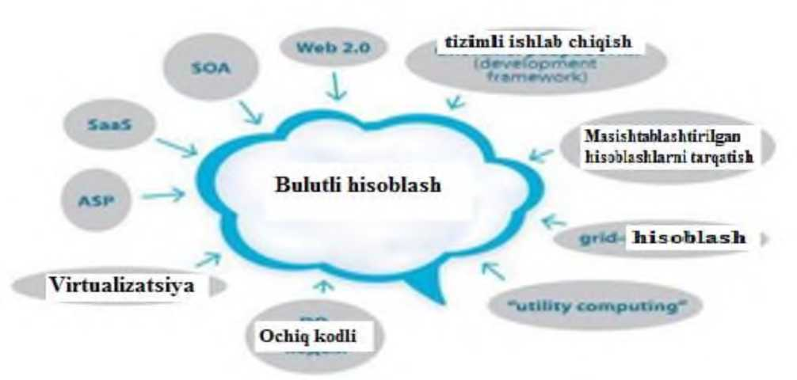
Figure 1.9 Service provision infrastructure levels.
Now that it's a little more clear, I think the profit scheme is pretty simple. However, in general, the cloud is a type of mash that performs calculations without the direct participation of your computer's resources, servers and other units.

It has been mentioned over and over again that it resides on servers, for example, in the cloud.
Basic literature

- Cloud technologies. Study guide. TEDelov. -Tashkent: 2020 -217 p.
2. Patrick Niemeyer, Daniel Lake Learning Java / 2014.
3. Cruz Zapata. Android Studio Essentials Belén 2013.
4.Ted Hagos."Learn Android Studio 3 with Kotlin" 2015.
5. J. Zdziarski. "iPhone SDK Application Development". Saint Petersburg. 2010.

Additional literature

- Android Programming Tutorials2013.
- Adam Sinicki. Learn Unity for Android Game Development 245 pages
- Matt Neuburg. iOS 12 Programming Fundamentals with Swift

Internet sites
1.https://intuit.ru/studies/courses/493/349/lecture/8337
2. https://www.fandroid.info/
3.https://developer.android.com/
- https://covde.oksei.ru/user/view.php?id=5&course=167 – for Android
- https://www.w3schools.com/java/default.asp– on website programming languages
- https://udacity.com. - online platform

LECTURE 5: Advantages and disadvantages of cloud technologies
Plan
5.1. | Advantages of using cloud technologies
5.2. | Disadvantages of using cloud technologies

Advantages of using cloud technologies
- Consumers do not look at the performance characteristics of computers. Computers do not need to have large memory and large disk drives to work at high power. Because all data and all programs are stored on cloud servers. Consumers can access the cloud through personal desktops, laptops, and netbooks with large capacity.
- Improving the performance of computers for consumers. Consumers should use fewer applications to make computer programs, files, and remote operations less burdensome. For example, Panda Cloud Antivirus is an antivirus program that can be used as a web service. Panda Cloud Antivirus allows you to remotely scan for viruses on powerful server data. Running this program on a consumer computer doubles the performance load.
- The efficiency of using the IT infrastructure increases and the number of outputs decreases. If we take the average server load estimate for the company, it is 13%. In some cases, the company has to use its additional resource power, but in some cases, the computing resources are idle and not used. In this case, the spending of money will be invalid. If the company uses remote cloud servers for computing resources, then the company's expenses will be reduced by half. Due to this, the flexibility of unstable economic production increases. When the reliability of storing its data in other organizations is lost, the company itself can create a private cloud and fully use all the capabilities of virtualization infrastructures.
- Reduction of costs in service provision and purchase of DT. The application of cloud computing technologies on personal servers is considered small in scale of the company, so they are easy to maintain. By avoiding a large number of physical servers, the problems of purchasing DT are reduced. Because the service and applications are in the cloud, consumers will not need to purchase DT.
- Increase in computing power. Comparing cloud computing resources with personal computers, cloud computing resources have great potential.
- Cloud computing power is measured by the number of its servers. It allows the consumer to use a supercomputer remotely, which of course is not possible to solve problems on a regular personal computer.
- Unlimited volumes of data storage. Depending on the size of the data storage, cloud technologies place it conveniently and automatically (depending on the user's wishes). This is not the case with cloud computing clients when there is not enough storage space for a typical personal computer client.
- Compatibility with the operating system. Cloud technologies do not care about the operating system that consumers have. A client using a Microsoft Windows operating system can seamlessly share data with Unix clients. When using services, each operating system standardizes depending on the browser.
- Compatibility with document formats. If the file on the personal computer is executed on the basis of the Microsoft Word 2007 program, it is not possible to open it in older versions, that is, in Microsoft Word 2003. In cloud computing, there is no problem of opening incorrect documents.
- Convenience of consumers working in a group. In cloud computing systems, several users can work at the same time. There will be no need to transfer documents from one computer to another. Document editing is reflected quickly, in addition, consumers have the option of updating the document.
- Availability of free access to files in cloud computing. If data is stored in the cloud, this data can be accessed by consumers at any time, as long as there is an Internet connection. For consumers to access the Internet from a wide range of devices
possible Cloud clients can use personal computers, tablets, netbooks, smartphones, laptops.
ADVANTAGES
COMPUTING
E
4
i.e
OF
CLOUD COMPUTING
Figure 1.11 Advantages of using cloud technologies.

- picture Cloud computing functions.
-Reducing the use of natural resources. In cloud computing technologies, it is possible to save computing power not only in terms of electricity, but also to reduce physical space and natural resources. The Data Processing Center (DCP) also has the option of storing in known cool areas. From the data
devices that can be used are now considered very compact, and less materials are used in production.
-Data loss tolerance. Data stored in the cloud places its copies on several servers. Therefore, data stored in the cloud is much less likely to be lost compared to a consumer's personal computer.
Disadvantages of using cloud technologies
Must be in constant connection with the Internet. When using cloud computing technologies, the network must always be connected to the Internet. In addition, there are several applications that can be downloaded to computers and can be used for long periods of time. In other cases, it is considered as simple as always and there is no work if there is no connection. Many consider this to be the biggest drawback of cloud computing. Taking into account the development of information technology, we can say that the Internet is now everywhere. Therefore, these problematic views will soon disappear altogether.
Slow performance. Many cloud services require a normal Internet connection for their full operation. Measures are being taken to prevent this problem from occurring, and we are confident that this problem will be resolved soon.
Programs running slowly and without full functionality. Several programs may run slower on cloud systems than on a local computer system. This may be due to loading difficulties of remote servers.
Risks to data security. The security of every piece of data placed by consumers on cloud technologies can be at risk. But the first issue is the consumer's trust in the provider. If the cloud technology provider reliably encrypts data exchange, backs up and has sufficient experience in the cloud technology market, then there are no security problems. It is a fact that data lost in the cloud cannot be recovered.

- picture Disadvantage of cloud technology
Features of cloud technology
- Self service on demand (self service on demand);
- Universal use of the network;
- Resource pooling;
- Elasticity;
- Consumption account.
Self service on demand - the consumer determines and changes the billing requirements as needed without contacting the provider. For example, server time, data processing speed, data storage size. Universal access to the network means that consumers can access data networks regardless of the terminal device they use. In order to dynamically allocate capacity to serve many consumers, the provider pools resources into a single currency. Because the demand for power is always changing. In this case, consumers control only the main properties of the service, such as data volume, access speed. But in fact, the distribution of resources provided to the consumer is performed by the provider.
Flexibility - services can be displayed, expanded and reduced automatically at any time.
Consumption accounting - this provider automatically reports the resources used. For example, it evaluates the amount of data stored, the number of users or the amount of transactions and the amount of services provided to consumers based on them.
Basic literature

- Cloud technologies. Study guide. TEDelov. -Tashkent: 2020 -217 p.
2. Patrick Niemeyer, Daniel Lake Learning Java / 2014.
3. Cruz Zapata. Android Studio Essentials Belén 2013.
4.Ted Hagos."Learn Android Studio 3 with Kotlin" 2015.
5. J. Zdziarski. "iPhone SDK Application Development". Saint Petersburg. 2010.

Additional literature

- Android Programming Tutorials2013.
- Adam Sinicki. Learn Unity for Android Game Development 245 pages
- Matt Neuburg. iOS 12 Programming Fundamentals with Swift

Internet sites

1.https://intuit.ru/studies/courses/493/349/lecture/8337
2. https://www.fandroid.info/
3.https://developer.android.com/
- https://covde.oksei.ru/user/view.php?id=5&course=167 – for Android
- https://www.w3schools.com/java/default.asp– on website programming languages
- https://udacity.com. - online platform

LECTURE 6:Cloud service provision
Plan
6.1. | Private cloud
6.2. | Community cloud. Public cloud. Learning to organize a cloud education system

Provision of cloud service Private cloud is an infrastructure used within a single organization to implement cloud computing.
Community cloud (community cloud) - cloud computing in this infrastructure can be used only by a separate team, (department) of the organization.
Public cloud (public cloud) - this infrastructure has the possibility of wide public use of cloud computing services.
Today, all attention is devoted to very interesting and promising technology (that is, the "golden veins" of the IT industry), cloud technologies hidden under a pseudonym, or to ordinary people - "the cloud".
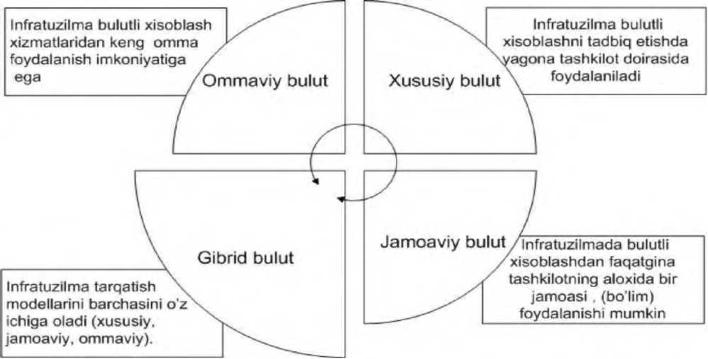

- picture Delivery Models No Expensive Equipment Costs - Generally, cloud solutions do not require outright purchase of server equipment, network storage, backup systems, disaster recovery systems, power or cooling systems, data center or utility costs. When businesses move to a cloud environment, they eliminate the need for servers and the space required to host those servers.
No need to spend capital on infrastructure software - cloud computing uses capital to purchase software such as Windows Server, SQL Server, Application and Database Servers, Client Access Licenses, Middleware, SharePoint, Citrix Server and client licenses. eliminates the need for etc. These costs are paid in monthly fees for the cloud environment and support.
Less Expensive Software Updates - Many software vendors include free software for applications that reside in the cloud and are paid as a subscription as a monthly cloud environment fee. This means that software updates are not expensive and there is no disruption to the business when updating software.
Cloud servers and network equipment are of a much higher quality - the main difference between an on-site network and a cloud-based network infrastructure is that the servers and network equipment are of the best and highest quality when purchased for a cloud environment. A good on-premises server is $10,000-$15,000, a cloud-based server is $70,000
- $100,000 or more. The same goes for firewalls, switches, and all the other hardware used in cloud environments. Cloud providers cannot cover equipment failure, so very high quality equipment is used and all of them are in excess demand in the data center.
The use of cloud technology in organizing the educational process of higher educational institutions
Examples of the use of cloud technology in education include personal offices, electronic diaries and journals for students, professors and others. Cloud technology makes it possible to organize access to various social software using all the advantages of information technology, which can serve as a platform for organizing mobile learning. Therefore, the use of cloud technology allows to reduce the costs of the educational process, to create educational materials, to provide access to them, and to increase the quality of education due to the rapid change of educational plans.
When using cloud computing technology, it has the following advantages:
- backup copy (data is saved in the cloud, even if the computer crashes);
- Storage (the cloud provides the user with the ability to store all types of data);
- Access rights (access to data in the cloud, access from a mobile device);
- Collaboration (the cloud allows several users to work together at the same time, with the help of this function, it is possible to create group projects, optimal planning of cooperation between professors and students in classes);
- Forming a conscious attitude to time and resources (professors will not need to spend time and resources on copying educational materials, and students will have the right to access educational materials online);
- Assignments (students save their assignments in the cloud, and professors have access to them at their convenience).
Cloud computing can be implemented in the following model views:
- Storage as a Service (SaaS) - can be provided in disk form on demand.
- Software-as-a-Service (SaaS) - provides access to software, meaning remote servers can be configured and managed by private providers.
- Platform as a Service (PaaS) is a set of physical data processing tools (servers, hard disk, etc.) built on the platform.
The SaaS model of cloud technology is also a perspective in increasing efficiency in the educational process.
Forming an educational environment based on cloud services. SECI (Socialisation, Externalisation, Combination, Internalisation) model developed by Ikujiro Nonaka under the authorship of the research of information creation in innovative companies is widespread among the use of online services in education.
Within the framework of the model, four phases of knowledge acquisition are defined: Socialization (Socialisation) - exchange of knowledge without disclosure, where knowledge can be gained only through the exchange of experiences.
Externalization (Externalisation) - the process of strengthening vague knowledge with concrete knowledge, that is, it is based on the acquisition of new knowledge.
Combination (Combination) - the process of supplementing relatively complex and combined systems with explicit knowledge.
Internalization (Internalisation) - the process of strengthening uncertain knowledge with concrete knowledge.
Cloud computing services can be used as part of the SaaS learning process.
To create a tool with characteristics characteristic for this, Cloud Services disk media is used:
- Joint access for participants of the educational process: teacher and students.
- The possibility of joint editing of texts, which allows sharing information on filling and enriching information.
- The access of teachers and students to personal information resources (social networks, e-mail) makes it possible to prepare a separate, personally oriented resource for each participant of the educational process.
In this way, cloud services can be tools for creating contextual learning tools that can create conditions for the formation of new knowledge. Since the creation of new knowledge subjects for students occurs through the completion of creative tasks, we use cloud services through the completion of creative tasks.
A number of technologies are used today to organize online education through the Internet. Cloud computing technology is the most effective way to organize an educational system through the Internet. Cloud technology, consisting of distributed data storage and processing systems, allows to organize an online distance education system consisting of a large number of educational materials at the same time, to organize all educational activities on a single platform. The organization of cloud education services has the following advantages over other methods:
- Ease of connection and simplicity of implementation;
- Low price and universality of the platform;
- High security;
- Reliability;
- Easy adaptability of the system to the network platform;
There are also a number of disadvantages of organizing cloud systems. The main one is to be connected to a constant network.
There are a number of advantages of organizing cloud computing systems:
- no special software is required on the subscriber's device, only an Internet connection is required;
- all training data and educational systems software will be hosted on a single platform.
- The system can be accessed from anywhere in the dune where the Internet is available;
- All services are online, there are no problems such as downloading and using;
- It will be possible to turn the entire university into an electronic university and manage it through the Internet.
Today, many developments have been developed to organize the educational system based on cloud computing technologies.
The following system model describes the organization and management of the educational system on a single platform based on cloud technologies (Fig. 1.15.)
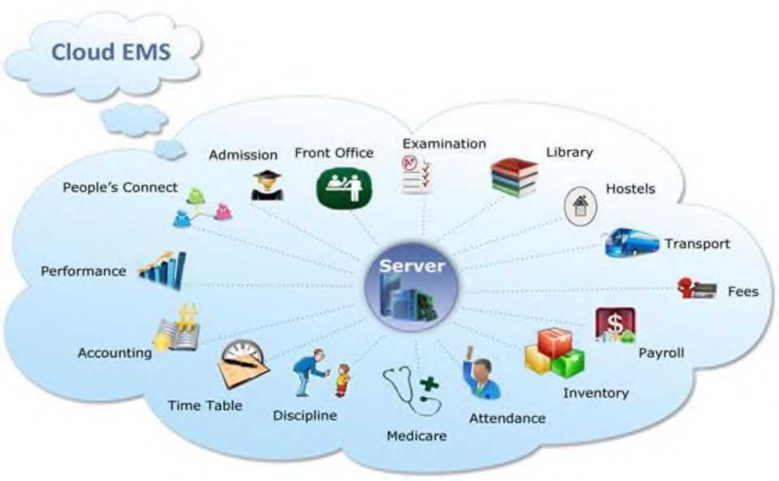

- picture Cloud Internet Education System To organize the cloud network platform, many servers are organized around the world today. For example, Yandex.Disk and Disk Google can be examples of popular cloud systems. Through these cloud servers, data can be uploaded, stored and managed from anywhere in the world. Today there are many Internet systems for organizing cloud services. The most commonly used of these systems are:
- Box.net;
- Dropbox.com;
- Diigo.com;
- Smartsheet.com;
- Microsoft Office 365.
Table 1.1. Quantitative analysis of cloud data storage systems
Name  Drop  box | 1 way to encrypt data for free  . i  2 SSL. AES256 | Operation 1  MT-imlarnl  support ' ■a  Windows. Mac OS. Linux. Audi sh J iOS | Group User on the Internet  general performance computers  a Ian is b opportunity sol“ opportunity , • available' m*T|ud eshz-  OS
Spider  Oak | '1KSA 2049. AFS | Windows. Mar OS Linux. Android | Marjud is not Marjud  OS
MS  Sky  Di*vt | 7 SSL. NPP 128 | Android.  lOS.  Wmik/wj.  Mac OS | Marjud I Marjud •  yes
Box.  COlll | 5 SSL. AES 256 | Android  Window»  Mobile.Ipad.  iphorw* | -Marjud Marjud ■  OS
 | RSA 20-48. SHA-256 | Mac OS.  Linux.  Android  iOS | it's not
Adnve  Vv-ir  . Disc | 50 SSL 1(J Hex | Android.  iOS Windows. Mac OS, Linux Android. iOS | Marjud! Marjud j  Marjud; Not available  OS

Learning how to organize a cloud education system
We will consider the sequence of organizing an educational system based on the Dropbox cloud server service. Dropbox cloud service systemhttps://www.dropbox.comorganized on the basis of the site. The organization of the system on this site and the placement of information on it are carried out in the following sequence.
- Registration. For user login through the web interface
performs registration (Fig. 1.15).
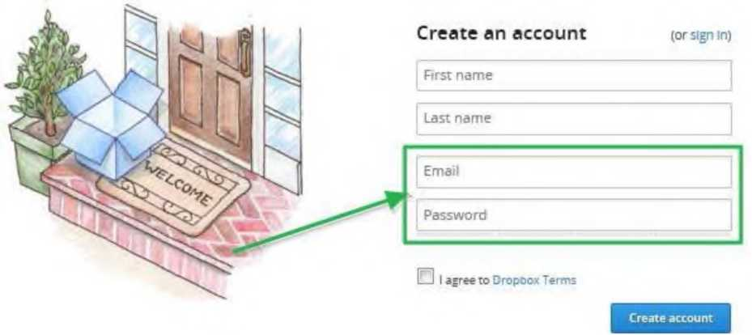

  - picture Sign up for Dropbox.
- Working in the Dropbox system via web interface. After registration, the following window will appear on the website.
Name • | wr*d | Moc | lifted
) Edu | (older
1 |  |  |  |  | Ltd-• 1
i7i joos common | snared fovoer | -
Personal | folder | -
D, Pnotos | folder |  | X | G
~&T, puojic | folder
Dropbox
L* La
V

- picture Dropbox service web interface.
Through this window, you can:
- Create new folders;
- Upload new files;
- Create or add new directories;
- Organization of general connection;
- Editing and deleting files.
Thus, the above-mentioned systems allow not only education, but also the organization of various systems based on cloud technologies.
Obvibase makes this very easy when it integrates with Google Drive and Dropbox. For example, the file in the "Check" column above
icons represent PDF files stored in Google Drive, and clicking on them will open a preview in a new internal window.
This is cool for several reasons. First, there is the division of labor: we can never do file storage like specialized services. Second, like Obvibase, Google Drive and Dropbox have very powerful free plans. And finally, there is no dependency: if you decide to stop using Obvibase, you need to export the data in CSV format and this data is attached to Google Drive or Dropbox contains permalinks. to database records
The purpose of saving in Dropbox and its possibilities.
Although you can store database files yourself, Dropbox and the Dropbox API do not offer a remote connection method to perform database queries / operations. You have to upload/download the database file every time you need to change it. I'm submitting this as a feature request, but I can't say much about how it works/works with local database files in a Dropbox folder. If you try to access a local database file synced in a Dropbox folder through the Dropbox desktop client, it may be the database program and the Dropbox desktop client may be preventing access to any of them when using the file (e.g.
Autosync in Dropbox is to disable the feature. There is an app called Beyond Compare that has a scripting feature. It requires registration, which costs $35. Works great for backing up to Dropbox. Synchronization can then be scheduled via the Windows Scheduler.
Files and folders in your Dropbox account can be shared with anyone (even if the recipient doesn't have a Dropbox account).
During and after granting access, you can control whether users can modify, comment, or view your files and folders.
Changes and comments are applied to the original file or folder and are visible to everyone who has access to them in real time.

LECTURE 7: Effective organization and management of cloud infrastructure components
Plan
7.1. Storage of information from cloud infrastructure components
7.2. Amazon S3, virtualrent of servers, provision of accounting resources
7.3. Amazon EC2. Amazon S3 online webservice
Effective organization of cloud infrastructure components and
manage
Web services provided by Amazon web-services Amazon web-services (AWS) is a cloud-based web services infrastructure provided by the Amazon company. This infrastructure provides various services.
"Hi amazon
web services"
- picture Amazon web services
These include data storage, Amazon S3, virtual server rental, provision of computing resources, Amazon EC2. Amazon S3 online web service provides the ability to store data of any size and access them anytime from anywhere in the world via the Internet. Amazon Elastic Compute Cloud (Amazon EC2) web service provides computing power and resources located in the cloud. AWS is a part of the infrastructure of the cloud web services platform provided by Amazon in early 2006. AWS offers virtual server rental, computing power, data storage (file hosting, distributed data warehouses), etc.
A simple web-based service interface allows configuration with minimal computer power and resources. It provides users with full control over computing resources as well as a comfortable working environment. This service reduces the time it takes to get and download a new server.
Cloud configuration
Cloud configuration is the process of setting the hardware and software information for elements of a cloud environment so that they can work and communicate with each other.
One of the challenges of a cloud environment is that it is more difficult to configure than a network with a simple or single location, a homogeneous network. A cloud provider has to make the service accessible to customers located at different points using all kinds of devices and software. Like a single network administrator in a single building, a cloud provider must ensure that service is reliable, quality is good, and communications are secure.
Cloud application program interfaces (APIs) sit on top of the client device to provide interaction with the provider's environment. Application programming interfaces (APIs) serve to deliver a unified programmable experience, regardless of what the underlying device is doing.
Configuration features differ between the 3 main elements of cloud provisioning.
In the software as a service (SaaS) distribution model, applications are deployed by vendors or service providers and are made available to customers over the Internet. Software configuration can be granted to users.
Software configuration can enable the user to make the same type of changes to configure a localized application. Software configuration can allow users to make the same type of changes in locally hosted applications. In other cases, there may be only one configuration offered. A provider's configuration responsibilities are usually defined in a service level agreement (SLA).
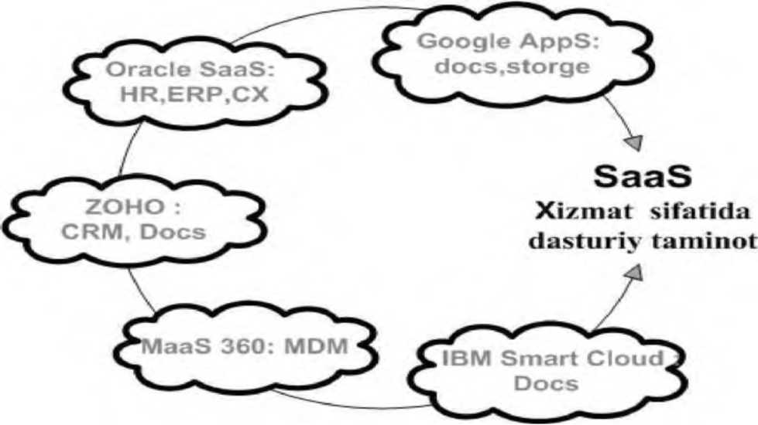
Figure 1.19. Major SaaS providers in cloud computing

In the platform as a service (PaaS) model, operating systems and requested services are delivered over the Internet without downloading and installing them. Platforms for developers can include operating systems, programming languages, application testing environments, databases, and web servers. Configuration and management of all elements is the responsibility of the providers.
The principle of operation is focused on two main methods: IP - encryption of packets using hardware and software, or simply through open traffic. Almost always, personal confidential data processed in corporate networks of companies is stored for access via IP network. Encoding all packets consumes a lot of system resources. Decreasing the level of encryption causes an increase in open traffic, and this leads to a decrease in the level of protection of confidential information. Such a situation is considered unacceptable in the spheres of human activity. The solution is to increase the speed of IP encryption.
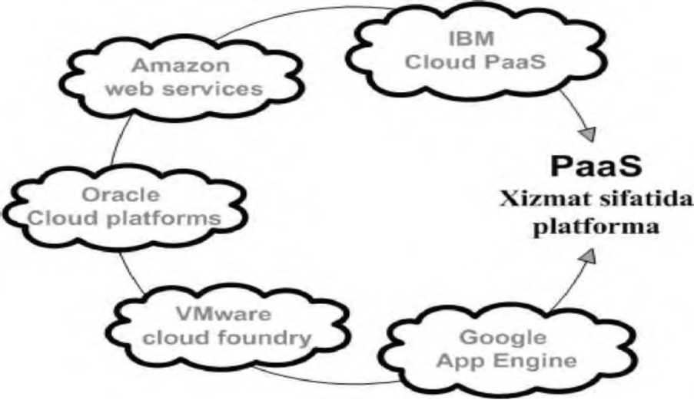
Figure 1.20. Cloud computing is based on PaaS providers

Infrastructure as a Service (IaaS) includes equipment used to support operations, including storage, hardware, servers, and network components. Similar to the PaaS service model, the configuration of all elements is the responsibility of the provider.
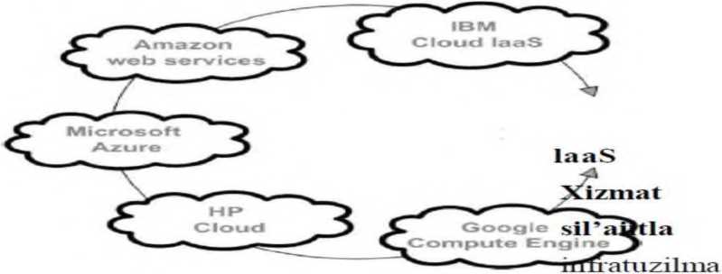

Figure 1.21 Major IaaS Providers in Cloud Computing Just as there are service level criteria in every service domain, cloud infrastructure has service level criteria. Criteria and requirements for cloud computing are regulated on the basis of Y.3500 recommendation of the International Telecommunication Union ITU-T.
The importance of hardware and software in the use of data center resources
Provision of consumer hardware and software.
Nowadays, encryption of IP streams by SSL protocol at the consumer workplace does not cause any problems in the approach of software and hardware. The speed can reach 1 Mbit/s without processing. Nowadays, there are quite a few certified companies that provide such services. Keys in consumer operating systems and protection of personal information in the corporate cloud is one of the biggest challenges in information security. An electronic lock is installed on the consumer's personal computers. Not only the consumer, but also the information security service of the company has the ability to control such blocking. But all these are available only in the private cloud and in the social cloud there are no such possibilities.
A hypervisor, as a software tool, manages hardware resources and distributes resources between guest operating systems, so it is considered the weakest part of a virtual environment. any corrupted state of it causes a crash in the guest operating system. Being able to exploit a hypervisor opens up a variety of opportunities for malicious actors. In fact, such access allows you to control all information flows through the hypervisor. Such opportunities give the right to common use of the virtual environment, that is: the administrator of the virtual structure has the right to use any information without restrictions.
Therefore, the security of information resources can be solved in a virtual environment. Logical virtual infrastructure is no different from physical infrastructure, so threats from the first are also considered to be relevant to the second. Then information protection tools should have the ability to optimize hardware resources while providing virtual infrastructure protection. In virtual infrastructures with a large volume, the use of information protection tools for rational purposes helps to build at the hypervisor level. The main risk potential in the cloud is caused by the virtualization specification, the emergence of new objects - cloud management system and system virtualization. Compromising one of them is tantamount to compromising cloud security.
If a simple antivirus is installed on the operating system of a virtualized server, 100 copies of the antivirus will appear on one physical hypervisor. Each copy has its own antivirus signature, driver: all these must be updated on time in all virtual machines. In this case, a new additional burden will appear on the hypervisor and physical server resources will begin to be used inefficiently.
In 2009, the VMware company was the first among the hypervisor manufacturers to deploy the hypervisor in depth, that is, to use it only in one virtual machine. The Hypervisor manufactured by VMware and its approach has become the standard. Defense virtualization tools and the main demand in the cloud environment are aimed at: reducing security costs, reducing resource requirements, increasing productivity and taking advantage of the opportunities provided by virtualization.
For example, virtualization security uses Hypervisor-level tools against viruses, attacks, and threats. Similar security approaches are also used at the network level. Networks are managed by hardware installed at the network boundary, using firewalls, intrusion detection and threat detection, and defense against attacks. In virtualization system maintenance, there are two possible solutions in cases where it is necessary to ensure security of traffic between virtual machines belonging to administrators.
The first solution is to take the standard hardware, isolate the relevant traffic in the virtualization environment, and wrap it in case it goes through that device and back. Even a standard solution for this is to use traffic filtering. But such an approach is considered inefficient.
Another way, that is, the second way, issues (solutions) can be placed at the Hypervisor level.
Control questions:
- The concept of cloud technology?
- Development of cloud technology
- Introduction of cloud technology in Uzbekistan
- Services provided by cloud infrastructure
- Concept of cloud computing
- Definitions of cloud computing
- The development of cloud computing on a global scale
- Analysis of work processes of MQIM
- Give an insight into the cloud computing ecosystem?
- Cloud ecosystem classification?
- interactions of participants in the cloud ecosystem
- Cloud pyramid concept
- Advantages of using cloud technologies
- Disadvantages of using cloud technologies
- Features of cloud technology
- Cloud advantage and disadvantage
- Services provided by cloud systems
- The possibilities of services provided by the cloud
- Sign up for Dropbox
- Explain the web interface of the Dropbox service
- Web services provided by Amazon web-services
- Cloud configuration only
- Understanding of hardware and software when using data center resources

LECTURE 8: Cloud infrastructure modeling
Plan
8.1. Cloud infrastructure modeling
8.2. Imitation approaches
8.3. Simulation models in the study of complex systems
Cloud infrastructure modeling. Imitation approaches
Simulation models are widely used in the study of complex systems. Simulation models are used in various sectors of the economy, aviation, railway transport, metallurgy, oil production, shipbuilding, etc.
Simulation is an approach to implement a model program within a model of a computing environment. The simulation process allows us to focus on modeling a specific part of the system abstracted from the rest of the system. Such an approach allows to achieve large-scale reproducible results on different platforms and experimental conditions, which allows to evaluate the behavior of distributed computing network in changing conditions, and on this basis, to optimize the strategic task of flow control. The main advantage of this approach is the flexibility of the system, since the program and the computing environment are models, and the experimental conditions can be easily changed. The downside is the complexity of the developing application models and computing environment.
In the development of simulation models, special modeling languages ​​and software tools based on the use of a graphical user interface are used. Currently, there are various specialized simulation modeling tools on the market, such as GPSS World, Arena, Extend, etc.
In addition to special environments for creating simulation modeling, there is also a way to create it based on the use of C, C ++, Pascal, BASIC and other universal programming languages. The advantage of this method is that it is possible to use the capabilities of a general-purpose programming language in addition to special modeling tools. In addition, the programming language can be integrated into the modeling tool, for example, AnyLogic integrates the Java programming language. With these languages, special libraries of functions and procedures (classes) have been developed for simulation purposes.
It is proposed to use libraries of procedures and functions of the Pascal language to develop the implementation of simulation models. articles review a cross-platform library of C functions for implementation on operating systems such as Windows and UNIX.
In recent years, the development of the so-called cloud computing, which is oriented towards the use of the Internet and is already known as the development of distributed computing technologies, has entered. the report examines the development trends of the simulation modeling environment, as well as the current simulation modeling implementation practices used in "cloud" computing technologies. In particular, a practice that can manage one or more instances of GPSS World on a remote server, known as a GPSS-server, is considered. Also, a systematic tire technology of modeling based on service-oriented architecture is presented. The perspective approach is based on a clear standard for creating a "cloud" model called GPSS Cloud. In fact,
In addition to the use of special modeling languages, it is convenient to use the Java language, which is characterized by the features of universal programming languages, in the "Cloud" simulation environment. Using Java for cloud computing has several advantages:
-Java language is, in fact, a special language for the Internet, with special security models;
-Java language applications can be used in server-side servlet applications, just like client-side web browser-applet applications (use of applets is done in the same way as simulation modeling in AnyLogic environment); it is also possible to create custom desktop applications and applications for mobile devices;
-The Java language is cross-platform, and applications run on both the Windows platform and the various environments of Linux operating systems.
The Java language supports multi-threading mechanisms and other modern features of object-oriented languages ​​(exception handling, graphics libraries, component model, etc.).
An overview of the Java class library for simulation modeling. Java's class library is focused on modeling discrete events and implements the same algorithms as Pascal's procedures and functions [ and C functions, using an object-oriented approach. The main methods of the library classes are similar in many ways to the GPSS language operators. The class libraries are included in a single package called SIMJava. To use the class library, it is enough to have the JDK SE (Java Development Kit Standard Edition) software version 6 or higher installed on the computer. For convenience, you can use one of the integrated development environments: Eclipse, NetBeans IDE, etc.
The main objects in the model are created as objects of the following classes:
Queue is a class for the task of queues in the model;
Facility is a class for single-channel devices;
Storage is a class for multi-channel devices;
Histogram is a class for representing a histogram;
Transact is a class for dynamic object transactions in the model;
Rand is a class for defining random number generators;
Syst is a class to create a "model" object, any mock model must create an object of this class or an object of the base class; the class contains the main system methods and also supports a separate thread to run the model; the class contains methods to output simulation results to both a file and a window or applet-type container.
The library also has helper classes for creating a list of various objects: ListF — a list of single-channel devices; ListS — list of multichannel devices; ListQ is a list of queues; ListH — list of histograms; ListT is a list of transactions and a few other classes.
An overview of simulation of cloud computing systems.
Currently, a lot of research is being conducted to study the behavior of large distributed systems, and software is being developed for these studies. Examples of such software include GridSim, SimGrid, and CloudSim. While the first two solutions focus on modeling grid systems, CloudSim is one of the few platforms focused on modeling cloud computing systems.
It should be noted that the grid system modeling environment is a suitable solution for creating models of very large cloud computing systems.
However, virtualization allows some cloud systems to be deployed in small test stations where backup of cloud resources, services, application load, etc. plays an important role.
Therefore, to create detailed models of cloud computing systems, it is necessary to use directly developed programs for modeling cloud computing systems.
Modeling and simulation platforms
- The CloudSim platform is a general and advanced simulation tool that enables complete modeling and simulation of cloud computing systems and infrastructures. It is an extension of the core functions of the GridSim platform, providing modeling of data warehouse, web services, resource allocation between virtual machines and more.
The CloudSim core is based on the SimJava behavior, which is based on event processing, creation of cloud objects (services, nodes, data centers, resource brokers and virtual machines), control of system elements and simulation flow, and the use of queues in the interaction of system elements. When developing a model of a cloud environment, the user must refine the key components of his model to achieve results as close to reality as possible.
The main objects of the platform for modeling are the virtual machine and the task. These components are specific to different groups of cloud systems. For example, it is common for cloud systems such as PaaS to host multiple applications on the same virtual machine.
The most important components in modeling are those that respond to resource management policies. Tasks handled by these components include:
- allocation of processor power, RAM and other resources for various objects of modeling systems;
- placement of virtual machines on nodes of modeled systems;
- distribution of tasks between virtual machines in the modeled system. The working principle of the model is based on the CloudSim platform, which provides the necessary components of the platform and the initial description of the simulation system and the execution of the simulation scenario in the form of source code. After starting the simulation, all information about the simulated system is transferred to the CloudSim kernel to be simulated.
It should be noted that the CloudSim platform does not allow for changes in the simulation system or simulation scenarios directly during model execution, which limits the capabilities of the platform.
- CDOSim.CDOSim (Cloud Deployment Options Simulator) is a simulator whose main task is to evaluate the performance of a cloud computing system or infrastructure. The CDOSim platform is designed to compare different options for deploying cloud systems and infrastructures in order to optimize the use of available resources and improve cloud computing system performance. The CDOSim platform can flexibly change the main parameters of cloud systems and infrastructure deployment:
- system resource conservation strategy;
- configuration of virtual machine instances;
- hardware and software used to develop a computing system;
- network parameters.
- TeachCloud. The TeachCloud platform is a simulator of cloud computing systems designed specifically for education. The TeachCloud platform provides a simple graphical interface through which students can change the configuration and settings of the cloud computing system, and conduct experiments with possible configurations of such systems.
- iCanCloud. The iCanCloud platform is a software simulator for large data storage networks. The iCanCloud platform allows you to maximize the use of resources by a specific application in a specific computing environment. The platform has a fully graphical interface that allows you to fully design and implement a typical warehouse simulation with complete information. In addition, the iCanCloud platform allows parallelization of cloud computing system simulation.
- SPECI.SPECI software (Simulation Software for Elastic Cloud Infrastructures) is a simulator that allows you to recreate and study the behavior and scale of large data centers. The SPECI program is designed to work with data centers that have been designed, but not yet built. In these cases, using the SPECI program can reveal system weaknesses and "bottlenecks".
- DCSim. (Data Center Simulator) platform is primarily a simulator working with IaaS systems that chooses the appropriate resource allocation and backup policy in each individual case. The DCSim platform significantly accelerates the process of developing and launching an IaaS system.
Mathematical modeling of cloud systems.
S. Islam, K. Lee, A. Feketeand A. Liu developed an elasticity model for clouds. They hypothesize that each type of resource (processor, memory, network bandwidth, etc.) can be allocated to units, and users will be aware of the allocated resources and QoS metrics relevant to their requests, as in Amazon CloudWatch. The model combines the prices of resources provided but not used with the cost of reduced efficiency associated with reduced production.
Analytical and simulation modeling of cloud networks in data transmission
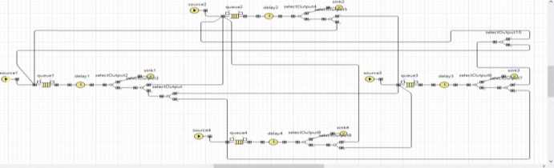

Figure 2.1. AnyLogic simulation model view
AnyLogic is a simulation software developed by the Russian company (formerly Ex X Technologies, XL Technologies). This tool has a modern graphical interface and allows you to use the Java language to develop models
In 2003, a major step was taken to release AnyLogic 5, which focused on business modeling. Using AnyLogic, it was possible to develop models in the following areas:
- production;
- logistics and supply chains;
- market and competition;
- business processes and services;
- healthcare and pharmaceuticals;
- asset and project management;
- telecommunications and information systems;
- social and ecological systems;
- pedestrian dynamics;
- to protect
The latest version of the program is AnyLogic 7. AnyLogic 7 is written in the Java programming language in the popular Eclipse environment. Anylogic 6 is a cross-platform software that runs under the Windows operating system and under Mac OS and Linux.
Basic literature

- Cloud technologies. Study guide. TEDelov. -Tashkent: 2020 -217 p.
2. Patrick Niemeyer, Daniel Lake Learning Java / 2014.
3. Cruz Zapata. Android Studio Essentials Belén 2013.
4. Ted Hagos. "Learn Android Studio 3 with Kotlin" 2015.
5. J. Zdziarski. "iPhone SDK Application Development". Saint Petersburg. 2010.

Additional literature

- Android Programming Tutorials 2013.
- Adam Sinicki. Learn Unity for Android Game Development 245 pages
- Matt Neuburg. iOS 12 Programming Fundamentals with Swift

Internet sites

1.https://intuit.ru/studies/courses/493/349/lecture/8337
2. https://www.fandroid.info/
3.https://developer.android.com/
- https://covde.oksei.ru/user/view.php?id=5&course=167 – for Android
- https://www.w3schools.com/java/default.asp– on website programming languages
- https://udacity.com. - online platform

LECTURE 9: Implementation of effective configuration of resources within SLA
Plan
9.1. SLA (Service Level Agreement)
9.2. Quality of service Organizational control
SLA (Service Level Agreement), Quality of Service The loss of organizational control is mainly due to human factors that create barriers to the transition to the cloud computing system. These factors may include the fear that certain individuals will lose influence over the organization, or the fear of losing their jobs if the cloud transformation affects functionally specific positions. The fear of losing control is widespread and applies not only to cloud computing changes, but also to many other organizational changes.
Another problem is that some organizations are not ready to accept change or are too slow to implement it. Therefore, it is important to secure top management support to implement change. Loss of organizational control is a complex issue and organizations are generally reluctant to disclose these types of governance issues.
SLA agreements.
SLA (Service-Level Agreement) is an agreement that defines the level of services provided by a cloud provider. In cloud services, SLA is measured in terms of average time between outages, errors, and other operational metrics such as network response time and system quality.
Companies should do their due diligence to carefully study the cloud provider's SLA agreements. Not all cloud providers are willing (or able) to offer the level of uptime required by organizations. Even cloud providers like Amazon only provide a guaranteed 99.95% annual uptime for their servers, while some organizations claim 99.99% annual uptime. If service uptime is below 99.95%, each customer with an agreement with Amazon can receive a service credit equal to 10% of their bill. Whether Amazon's SLA customer's server is down for two hours or 10 days, the customer company still receives the same amount of compensation.
Data Portability / Integration.
Integrating information from a company's internal data center with information located in a public closed cloud can be technically challenging. Hybrid clouds where data is distributed in both private and public cloud
organizations that intend to use may face several problems in data integration (integration):
- Security issues (data management, network communication, etc.);
- Transaction integrity issues (impossibility to support transactions across clouds);
- Difficulties in using large amounts of data;
- Lack of mechanisms to detect changes in data;
- Data quality control issues;
- Problems of determining the authenticity (originality) of data.
Quality.
Many cloud provider SLAs only cover infrastructure availability, not quality. If a company's software has specific performance requirements, the company should discuss those requirements with cloud providers and confirm that those requirements can be supported. It's a good idea to include these requirements in your SLA agreement, and it's standard practice to negotiate an SLA with your cloud service provider.
When choosing a cloud provider, companies should evaluate whether the provider can support the expected growth and guarantee a sufficient level of quality in infrastructure expansion.
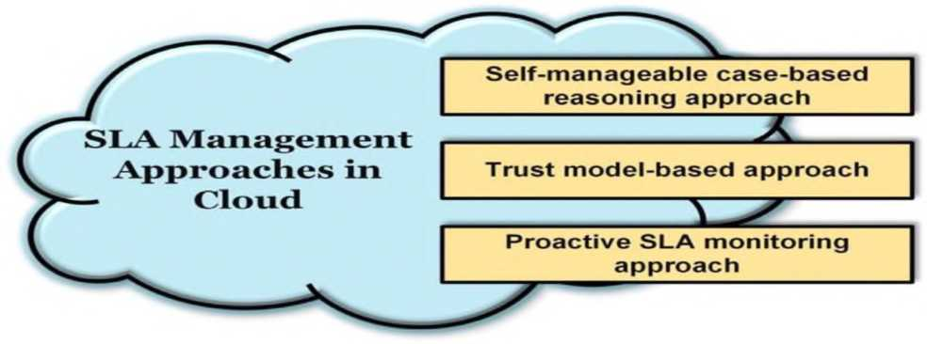
Figure 2.2. SLA management approaches to cloud computing
classification
A Classification of SLA-Management-Approaches to Cloud Computing
60

- Self-controlled situational resonating
- A model-based approach
- SLA monitoring approach
Assumes responsibility for monitoring cloud customer cloud performance and ensuring compliance with requirements and SLAs - collected performance metrics must be analyzed on an ongoing basis. If cloud-hosted applications are deployed globally, it is important to monitor quality parameters such as network latency at all major customer locations.
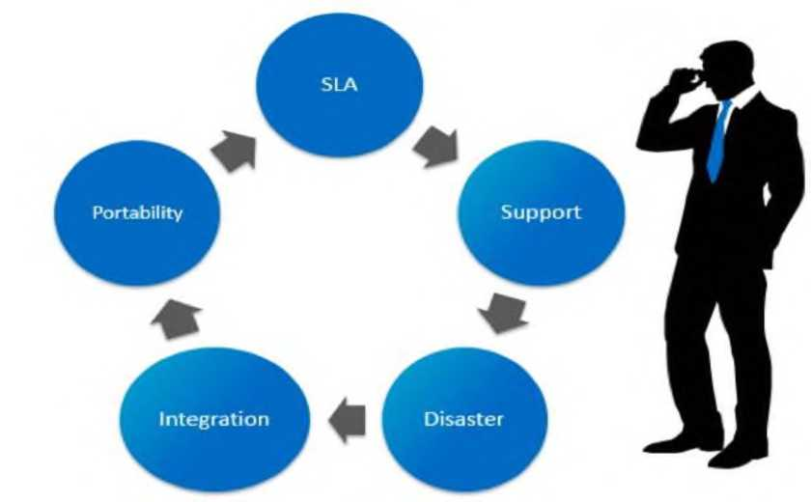

- picture Most business cloud questions are closed review
- Portability
- Integration
- Support
- Problem
As mentioned above, there are several problems with cloud systems. Many of them are important. As a cloud service provider solves these problems, the level of network reliability is greatly increased. In order to improve the quality of service in the network, attention is paid to several parameters. These parameters can be jitter, packet loss value, waiting time during packet service. This dissertation
The issue of reducing the waiting time during packet service, which is one of the indicators of service quality, is considered in the work. For this purpose, it is possible to reduce the service time of packets through the effective distribution of the load in the system, and the creation of a model for the effective distribution of the load coming to the system is a research issue of the thesis work. The resulting solution will help improve cloud network performance and meet service demands in a timely manner.
Implementation of effective configuration of resources within the concept of quality system (service level agreement, SLA).
It is well known that quality service is the basis for increasing the number of consumers and becoming a regular customer. And the income received from useful and guaranteed services is the foundation of the development of the industry.
A service level agreement (SLA) is an agreement between a service provider (internal or external) and an end user that defines the level of service expected by the service provider. SLAs are output-based, and their goals are to specify exactly what the customer will get. The SLA does not specify how the Service will be provided or delivered. An Internet Service Provider (ISP) is a prime example of an SLA from a service provider to its customers. Indicators that determine the level of service for an ISP are aimed at guaranteeing the following:
- Definition of Services - Definition of services provided such as storage of provided network connectivity, domain name servers, dynamic host configuration servers protocol.
- Reliability - when service is available (percent uptime) and restrictions can be stopped.
- Responsiveness is the repeatability of services performed in response to requests and scheduled service dates.
- Procedures for reporting problems - who to contact, what problems to report, escalation procedures, and what other steps to take to resolve the problem effectively.
- Service level monitoring and reporting – who monitors work, what data is collected, and how often access to customer performance statistics is granted.
- Consequences for failure to meet service obligations may include credit or fees to customers or allowing the customer to terminate the relationship.
Disclaimers or Limitations - Circumstances in which the promised level of service does not apply. For example, in cases where floods, fires, or other dangerous situations could damage an ISP's equipment, the issue may be exempt from the uptime requirements.
SLA (Service Level Agreement) is a service level agreement, which is an important contract that determines the quality of communication, information delivery and service. This contract usually appears in three different forms:
- Between the provider and the customer (Provider to Customer);
- Between providers (Provider to Provider);
- Between customers (Customer to Customer).
Although the exact metrics for each SLA depend on the service provider, the parameters they provide are similar: volume and quality of work (including accuracy and thoroughness), speed, responsiveness, and efficiency.
Service level definitions in each area must be clear and measurable. This allows the quality of the service to be compared, and if the agreement is stipulated by the contract, then it will be appreciated or penalized accordingly. SLAs typically use technical concepts that determine the average time between outages or a target (average) or minimum value for recovery, response, and decision-making.
The concept of service level should be clear and measurable. For example, using SLAs with other departments (customers) through the IT help desk allows you to compare them to determine the quality of their work. The use of SLAs is also common in outsourcing, cloud computing, and other industries. The use of SLAs is also common in outsourcing, cloud computing, and other areas where the outsourcing responsibility is transferred to another supplier.
A Service Level Agreement (SLA) is as follows:
- speed required during the session;
- delays in packet flow;
- probabilities of packet loss allowed in the data flow;
- compatibility of the agreements on the level of service quality with the traffic parameters used in reality;
- data for packet routing (address / point address / point designation).
If the user cannot use the services of the components, then the operator offers one of the standardized class quality service methods.
Quality of Service SLA guarantees the resolution of problems in cloud services. In their paper, they proposed a new cloud model called (SLA aware Service). This model is orthogonal to other SaaS, PaaS, and IaaS cloud models and can apply to any of them.
Cloud computing provides distributed resources to global users. Cloud computing includes a wide range of architectures that provide the services required by outsourcers in various industries. However, there are many problems with cloud services. Different approaches have been proposed for different problems of cloud services. In their paper, Usman Wazir, Fiaz Gul Khan and Sajid Shahoz reviewed various models proposed for SLA in cloud computing to overcome the challenges inherent in SLA.
Issues related to performance, customer satisfaction, security, revenue and SLA violations. A discussion of SLA architecture in cloud computing is reviewed, followed by a discussion of the available models for SLA in various cloud service models such as SaaS, PaaS, and IaaS. Then, with the help of tables, they discussed the advantages and limitations of the existing models and gave their opinions and conclusions.

SLA
a must
no name
- picture The SLA is between the service provider and the customer
negotiated agreement.
When ensuring the quality of service in cloud computing systems, attention is paid to the operation of the following parameters at the values ​​specified in the SLA contract:
QoS (Quality of Service), Quality of Service Quality of Service (QoS) has been considered one of the most important topics during the entire development of the telecommunications industry. Until recently, Internet service providers and other large companies had to build separate networks to carry voice, video and other types of traffic. Nowadays, it is no secret that all networks are converging into a single network that transmits data in packet form based on the IP (Internet Protocol) protocol.
QoS methods should reduce the congestion level of congestion-sensitive traffic (eg, voice) and also ensure the average speed. The complexity of the task is that the packet switching method is actually designed for traffic with low sensitivity to jams, that is, random jams in the buffers of network intermediate devices (for example, routers) do not cause significant damage.
When evaluating the quality of service in cloud computing systems, several parameter indicators are evaluated:
- network performance;
- reliability of network and network elements;
- seizures;
- seizure variation (djitter);
- packet loss;
- packet transmission errors.
Network performance, or data transfer rate, defines the effective speed of transmission, measured in bits transmitted per second. It should also be noted that the value of this parameter does not correspond to the maximum bandwidth of the network, erroneously known as bandwidth.
Reliability of network and network elements. Users always expect a high level of reliability when using services. Network reliability is evaluated by the "readiness" coefficient. Ideally, the readiness factor should be equal to 1, which means that the network is 100 percent ready. In practice, the readiness coefficient is represented by numbers 0 and 9. For example,
- 999 means no network access for 9 hours per year. For example, when the availability factor of a cloud computing network is equal to 0.99999, as in the UFTT network, this means 5.5 minutes per year.
It should be noted that providing a 0.99999 availability factor in cloud networks built on the basis of traditional devices, that is, servers, routers, is considered one of the serious problems. The reason for this is that information processing in cloud networks is not based on hardware, as in UFTT, but also on software.
Delay in packet delivery (transfer delay). This parameter is determined by the time interval (t2-t1), that is, the difference between the times of occurrence of two processes. Here, t1 is the time the packet enters the network entry point, t2 is the time the packet leaves the network exit point, and (t2-t1).
In general, the latency parameter is determined by the time taken to deliver all successfully transmitted and errored packets from the source to the receiver.
The average delay parameter of packet delivery is determined by the arithmetic mean value of the delays of transmitted and received packets. The average interception cost depends on the traffic carried on the network, available network resources and, in many cases, the nature of the throughput. An increase in load and a decrease in available network resources lead to an increase in the queue at the network nodes, which in turn increases the average delay in the delivery of packets.
Certain types of packages are sensitive to interception. If the delay in packet delivery exceeds the specified Tmax value, such packets are dropped. In real-time applications, this situation leads to poor quality of service. Limitations related to the average capture of packets play an important role when using voice and video services.
Delay variation. The Vk parameter describes the variation of packet interception. This parameter is determined for a package with index k by the difference between the absolute value of interception Xk between the network entry and exit points of this packet and the specified standard value of interception, d1, 2, i.e.:
Vk = Xk — d1,2
The standard delay time for IP packet delivery between the source and receiver is determined by the absolute value of the first packet delivery delay between these network points d12. Packet capture variation, i.e. jitter, is manifested in the fact that consecutively sent packets arrive at the receiver at random times.
Packet loss ratio. The packet loss ratio is determined by the ratio of the total number of lost packets to the total number of transmitted and received packets. Packet loss in cloud networks can occur when the delay value in their transmission exceeds the standard value, i.e. Tmax. If packets are lost, they can be re-sent at the request of the receiving party. Packets arriving at the receiver with a delay time greater than Tmax are dropped. This, in turn, causes distortions in the received data. One of the main reasons for this is the congestion of network nodes.
Packet error ratio. The packet error rate is determined by the ratio of the number of packets received with errors to the total number of received packets.
Often, the interval taken to measure capture, jitter, and loss in a network is taken to be larger than the transmission rate.
A general description of the concept of quality is given in the international standard ISO 8402 of 1994: "a set of characteristics of an object that satisfies a defined and intended purpose". In 2000, the ISO 8402 standard was replaced by the ISO 9000 standard, which defines the concept of "quality" as the degree of conformity to its requirements. The main terms in the field of quality of communication services are defined in the recommendations (Quality of Service, QoS).
In ITU-T Ye.800 Recommendations, QoS is defined as follows: "a general indicator of the characteristics of the use of the service, which determines the level of satisfaction of the user with the service." Most standards, reports and classifications rely on ITU-T Recommendation E.800 when using the QoS concept.
One of the important tasks of quality provision of cloud network services is traffic management. By this we mean a set of algorithmic tools aimed at effective use of network resources using hardware and software to ensure quality service activity. To ensure QoS, it is necessary to perform the following tasks:
-Traffic classification (Classification);
-Traffic marking (Coloring);
- Fixed connection management (Connection Admission Control);
-Scheduling and queue management;
- Overload management (Congestion Management);
-Load management (Congestion Avoidance).
Scheduling Services:
- Priority of Service: Traffic classes have different priorities and it depends on the traffic assignment, the first traffic class is the one with the highest priority and the rest are forwarded in turn.
- Packages are served on a rolling basis.
- Periodic service (Round Robin). The fixed time for each package service is given in turn.
- Basically fair buffering (Weighted Fair Queuing, WFQ). It depends on how much time has passed and how many are passing through to serve the different packet classes.
Load control and management:
- Token Bucket - during a given period of time in serving a limited number of downloads, limiting the average flow rate, providing incoming and outgoing packets with specific parameters.
- Leaky Bucket - measure and manage incoming traffic.
The passive algorithm of the packet control procedure is as follows:
- the simplest algorithms for handling packets;
- the ability to "catch" one flow of packets in the order of transmission
no
- the state of advance detection of the moment of overload is not provided;
- the problem of preventing the possibility of trapping one or more streams in the order of packet transmission;
- solving the problem of the possibility of early detection of overload;
- providing delay during the transmission of packets.
Issues of implementation of such mechanisms and implementation by the operator or provider include monitoring the quality of communication services, obtaining statistical data or control measurements, analyzing requests and complaints from users of communication services. depends on the factors.
Also, necessary modeling work and instructions are provided to apply the alternative mechanism in different conditions.
In general, cloud computing provides users with convenient access to a set of configurable, shared computing resources: networks, servers, storage devices, applications, and services that are readily available to users from anywhere, with minimal management effort or service provider intervention. provide a model that provides on-demand access to services that can be provided and distributed.
In this model (according to ITU-T Research Group 13), there are five categories of cloud computing services:
- software as a service (SaaS);
- communication as a service (CaaS);
- platform as a service (PaaS);
- infrastructure as a service (IaaS);
- network (NaaS) as a service, as well as various distribution models (state, others).
private, hybrid and
In cloud computing ecosystems, many services are provided to many users with high quality of service (QoS) and optimal use of resources.
Depending on the requirements and possibilities for configuring cloud resources, regardless of the model, the cloud computing environment can be connected to each other.
Consider a general configuration management scheme (Figure 2.4) that can serve as a methodological basis for working in a connected manner.
possible: SaaS, PaaS, IaaS.
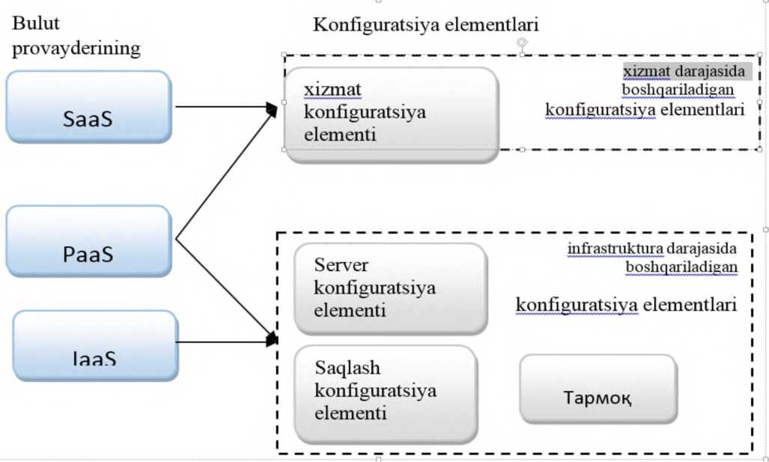
Figure 2.5. Principles of configuration in the cloud environment.

Computing resources are used to support virtualized resources and the necessary cloud services that can be managed, monitored, and other system functions.
LECTURE 10: Method of effective organization of network resources in cloud infrastructure
Plan
10.1. Load balancing (load balancer) located in the cloud system.
10.2. Load balancing a number of computing resources on computers
10.3. Load sharing between computers, networks, CPUs or disks
Load balancing (load balancer) located in the cloud system. In computers, load balancing is the distribution of the load among several computing resources, such as computers, networks, CPUs, or disks. The main purpose of load balancing is to balance the load among nodes to minimize system dwell time, minimize latency, increase resource utilization, reduce response time, increase throughput, and more. Using multiple components instead of a single component can increase network reliability and accessibility.
In clouds, load balancing is a mechanism that regularly distributes the redundant load across all nodes. This is done in order to achieve a high level of satisfaction of user requirements and to increase the percentage of resource utilization, to avoid overloading one node and, as a result, to improve the efficiency of the system. The important issue here is how to achieve a balance in the load distribution among the processors to finish the computation in the shortest possible time. In parallel and distributed systems, the concept of load balancing is used to distribute the load among servers.
In the cloud infrastructure, it is possible to reduce the time the packets stay in the system by serving the incoming flows using a multi-agent method. This is done by load balancing in the cloud computing system.
Load balancing in a cloud computing system is a method of distributing the load among several network devices (for example, servers) for the purpose of optimizing the use of cloud computing resources, increasing network efficiency by reducing the response time to requests.
Load balancer distributes the load between computing resources. Figure 2.6 below shows the location of the load balancer in the cloud.
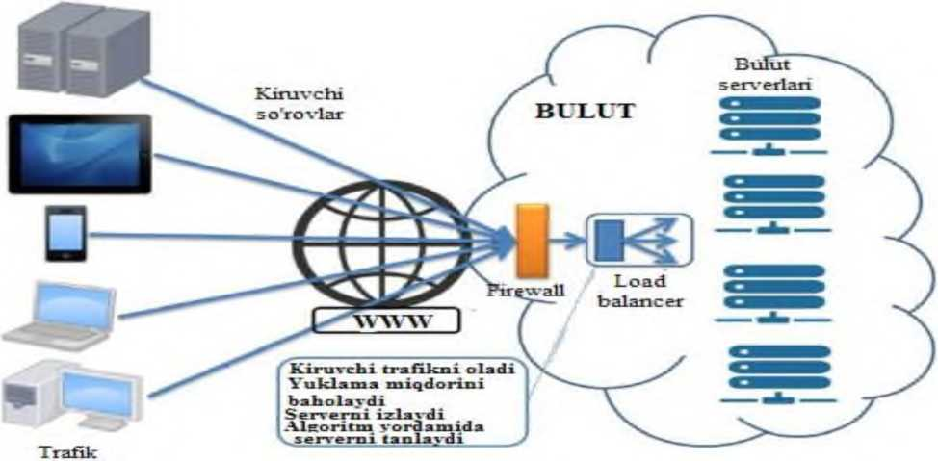

Ya en erat oars
- picture Load balancer (load
balancer).
The load balancer distributes traffic to cloud computing resources over the Internet to cloud computing resources. As you can see from the picture above, the load balancer is located in the edge part of the cloud infrastructure in the management part of the provider. Figure 2.7 shows its location more clearly. How the load balancer does this is determined by the distribution algorithm included in it. For example, this algorithm is a typical ring distribution (equal distribution of load to nodes in turn), time distribution (distribution of load to each node at specified time intervals), probabilistic, multi-agent method algorithms according to our own algorithm. can be.
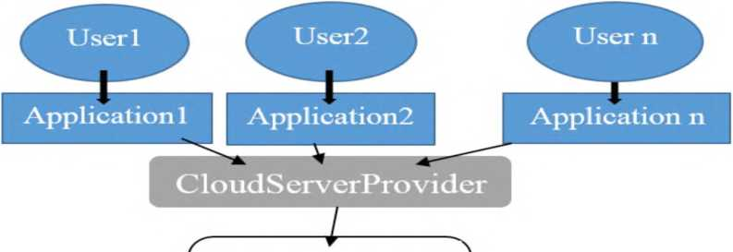
Cloud manager Load Balancer

BM
V ^ / \ 2^J
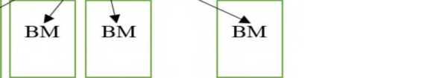
- picture Load balancer (load balancer) provider in the cloud
located in the management section.
Multi-agent systems are considered a promising technology to address the existing requirements of large-scale distributed and complex systems, such as autonomous transport systems or risk management. Applications of multi-agent systems place special demands on fast computing time for such large systems characterized by millions of distributed nodes.
Cloud computing system integration with multi-agent system. Multi-agent systems are a computing paradigm originating from the field of artificial intelligence, characterized by decentralized and parallel execution, based on autonomous agents. Because agents have limited knowledge and skills, they must interact, for example, communicate to achieve their individual goals, as shown in Figure 2.7. The high level of autonomy and collaboration provided by such solutions allows them to respond quickly to changes. Multi-agent systems can be used to solve problems that are difficult or impossible for simple systems to solve. In doing so, they offer models to represent a complete and dynamic real-world environment.
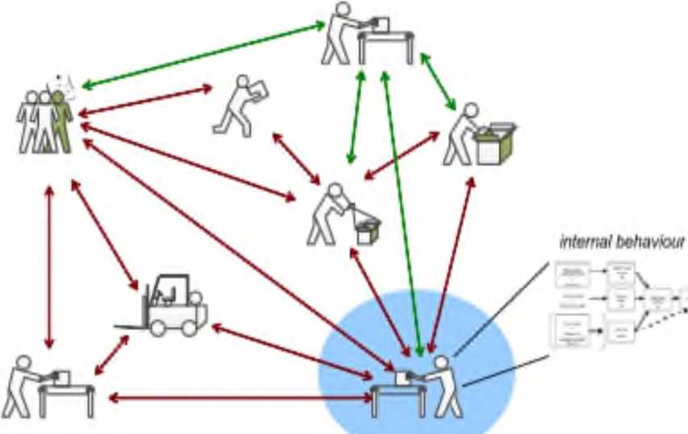

- picture An example of multi-agent systems.

Building multi-agent system solutions is greatly simplified if an agent development platform is used, taking advantage of the useful features and services provided, such as registration and management services. In some cases, they follow protocols created by the Foundation for Intelligent Physical Agents (FIPA). Examples of such agent development platforms are the Java Agent Development Framework (JADE), AGlobe, and JACK. JADE is a Java-based architecture that uses Remote Method Invocation (RMI) to implement Java-based application deployment. It provides low programming complexity and support features for agent-based solution management.
In the dissertation work, it is envisaged to create a model in the AnyLogic simulation environment for effective balancing of the incoming load using multi-agent in cloud computing systems. Modeling of the cloud infrastructure environment. To implement the model, we use a cloud network, the Internet, and several agents in the AnyLogic environment. The simulation structure is given in Figure 2.9.
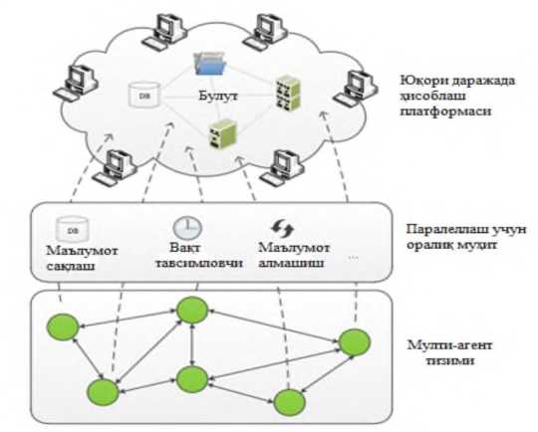

- picture Cloud computing system integration with multi-agent system.
A load balancing agent initially waits for incoming requests (packets). It then forms a collection of existing nodes. It then collects data on each node's load. It then determines which node serves which type of service. The required node (virtual machine) is selected based on the values ​​of the loads on the received nodes and the service type of the received packet and forwards the packets to it for service. The operation algorithm of the load balancing agent is presented in the figure.
G"N Nodes
download
clarify
^. J
i
s'ch
The provision of services v J

Wait
i
S''Ch
Nodes
shaping
^J
g l Node ni
clarify

- operation algorithm of the load balancing agent.
Another level of using the principles of multi-agent systems is called Agent-Based Modeling (ABM-Agent-Based Modeling), a paradigm for creating, analyzing, experimenting, and simulating systems populated by cooperative agents. The dynamics of the simulation are defined as the rules of the agent's behavior, and the goal of the simulation is individual
is to show the population-level structure that is the result of behavior at the level.
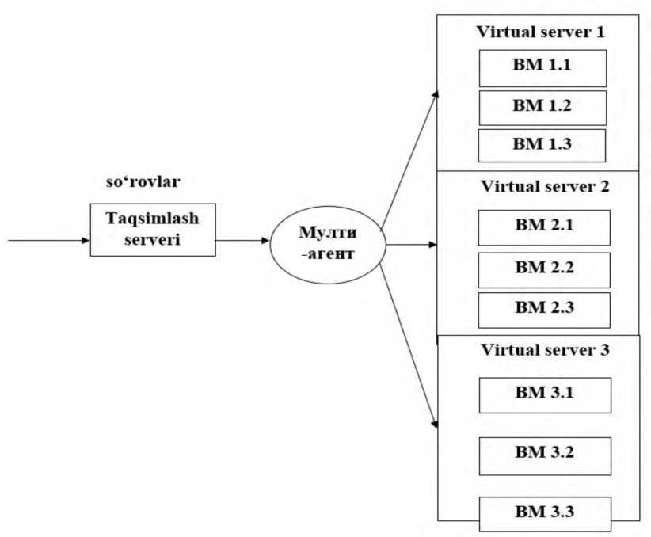

Figure 2.11. Structure of multi-agent distribution model.
We collect all of them in the AnyLogic simulation environment and create one general network scheme (Fig. 2.12).
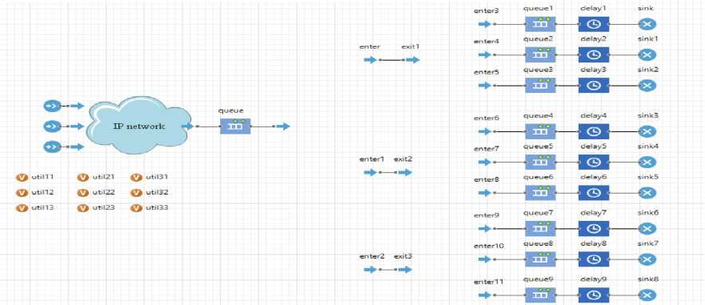
Figure 2.12. A multi-agent system cloud infrastructure created in the AnyLogic simulation environment.

In the cloud infrastructure, before requests arrive at computing resources, agents in the system send them to the most suitable node for service according to established algorithms. It is possible to increase the efficiency of the network by introducing various algorithms to the agent. Allocating service types, determining node load, sending requests to specific computing resources, etc. are among the capabilities of the agent. In this dissertation work, by balancing the load on the network from the multi-agent system, it is possible to reduce the response time to requests, the time these packets are in the system, as a result, to achieve faster service to cloud service users, to increase the quality of service (QoS). possible
In the cloud network in the model, 3 servers are conditionally taken for simulation. Each of these servers serves 3 different types of service packages. The initial agent (exit) in the model is designed to identify service types. It determines which service type the incoming requests belong to, while the next 3 agents (exit1, exit 2, exit 3) only detect one type of service.
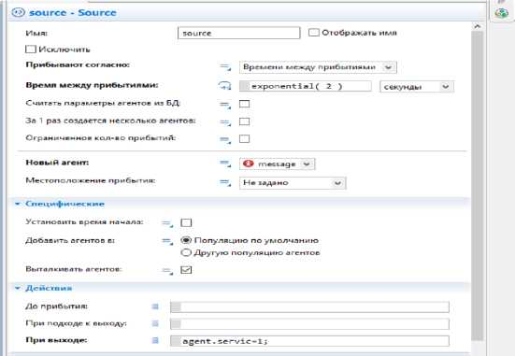

- picture Creating a service package in the generator.
In the created network, the part after the IP network is the internal part of the cloud environment. In the model, 3 generators (in real case, different subscriber devices) generating 3 different types of service packets are taken. Requests from these generators reach the cloud infrastructure via the IP network. Figure 2.12 shows the formation of a service packet of type 1 (service! packet) to this generator 1.
In the same way, 3 different service packages are generated in 3 generators.
After that, the service type detection task program is written to the initial agent located in the cloud network (Figure 2.14). In doing so, it determines which service type the incoming request packets belong to.
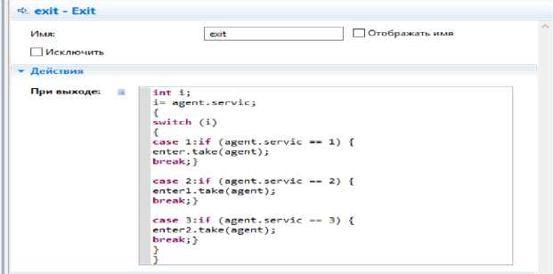

- picture Forwarding the packet to the next agent by service type.
Once a packet type is detected, it forwards the packet to an agent serving that packet type. Each of the next 3 agents in the model is different and serves only one type of request. The figure shows that after the first agent detects the service type, the code is written to the agent to pass it to the next appropriate agent. One of the next agents receiving the packet determines which of the virtual machines serving the packet on the servers is running with the smallest load. These loads are determined by the utilization values ​​of the virtual machines in the model. Figure 2.15 shows the input of the algorithm for determining the smallest utilization value to the agent.
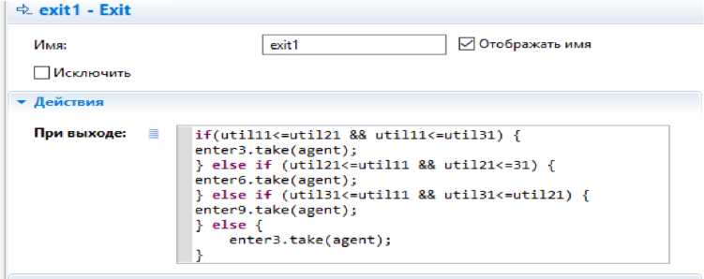
Figure 2.15. The computing resource with the least load on the agent
determination.

In the model, each of the 3 computing resources (servers) in the cloud infrastructure is divided into 3 virtual machines. Virtual machines 1 (VM1.1, VM2.1, VM3.1) of all three servers serve only service pack type 1. Similarly, their 2nd virtual machines (VM1.2, VM2.2, VM3.2) support type 2 service packs and their 3rd virtual machines (VM1.3, VM2.3, VM3.3) support type 3 service packs shows.
Whichever of the virtual machines is running with the smallest load, the agent sends incoming packets to those virtual machines for calculation (servicing). Virtual machines that receive packets start serving them. Incoming packets are served only by that VM, and as the number of packets arriving at it increases over time, so does its overhead. An algorithmic load control agent is triggered when its load value exceeds the load of a VM with a higher load. It immediately starts forwarding incoming packets to another VM that has less load. In the same way, in the cloud infrastructure, the service of incoming requests to the system is carried out, and the response time (response time) and the time of being in the system (execution) using the computing resources with the least load instead of the computing resources working with overload time) value reduction is achieved. A reduction in these times means an increase in the quality of service (QoS) in the cloud infrastructure and the efficient use of computing resources in the network.
Basic literature

- Cloud technologies. Study guide. TEDelov. -Tashkent: 2020 -217 p.
2. Patrick Niemeyer, Daniel Lake Learning Java / 2014.
3. Cruz Zapata. Android Studio Essentials Belén 2013.
4. Ted Hagos. "Learn Android Studio 3 with Kotlin" 2015.
5. J. Zdziarski. "iPhone SDK Application Development". Saint Petersburg. 2010.

Additional literature

- Android Programming Tutorials 2013.
- Adam Sinicki. Learn Unity for Android Game Development 245 pages
- Matt Neuburg. iOS 12 Programming Fundamentals with Swift

Internet sites

1.https://intuit.ru/studies/courses/493/349/lecture/8337
2. https://www.fandroid.info/
3.https://developer.android.com/
- https://covde.oksei.ru/user/view.php?id=5&course=167 – for Android
- https://www.w3schools.com/java/default.asp– on website programming languages
- https://udacity.com. - online platform

REPORT 11:Oracle VM VirtualBox program.
Plan
11.1. Concept of virtuality
11.2. Current reality in the world
11.3. Dolzarb issues and the need to effectively solve them
Oracle VM VirtualBox software
Concept of virtuality. The current reality in the world creates new issues and conflicts related to the need to effectively solve them. In particular, while the wide development of information and communication technologies related to the Internet system is being observed, on the other hand, there is a need to prepare the society and the educational system to fully utilize these processes.
Virtual reality is an artificially created information environment that reproduces the perception of the environment in the usual way - using various technical means.
focused on replacing with information generated on the basis of Creating information visualization tools aimed at developing virtual reality tools for educational purposes can provide pedagogical results that cannot be achieved with other technical tools.
The term "virtuality" is derived from the Latin word "virtualis", which means "a process that occurs or can occur under certain conditions", or does not exist, but has the potential to occur. means like Since this term is found in many areas of human activity, there are enough reasons to introduce it into the educational system. There are many examples of this when explaining the concepts of various disciplines. In particular, in physics, particles that can exist only in the state of interaction of other particles are called virtual particles (virtual photon, boson, etc.). It is only because of virtual particles that the interaction of real elementary particles occurs, and the mutual exchange of virtual particles occurs. The concept of virtuality is also used in the field of meteorology. In this field, the dry air index of the air temperature with a certain humidity corresponding to the same pressure is called the virtual temperature.
The virtual memory of the computer is considered as virtual memory, which physically does not correspond to any separate memory carrier, that is, virtual memory is created as a result of the mutual functional interaction of computer elements. Thus, with the help of software tools that create virtual memory, a person will have the opportunity to use a very large amount of information. Modern computers in use
all equipped with a special java virtual machine.
Figure 2.16. Virtuality
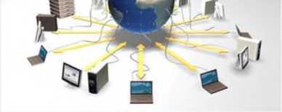
Elements of virtual reality based on films and various illustrations have long been used in education. The fact that computer technology was able to combine information related to movement and sound into a single set,
made a qualitative turn in the creation of educational resources based on virtual reality by creating opportunities for learners to actively influence (communicate) the observed processes.
Today, educational resources based on virtual reality can be classified as follows:
- first level — achieving full virtuality by means of special technical means (helmet display, special gloves, etc.);
- the second level — three-dimensional (or stereoscopic) monitors or a projector and special glasses to create a three-dimensional image;
- the third level is the display of virtual reality based on a standard computer monitor or projection device.
General-purpose virtual machines (as opposed to specialized machines such as the Java VM) use:
- Run applications that are not supported by the main system.
- Protect your system from possible harm from untested programs.
- As an additional barrier against viruses when visiting suspicious web resources.
• Create a safe environment for learning about malware. As a testing ground for debugging your own developments.
- Studying the technology of building construction.
- For duality in some game portals and more.
And, of course, virtual machines everywhere server work resources
used for distribution. Today, we will not deal with the industrial use of VMs, but only look at things that might be useful for Windows users.
Oracle VM VirtualBox software
Oracle VirtualBox virtual machine is the most famous and popular among home computer users, it is free, supports all major operating systems, including the Android operating system, and is very easy to use. Even a poorly developed user can perform the minimum necessary settings and install an operating system on it, if he has instructions for installing the selected operating system.
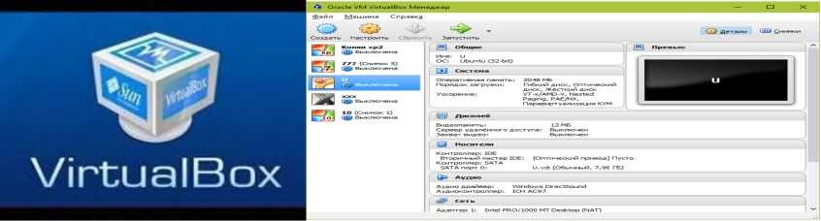

Figure 2.17 VirtualBox workspace It's enough to understand the contrasts of the VirtualBox workspace, what it is and how to use the program. On the left is a list of all operating systems installed on the VirtualBox platform (guest), on the right is a window of virtual settings of the selected OS operating system in the list or a window of images of the saved state of this system. The top panel contains the main controls: buttons to create a new VM, go to the settings menu, and start the VM. Right keys to switch the tabs on the left side of the window (the settings window is shown in the screenshot).
VirtualBox is a free program for creating virtual machines, but there is also VMware, which is paid, but has a free version in the form of VMware Player.
So, using VirtualBox, you create a virtual machine, manually specify the number of processor cores, determine the amount of RAM, the size of the hard disk. You will also add necessary devices such as network card, USB port, etc. All this works in your home, so that you have another Windows in a virtual machine (it will be in a separate window). You can work in multiple windows at the same time, no fiction!
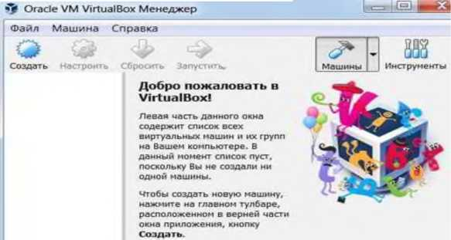
Figure 2.18. VirtualBox program window

For the virtual machine to work properly, the processor must support virtualization technology.
There is often a debate on the Internet, which is better than VMware or VirtualBox? Many users prefer VirtualBox and are sure that this virtual machine works faster than VMware. Creating a virtual machine on Oracle VirtualBox.
To learn the main functions of the program - installing and starting the operating system, setting the parameters of the virtual computer, most users will succeed without commands. For those of the most intelligent who seek to understand all the secrets of the virtual library, there is a tutorial in English on the official website.
We can consider the process of creating a new virtual machine and starting the installation of Windows 10.
- By pressing the "Create" button on the top panel, we can start the work process.
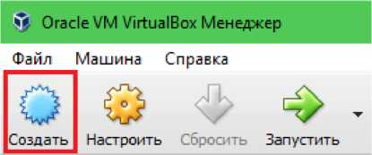

Figure 2.19. Start the VirtualBox program
- In the first window of the VM creation base, we indicate the name of the operating system (displayed in the list of guest systems), its type (Windows, Linux, etc.) and version. In our example, this is Windows 10 32 bit (you can install 64 bit, but more resources are needed). Click Next to go to the next step.
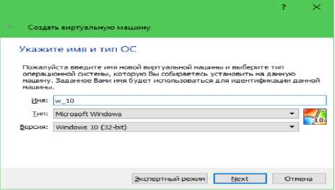
Figure 2.20 Selecting the operating name of the virtual machine

- Next we determine the RAM size of the VM. By default, 1 GB is allocated to Windows 10 x86, but you can increase this value by moving the slider to the right. If your computer doesn't have a lot of RAM, don't make the VM more than 2-3 GB, otherwise the main system will slow down due to lack of memory.
 | ? X
Create a virtual machine
Ukajite volume plan
Specify the amount of RAM (RAM) allocated for this virtual machine.
The recommended volume is 10^4 MB.
9 | | 102<1 MB
^MB | 8192. MB
Next | | Otmena

- Fig. select the hard disk of the virtual machine
- The data storage format is the space in the physical memory of the computer allocated to the VM. Then you can have a constant or dynamically expandable size within the limits you specify. A dynamic format is chosen to save space.
7 X
Create a virtual hard drive
Ukajite imya i razmer file
In the window, specify a name for the new virtual hard disk and use the field below
knopku s iconkoy papki sprava et nego.
|w_lp| IS-shch
Specify the size of the virtual hard disk in megabytes. And the size is limited
The size of the file is dannyx, which the virtual machine stores on the disk.
_{f}^ | 32.00 GB~|
| Sozdat |Otmena
- image Next volume name (virtual disk C) and volume
shows.
- After clicking the "New" button in the last window, a list of new virtual machines will appear. Displays the parameters of the frame on the right.
- Click the "Start" button on the top panel to proceed to Windows installation.
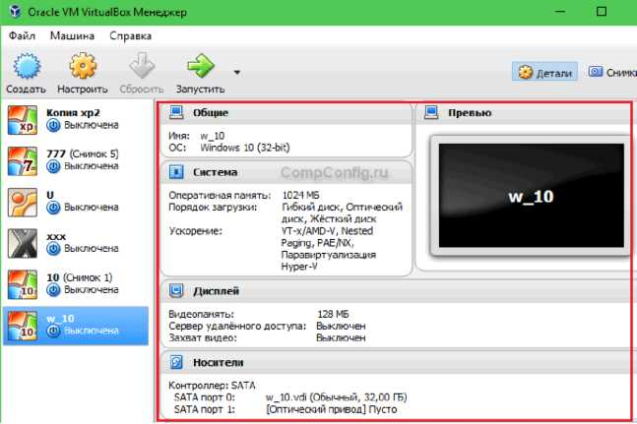

- picture Created VM This is how a virtual machine is created, in which we created a virtual machine to install Windows 10 operating system, you can install the operating system on this machine as you want
Basic literature

- Cloud technologies. Study guide. TEDelov. -Tashkent: 2020 -217 p.
2. Patrick Niemeyer, Daniel Lake Learning Java / 2014.
3. Cruz Zapata. Android Studio Essentials Belén 2013.
4. Ted Hagos. "Learn Android Studio 3 with Kotlin" 2015.
5. J. Zdziarski. "iPhone SDK Application Development". Saint Petersburg. 2010.

Additional literature

- Android Programming Tutorials 2013.
- Adam Sinicki. Learn Unity for Android Game Development 245 pages
- Matt Neuburg. iOS 12 Programming Fundamentals with Swift

Internet sites

1.https://intuit.ru/studies/courses/493/349/lecture/8337
2. https://www.fandroid.info/
3.https://developer.android.com/
- https://covde.oksei.ru/user/view.php?id=5&course=167 – for Android
- https://www.w3schools.com/java/default.asp– on website programming languages
- https://udacity.com. - online platform

LECTURE 12: Service models and key delivery providers
Plan
12.1. (SaaS) –software as a service
12.2. SaaStype provider
(SaaS) - software as a service.
A SaaS type provider manages, provides, and ensures reliable operation of software hosted on a cloud infrastructure.
Salesforcel Sales Cloud/Salesforce (CRM), Oracle Cloud Applications/Oracle (HR, YeRP, CX, YeMP, SCP, Business Intelligence), Google Apps/Google - cloud service office package (Google Docs, Google Drive, Google Sites, communication: Hangouts, gmail, Google Calendar, etc.), IBM
SmartCloud Docs/IBM, Microsoft Dynamics CRM, Microsoft OneDrive (Office Online), Office365/Microsoft (Office Web Apps, Lync Online, Yexchange Online, SharePoint Online), ZohoDocs/Zoho (online office suite), Zoho Reports/Zoho (Business Intelligence ), Zoho CMR/Zoho CRM/Zoho, Informatika Cloud MDM/Informatika, MaaS 360/Fiberlink, Cloud PBX from Vonage Business Solutions.
There are other types of SaS - service in cloud computing, Cisco WebEx - cloud service for web conferencing; CMS - to the SaS model (SaS - platform UMI.Cloud); Ye-Commerce B2B/B2C
- an to SaS model; Marketing is based on SaS; "Antivirus Dr.Web" SaS model; SugarCRM - CRM commercial system with open source codes; For business process modeling and automation with BPMonline CRM tools.
It is worth mentioning that the concept of cloud computing provides consumers with several additional types of cloud services: Storage-as-asService, Database-as-a-Service, Information-as-a-Service, Process-as- a-Service, Process-as-a-Service, Integration-as-a-Service, Testing-as-a-Service, etc., in addition to Storage-as-a-Service, there are many cloud storage files: Amazon Simple Storage Service (Amazon S3), DropBox, GoogleDrive, MicrosoftOneDrive, etc.
How can cloud technologies and cloud computing be implemented in educational institutions? The Google company offers the Google Apps for education cloud application to educational countries as an electronic education. Microsoft recommends the Office 365 for education (Windows Azure in education) cloud service to university students. Applying cloud computing to schools and higher education institutions provides enough knowledge to pupils and students.
In order to determine the requirements of cloud computing models and the Internet resources that belong to this model, their characteristics can be checked with the main characteristics of cloud computing: National Institute of Standards and Technology (on-demand self-service, in resources shared use of a single currency, elastic and scalable at the same time, pay only when using a real service, universal network access).
(PaaS) - platform as a service
PaaS - manages the cloud infrastructure and the software that ensures the connection of components (that is, the software that creates the middle environment necessary for cloud clients to work with cloud resources);
A PaaS service provides an application platform and a service as a service, which includes:
-OS - operating system network (Unix-systems, including Ubuntu Server, BSD/OS Family, Solaris/SunOS or Windows Server);
- Database - database management system MBBT (MySql, Microsoft SQL, SQL Database, PostgreSQL, Oracle, etc.);
-Middleware - middle layer software or related software, which ensures that various programs, applications, systems and components work together;
-Software development tools and testing - instrumental software is used in web application development and testing;
- App server - application server, used in development, testing, working with web applications;
Main PaaS Solution/Vendor:
-AWS Elastic Beanstalk/Amazon (Java, NET, PHP, Node.js, Python, Ruby and Apache HTTP Server, Apache Tomcat, Nginx, Passenger, and IIS);
-IBM Bluemix/IBM (the IBM Bluemix cloud platform implements a wide range of languages ​​and frameworks for building applications, for example, Liberty for Java, SDK for Node.js, ruby ​​on rails);
-Microsoft Asure/Microsoft (ASP.NET, Java, PHP, Python, Django, Node.js and Azure SQL Database);
-Google App Engine/Google (Python, Java, PHP, Go and our MySQL);
-Salesforce Platform Cloud application development/Salesforce combines Force.com, Heroku and ExactTarget into a single cloud service and tools used in application development. For example, in the development of mobile applications, Salesforcel Mobile App/ Salesforce is widely used;
-Heroku/Salesforce (Ruby, Java, Node.js, Scala, Clojure, Python and PHP and postgreSQL);
-Cloud Foundry/VMware (Java Spring, Ruby on Rails and Sinatra, NodeJS.Net and MySQL Redis, MongoDB);
(IaaS) - infrastructure as a service. IaaS provides and manages computing power, data storage systems, networking facilities, hosting environment and cloud infrastructure for its customers.
IaaS is the delivery and virtualization of computer and network infrastructure to consumers. In other words, a data center or data center provider creates virtual infrastructure as a service to consumers. Virtualization tools allow the physical infrastructure of the data center to be virtualized, thus creating the first cloud service layer, IaaS.
What is virtualization itself? Resource virtualization technology is designed to work on physical equipment (servers, database, data transmission network). They are divided into several parts among consumers. For example: from one physical server, hundreds of virtual servers can work. Virtualization is implemented at the software and hardware level.
In addition to virtualization, automation is also used in the creation of IaaS, which provides the ability to dynamically allocate resources without the involvement of the provider. The automatic system can increase or decrease the number of virtual servers, change disk space for data storage or network channel communication. Virtualization and automation cloud service IaaS allows for efficient use of computing resources and lower rental costs.
IaaS has an arena for corporate customers. When customers build their own computing infrastructure, they are provided with integrated resources. In such cases, it is necessary for the consumer to install and configure the OS and the software and applications necessary for development tasks. The concept of IaaS allows the consumer to purchase this computing power only to perform specific tasks. Additional services of IaaS include connecting to the physical equipment of each consumer through the cloud platform and placing it in the data center network.
Infrastructure as a Service is an enterprise solution for a wide range of businesses. The infrastructure can be located in the data processing center, and in the external data center. The IaaS service is organized to create and protect private, social, hybrid clouds. The provider integrates the local network to the cloud network platform with the customer's office in providing the construction of the hybrid cloud configuration. In addition, IaaS cloud computing services include cloud hosting. Cloud hosting is hosting that allocates resources dynamically, automatically scales resources and offers high stability. Cloud hosting is an alternative to virtual hosting, VPS/VDS hosting on a virtual server, and physical hosting on a dedicated server.
Cloud hosting provider, site owners only need site resources: virtual servers, amount of RAM and hard disk size, hosting infrastructure management options (for example, selection options, operating system, number of RAMs, HDD size and type, number of CPU cores, clock frequency and input speed). Cloud hosting rental payment is made based on the consumption of resources and facts: the number of processor times, the number of disks, the amount of RAM used and the speed of opening sites. At the same time, the cloud hosting tenant (site owner) can change the hosting resources and set the resources to increase automatically when the pressure increases. However, consumers only pay for the resources they use. When the cloud hosting fails, the site hosted on it will continue to work on other virtual servers at the same time, the failure of one of them does not interfere with the ongoing work. Nowadays, the hosters prefer to rent CMS prepared with cloud hosting. Hosting - providers, when organizing cloud hosting, replace their servers with CMS installed on the platform as an infrastructure. The functional platform Jlastik installs both the hosted CMS and the optimized page in one attempt. Nowadays, the hosters prefer to rent CMS prepared with cloud hosting. Hosting - providers, when organizing cloud hosting, replace their servers with CMS installed on the platform as an infrastructure. The functional platform Jlastik installs both the hosted CMS and the optimized page in one attempt. Nowadays, the hosters prefer to rent CMS prepared with cloud hosting. Hosting - providers, when organizing cloud hosting, replace their servers with CMS installed on the platform as an infrastructure. The functional platform Jlastik installs both the hosted CMS and the optimized page in one attempt.
Jelastic is considered a product that includes PaaS functionality and IaaS infrastructure quick configuration. Jel astic is a platform that runs Java and PHP applications, and it is used not only by hosters for cloud hosting, but also for corporate environments (in private or hybrid clouds) and web application development. In cloud hosting, cloud sites are considered modern applications. in cloud sites data, server applications are stored in cloud MB and all in virtual cloud servers
Cloud Infrastructure Services/Oracle. It is worth saying that IBM implements a reliable and open IBM SmartCloud infrastructure IaaS in management or self-service.
Nowadays, providers are using a wide range of mobile communications (mobile operator) IaaS services to create cloud-based networks. Such services are provided by, for example, the cloud telecommunications platform from Huawei and the NSN Telco Cloud solution from Nokia Siemens Networks.
Cloud Clients
Web browser, mobile a pp. thin client, terminal
emulator, ...
1 |  | t
Sa aS
CRM. Email, virtual desktop, communication.
games, ...

PaaS
execution runtime, database, web server, development tools, ...
IaaS
Virtual machines, servers, storage, load balancers, networks, ...
- Fig. Cloud user connection to services The FusionSphere platform from Huawei provides virtualization of computing resources, storage resources, network resources, and integrates configured computing resources into a single currency with a single engine management and scheduling.
Basic literature

- Cloud technologies. Study guide. TEDelov. -Tashkent: 2020 -217 p.
2. Patrick Niemeyer, Daniel Lake Learning Java / 2014.
3. Cruz Zapata. Android Studio Essentials Belén 2013.
4.Ted Hagos."Learn Android Studio 3 with Kotlin" 2015.
5. J. Zdziarski. "iPhone SDK Application Development". Saint Petersburg. 2010.

Additional literature

- Android Programming Tutorials2013.
- Adam Sinicki. Learn Unity for Android Game Development 245 pages
- Matt Neuburg. iOS 12 Programming Fundamentals with Swift

Internet sites
1.https://intuit.ru/studies/courses/493/349/lecture/8337
2. https://www.fandroid.info/
3.https://developer.android.com/
- https://covde.oksei.ru/user/view.php?id=5&course=167 – for Android
- https://www.w3schools.com/java/default.asp– on website programming languages
- https://udacity.com. - online platform

LECTURE 13: Existing threats in cloud technologies and their countermeasures
analysis of coping mechanisms
Plan
13.1. Cloud management and control are key security concerns
13.2. All resources in cloud technologies
Cloud management and control is one of the main security issues. In cloud technologies, all resources are calculated, and not only are they under constant control by virtual machines, but additional processes are not started and cloud elements are not damaged. It is considered a high-level threat, it is related to cloud management, it serves as a single IT system, and it is necessary to build a high level of overall protection.
For this, of course, it is necessary to apply risk management models in the cloud infrastructure. On the basis of physical security, access to physical threats to the server and network infrastructure must be strictly controlled. Compared to physical security, network security primarily focuses on security against model threats and eliminates them through a cross-network screen. The firewall acts as a filter and restricts the use of the data processing center network (MIBM). In this case, separate servers, that is, servers on the Internet or intranet. Virtualization as a platform plays the main role in cloud computing.
The most common and major threats to data integrity and security in cloud computing.
Difficulties in deploying cloud servers, cloud computing.
The security requirement of cloud computing is not different from the security requirement of data processing center (MIBM). But the virtualization of the data processing center (MIBM) and the transition to the cloud environment cause new threats to appear. Controlling computing power over the Internet is one of the key characteristics of cloud computing. In many traditional data processing centers (MIBMs), engineers use servers that are controlled on a physical site and run over the Internet in a cloud environment. System-level provisioning of access-controlled restrictions and transparent changes is considered critical protection.
Dynamics of virtual machines. Dynamics of virtual machines. It is the process of creating a new machine, stopping and restarting it in a short period of time. They can be confused with physical servers. Such changes make it difficult to reproduce the security integrity of the system. However, an operating system or application vulnerability spreads uncontrollably in a virtual environment and begins to propagate rapidly over a period of time (for example, when restoring from a backup). Above all in a cloud computing environment
correction of system security status, it should be taken into account that it should not depend on its status and control location.
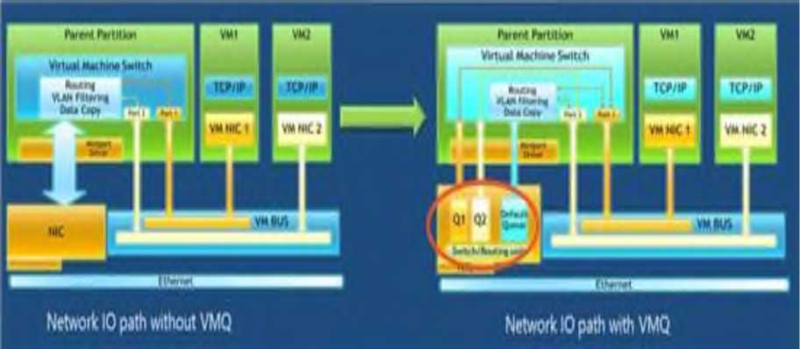

- picture Virtual machine dynamics Weaknesses in the internal virtual environment. Cloud computing servers and local servers use the same operating system and applications. Remote hacking or malware threats are common for cloud systems. Parallel virtual machines increase the risk of attack. To the protocols based on threats
(Sistemaobnaruzheniyavtorzhenii) and their elimination protocols should identify malicious activities at the virtual level.
Protection of failed virtual machines. When a virtual machine is powered off, it is more vulnerable to damage. Access to images stored in virtual machines will be sufficient. Software security cannot be run at all on a virtual machine that has not started. In this case, not only internal security should be implemented in the virtual machine, but also at the hypervisor level.
Area security and network restriction. When using cloud computing, the local area network is reduced or completely lost. This leads to the fact that security is not at a high level, and the network part determines the overall security level. Virtual machines need to ensure their own security when segmenting reliably in the cloud.
Attacks in cloud technologies and their elimination.
Serial attacks in DT. Vulnerabilities of the operating system, module components, network protocols, etc. are among traditional threats, and problems can be solved by installing network screens, antivirus, IPS and other components in order to ensure protection. It should be taken into account that such protection must work effectively even in virtualization.
Functional attacks on cloud elements. This type of attack depends on the common security principle with multi-layered cloud. Regarding cloud security, the following can be taken as a solution: to protect against functional attacks, the following source of protection should be placed in each cloud part: for proxy - DoS - effective protection against attacks, for web - server - page integrity control, server for applications - screen-level applications, for MBBT - SQL injection protection, for data storage systems - provision of correct backups (backup), restriction of use. The protection mechanisms listed above have been developed, but they are not yet assembled together to provide comprehensive cloud protection. Therefore, when creating a cloud,
Attacks on customers. Many customers use a browser when connecting to the cloud. One of the attacks is Cross Site Scripting, "stealing" passwords, intercepting web sessions, etc. The only true and effective defense against such an attack is clear authentication and mutual authentication with SSL encryption. But this method of protection is very inconvenient and time-consuming for cloud developers.
Attacks on the hypervisor. A hypervisor is one of the key elements for virtual systems. One of its main functions is to allocate resources to virtual machines. An attack on the hypervisor can cause one of the virtual machines to use the memory resources of another virtual machine. It can also capture network traffic, seize physical resources, and stop a virtual machine from running through the server. It is recommended to use the necessary specialized products in the virtual environment when implementing standard protection methods.
Integrating host servers with directory services Active Directory, as well as standardizing the way to use host server management tools. At the same time, abandoning services that are not often used, for example, web access to virtualization server.
Control system attacks. Most virtual machines used in the cloud require separate system management. Tampering with the management system causes virtual machines to crash and make another virtual machine the culprit by blocking one virtual machine.
One of the most effective ways to provide security in the cloud sector is the Cloud Security Alliance (CSA), which has analyzed the following information:
Data storage. Encryption is one of the most effective ways to protect data. The data access provider must encrypt the customer data stored in the data processing center (MIBM) and delete it irretrievably when it is no longer used.
Data Security in Transmission. Encrypted data transmission can only be done after authentication. Data can be read or changed, access to them is done through secure connections. Such technologies are implemented by very popular algorithms and reliable protocols AES, TLS, Ipsec.
Authentication. Password protection. Tokens and certificates are focused on providing greater reliability. The provider must act in a transparent manner when passing the authorization with the identification system. It uses LDAP (Light Directory Access Protocol) and SAML (Security Assertion Markup Language) protocols.
Isolation of consumers. Individual use of virtual machines and virtual networks. The following technologies should be implemented in virtual networks. VPN (Virtual Private Network), VLAN (Virtual Local Area Network) and VPLS (Virtual Private LAN Service). Providers often isolate customer data from each other as code changes within a single application environment. Such an approach is considered risky, and it is standard basic methods.
Legal methods. Ensuring the security of legal methods includes the production of normative-legal acts, regulation of information relations between participants and normative-methodical documents, issues of information security. The most important of these activities include:
can find a way out of non-existent code and use consumer data.
It is essential to ensure data protection in cloud technologies
methods
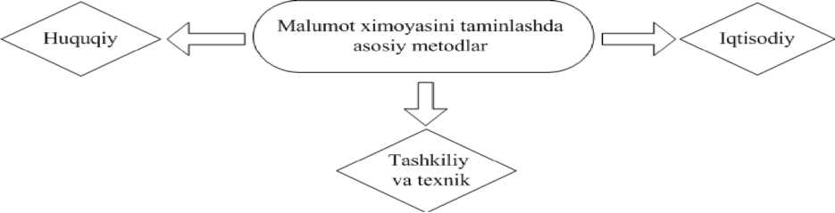
2.26 - picture. Ensuring data protection in cloud technologies
- timely amendments and additions to state legislation, regulations related to the field of information security;
- resolving conflicts related to international agreements;
- establishing responsibility for the offense;
- limitation of powers in the field of information security;
- development and adoption of normative legal acts;
Organizational and technical. Such methods include:
- creation and modernization of information security system;
- effective use and improvement of information protection and control methods in production;
- identification of risks arising from technical devices and programs in ensuring information security;
- certification of information security tools;
- in protected information systems, strictly control the actions of employees;
- formation of system monitoring indicators and information security characteristics;
Economical.Economic methods include the following safeguards:
- Develop information security plans.
- together with the financing of work in system improvement, organizational rights and organizational - technical methods.
Service level customization. At present, the lack of legal regulations and rules for regulating cloud resources is considered one of the most important criteria of cloud computing providers. Unfortunately, many providers these days structure service level customization in a way that results in less accountability. Based on this, before using confidential data in cloud computing, it is necessary to choose providers with a good level of service.
Setting up a cloud security channel up to the system. When communicating with a system in the cloud, the channel is encrypted. VPN (virtual private network) technologies are used to establish security channels. Despite this, telecommunication has a lower level of reliability in the network and channel reliability remains at a higher level. Depending on the use of cryptographic tools (encryption, authentication, public key infrastructure and prevention of modification of the data being sent). This method is considered the simplest and most reliable, it protects against MITM (man-to-man) attacks. But this method only protects the system and channel communication in the cloud. Information passing through the entire system is considered public.
Distribution of roles in the use of information. If a guest system consisting of several files is only an image, the administrator of the virtual infrastructure can at any time copy the data and run it on other computers to conduct research on confidential data. Copying data is considered a time-consuming task, and in such a way, confidential information can be leaked to the administrators of the virtual infrastructure, which administrators can use for their own benefit. In order to avoid such a problem, divide the roles of administrators into two: virtual infrastructure administrator and security administrator. This job includes the MIBM role and does not allow you to change the security setting unilaterally. Unfortunately, this distribution depends on how the provider of cloud technology resources works. Currently, various cloud technology companies are producing tools that serve such technologies. As an example, the provision of vGate is made, which runs on the VMware base system.
Segmentation of virtual machines. In segmentation, virtual machines are segmented to meet customer and security requirements. This involves the sharing of shared network traffic and access to political governance, even when they are running on shared physical hardware with a shared network infrastructure. When creating a private cloud, this partitioning segments, for example, virtual machines belonging to accounting and virtual machines belonging to processing departments. There is a possibility that these segments can be separated when working with different network interfaces.
Encrypted data stored in the cloud. This method involves cryptographically encrypting each file that is sent to the cloud for storage. According to this method, no one has access to the data, only those who have the original decryption key can open the file. Such methods are more appropriate for individuals or small organizations. However, due to the large number of consumers with the key, this method causes many disadvantages. Because of this, controlling the key causes difficulties.
Using a proxy server for data encryption. In this method, equipment in a reliable environment is used. All data sent goes through it. This method encrypts all data before sending it to the cloud and decrypts the initial data upon request. Based on this, the encryption and decryption key is known to the server that provided it. Also, the server log report can be used to access the file. Based on this, using a proxy server makes working with files transparent for the consumer.
Data processing with the possibility of correction in the cloud. When using this method, it cannot be used by a third party when transferring data to the cloud. For this purpose, the data is sent not as a whole, but in pieces, so that the data in the system cannot be related to each other. Confidential information will always be kept in a safe place.
Information protection when using cloud technologies.
If we look at cloud technologies from a technological point of view, application performance requirements are not much different from traditional performance requirements. Business systems also run on separate computing power, only in cloud technologies they can be virtual. Data is stored on servers, and they are divided into several computing nodes or placed on a single large server. Many experts believe that information security in cloud technologies should be built on the principle of traditional system protection.
Based on the fact, we can divide the protection of cloud technologies into two - prevention of equipment security - data security.
In order to ensure the protection of customers, it is considered necessary for the provider to protect its hardware and software systems from unauthorized access, damage to IT systems, and code modification. In turn, the client has the opportunity to use encryption technology to protect it from external attacks when entering any necessary or personal information into the system. This includes several advantages of security in "Cloud technology".
The protection of "cloud technology" is determined not only by the operator or the client, but also by the type of methods and where it is used.
Private Cloud. It is very easy to ensure information security in a private cloud environment. When working with a private cloud, we can only use computing resources and data storage service model and graph. Then all valuable information remains with the company. In strict measures, the data on the virtual desktop may not be saved when the network goes down. The Private Cloud will be able to provide maximum types of protection not only in the implementation of full functions of the platform and applications.
The private cloud has an arsenal of administrator-encoded, protected differentiated, cluster resolved, authenticated, audited operations and protected data.
A modern software solution can do many things, reflecting the ease of personal use of the database system. In particular, such functions as "Run-Time Privilege Analysis" and "Data Redaction" give organizations the privilege of identifying actions accessing and using data stored in "Cloud technologies". But the Private Cloud requires qualified personnel to ensure a high level of service to the servers, non-stop and efficient virtual software.
Likewise, in the Cloud, business applications, workloads, and service requirements are maintained. Must be seasoned and experienced professionals in cloud security. Not all companies have such a situation, so one of the most common types is social cloud technology.
Social Cloud. One of the advantages of the public cloud is that another organization is in charge of your data, and at the same time ensures the transfer and storage. As valuable data regularly leaves the network, it requires additional protection. Social and hybrid or traditional, private cloud cannot provide essentially the same level of security installed in enterprise systems. Therefore, many providers have to focus on service-limited activities to effectively implement security in the social cloud. However, many organizations prefer to choose providers for cloud security. In recent years, a significant amount of data stored in the cloud has raised fears that it could be vulnerable and monitored by other government users. This is what Steve Rose, director of the Verint Systems consulting department, says.
Defense technology. In the field of IT, the cloud protection strategy allows for a very high level of security, while at the same time it has the highest standards of personal data protection. Cloud computing always allows participants to determine the requirements for each component level. The possibility of implementing such requirements is being found today. The focus should be on reliable deployment and implementation of the program. Ilya Trifalenkov, director of the information security center "R-Style" - it is the application software level that provides access to data. Only this application software level is at the forefront of maximum risk.
I na Sh I fe |E8 J
Figure 2.27. Free cloud services in social networks. The most common threats in cloud environments are theft of virtual machines from their working state, changes in IT infrastructure network topology using only program parameters, IT attacks from network protection mechanisms. go straight. This risk is reduced due to the protection of all stages of the construction of the virtual environment, namely: virtual infrastructure, within the system management and storage system, hardware, system software graph (hypervisor).
If we look at modern solutions, it allows to create an inter-network screen on virtual machines, which provides continuous monitoring and operational control of virtual machines. The service level of protection is protected through the network interface, it operates in the cloud computing environment.
Screens between networks can be processed at the service level according to network protocol requirements, that is, specialized protocols can be filtered. The security level of cloud computing is ensured by the caster firewall hardware, which includes controlling the access of free users to the address information of the virtual environment. When updating the journal, you can enter it automatically or manually.
The level of protection is provided by segment AIS hardware or a personal firewall. Depending on the requirements of network reliability, high reliability, separate installed firewall, user workstations installed firewall, a group can be used.
Control questions:
- explain about load balancer?
- Cloud based load balancing
- What is a multi-agent system?
- Explain about virtual machine?
- What is Virtual Machine Convenience?
- Give an insight into Oracle VirtualBox?
- Create a Virtual Machine on Oracle VirtualBox
- Install an operating system on your virtual machine
- (SaS) - Explain about software as a service?
- (PaS) - give an insight into platform as a service?
- (IaaS) - What is Infrastructure as a Service?
- What do you understand about SmartCloud infrastructure?
- List the types of threats to cloud technology?
- List the attacks that are carried out in cloud technologies and how to eliminate them?
- Information protection when using cloud technologies.
- Tell us about Social and Private cloud tariff.

LECTURE 14: Analysis of existing threats in cloud technologies and mechanisms to combat them\
Plan
14.1 Apparatusbasic confirmation of stops in the means
14.2 Processing of confidential information in corporate networks
14.3 Apparatusadvantages in using tools
Hardware and software tools in cloud technologies, their application and application
The importance of hardware and software in the use of data center resources
The processing of confidential information in corporate networks is considered to be well developed as the main confirmation of hardware interruptions. It stands out for its advantages in the use of hardware, quality guarantee, reliability and endurance in the work process. Companies that manufacture hardware components respond to their warranty. It also eliminates the hardware part of the data processing center from illegal use by organizational and technical protection. Because such situations arise when a hacker violates the information security regime.
That is why constant monitoring is carried out to detect adjacent signals and electromagnetic effects. In such cases, signal research and protection against external influences are carried out using specific methods. The use of such actions is mainly performed in analog situations, through social access in cloud computing systems.
The principle of operation is focused on two main methods: IP - encryption of packets using hardware and software, or simply through open traffic. Almost always, personal confidential data processed in corporate networks of companies is stored for access via IP network. Encoding all packets consumes a lot of system resources. Decreasing the level of encryption causes an increase in open traffic, and this leads to a decrease in the level of protection of confidential information. Such a situation is considered unacceptable in the spheres of human activity. This can be solved by increasing the speed of IP encryption.
Provision of consumer hardware and software. Nowadays, encryption of IP streams by SSL protocol at the consumer workplace does not cause any problems in the approach of software and hardware. The speed can reach 1 Mbps without processing. Nowadays, there are quite a few certified companies that provide such services. Keys in consumer operating systems and protection of personal information in the corporate cloud is one of the biggest challenges in information security. An electronic lock is installed on the consumer's personal computers. Not only the consumer, but also the information security service of the company has the ability to control such blocking.
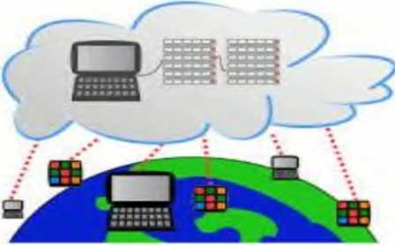

Figure 3.1. With consumer hardware and software
provide
A hypervisor, as a software tool, manages hardware resources and distributes resources between guest operating systems, so it is considered the weakest part of a virtual environment. any corrupted state of it causes a crash in the guest operating system. Being able to exploit a hypervisor opens up a variety of opportunities for malicious actors. In fact, such access allows you to control all information flows through the hypervisor. Such opportunities give the right to common use of the virtual environment, that is: the administrator of the virtual structure has the right to use any information without restrictions.
Therefore, the security of information resources can be solved in a virtual environment. Logical virtual infrastructure is no different from physical infrastructure, so threats from the first are also considered to be relevant to the second. Then information protection tools should have the ability to optimize hardware resources while providing virtual infrastructure protection. In virtual infrastructures with a large volume, the use of information protection tools for rational purposes helps to build at the hypervisor level. The main risk potential in the cloud is the virtualization specification, through the emergence of new objects - cloud
management system and system virtualization. Compromising one of them is tantamount to compromising cloud security. Physical servers in a virtual environment can have many virtual machines. If a simple antivirus is installed on a virtualized server operating system, there will be 100 copies of the antivirus on one physical hypervisor. Each copy has its own antivirus signature, driver: all these must be updated on time in all virtual machines. In this case, a new additional burden will appear on the hypervisor and physical server resources will begin to be used inefficiently.
In 2009, the VMware company was the first among the hypervisor manufacturers to deploy the hypervisor in depth, that is, to use it only in one virtual machine. The hypervisor produced by VMware and the approach to it were considered standard. Defense virtualization tools and the main demand in the cloud environment are aimed at: reducing security costs, reducing resource requirements, increasing productivity and taking advantage of the opportunities provided by virtualization.
For example, virtualization security uses hypervisor-level anti-virus, anti-intrusion, and anti-threat tools. Similar security approaches are also used at the network level. Networks are managed by hardware installed at the network boundary, using firewalls, intrusion detection and threat detection, and defense against attacks. In virtualization system maintenance, there are two possible solutions in cases where it is necessary to ensure security of traffic between virtual machines belonging to administrators.
The first solution is to take the standard hardware, isolate the relevant traffic in the virtualization environment, and wrap it in case it goes through that device and back. Even a standard solution for this is to use traffic filtering. But such an approach is considered inefficient.
Another way, that is, the second way, issues (solutions) can be placed at the hypervisor level.
The advantages of the software-configurable network-based architecture of the cloud data processing center are that the mutual data transfer processes between the components of the data processing center are mainly implemented on the basis of the seven-layer protocols of the OSI model.
The protocols of the seven-layer OSI model ensure the transfer of information between network end devices. Each level performs certain functions. Below are the basic functions of layer protocols.
The highest level 7 (application) protocol of the OSI model provides access to network resources and services, the 6 (presentation) level protocol coordinates the sending and receiving syntaxes with the network transfer syntax, establishing a session by request and performs the functions of completion and information transmission, the 5th (session) level protocol ensures the initiation and termination of the session, the implementation of reconnection procedures in case of failure (failure) at the level of the transport network.
- The main task of the (transport) layer protocol is to deliver packets without error, without loss in the initial sequence, with a guarantee. At this stage, the data is rearranged: long ones are divided into several packets, and short packets are combined. This increases the efficiency of sending packets from the network. At the transport stage, the receiver sends a confirmation signal that the data has been received.
3 (network) layer protocol is used for switching the network and physical environments, establishing network connections that ensure the transmission of information for the transport network level independent of routing, providing means of keeping and terminating network connections active, control data flows, organize the sequence of sending packets, provide urgent information transfer, find and correct errors
At the network level, it is accepted to call data packets. At the network level, 2 types of protocols work: network protocols - control the movement of packets through the network, and routing protocols - collect information about network topology and inter-network connections.
The network layer serves to form a single transport system connecting several networks, can use different principles of data transmission between the end nodes of these networks and have an optional communication structure.
At the network level, data transmission is carried out by the channel layer. It solves issues such as inter-network data delivery, selection of data transfer routes. Networks are interconnected with router devices.
- A (physical) layer protocol deals with the transmission of a sequence of bits over physical channels - coaxial cable, fiber optic cable or radio medium. Physical Layer Establishes physical connections, keeps active, and controls its mechanical, electronic, and procedural devices, bitwise synchronization, duplex or half-duplex transmission of bits, two-point or multipoint transmission, failover at the physical layer provides channel-level alerts on statuses.
- The (channel) layer protocol establishes channel transmissions and transmits data fragments (frames), provides frame synchronization, error detection and correction, information flow control, and frame sequencing.
Recently, the number of electronic resources and requests for their use, as well as the scale of companies operating in electronic form, have increased dramatically.
due to the increase, the volume of information circulating and processed in the existing network is increasing sharply.
In other words, there have been great changes in quality and quantity in the modern network lately. Previous architectures are increasingly unable to meet the demands of today's rapidly evolving information technology era.
Statistics conducted by developed companies
according to the results of research, the volume of Internet traffic in 2016 is approx
It is 820 bytes. (1exabyte = 10 bytes). The growth rate of traffic in recent years is presented in Figure 3.2.
It is increasingly likely that existing network facilities and communication channels will not have enough bandwidth to handle and transmit such a large volume of traffic.
Their bandwidth growth is lagging far behind traffic growth.
On the other hand, the growth of computing power is causing the volume of applications and information in electronic form to increase, and according to statistics, the volume of mobile traffic today is growing dramatically (on the basis of geometric progression).
In short, the problems that arise in the network based on the OSI model today can be explained as follows:
its structure, the type, size and complexity of the issues being solved are increasing, and it is becoming difficult to manage it;
requirements for information security are getting stronger;
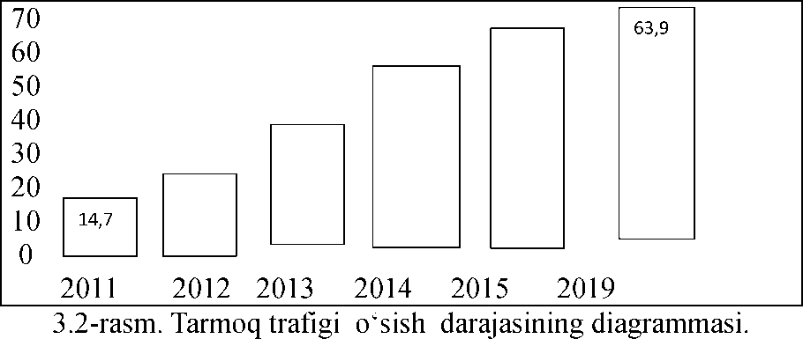
Hundreds and thousands of switches, routers and other devices in the network are becoming increasingly complex: in a distributed network with a complex structure, the number of data transmission protocols is increasing - it is noted that their number exceeds 600;
Thus, a number of problems have accumulated in the network operating today, and in order to implement their solution, it is necessary to make certain changes to the existing network architecture.
Therefore, software configurable network architecture based on a new idea has been developing more and more in recent years.
The main idea of ​​Software Defined Networks (SDN) is to manage the existing network devices (ie, routers and switches) without changing their management processes using special software installed on a single computer. is implementation on the basis of supply. This software is under the control of the network administrator.
In DKT, the data flow management level is implemented separately from the data transfer level. Such separation is done by uploading to a central tool called a single controller.
The management layer performs its tasks independently of the physical infrastructure of the network and the level of data transmission. The data transmission and control levels of the network are connected through a single unified interface.
Such a network primarily led to the further improvement of the operation of data processing centers and corporate systems.
DKT architecture consists of three levels (Figure 3.3):
- The infrastructure layer of the network - includes network devices, i.e. switches, routers and communication channels
- Network Management Layer - A global view of the network is supported and controlled. The global view of the network is the network topology and the status of network devices.
- The level of network applications - various functions of network management are performed: control of information flow in the network, security management, traffic monitoring, quality of service management, etc.
DKT architecture based on centralized management has the following advantages over traditional distributed management based network architecture:
- Since network management is performed on the basis of programs, management is simple, management is automated;
- Network management is performed in adaptive mode, that is, management changes depending on the current state of the network.
The time and cost of creating new network applications is much less than the time and cost of "manual" network configuration changes.
- Network software does not depend on network devices;
- The reliability of the network increases due to the reduction of the volume of distributed management information and operations.
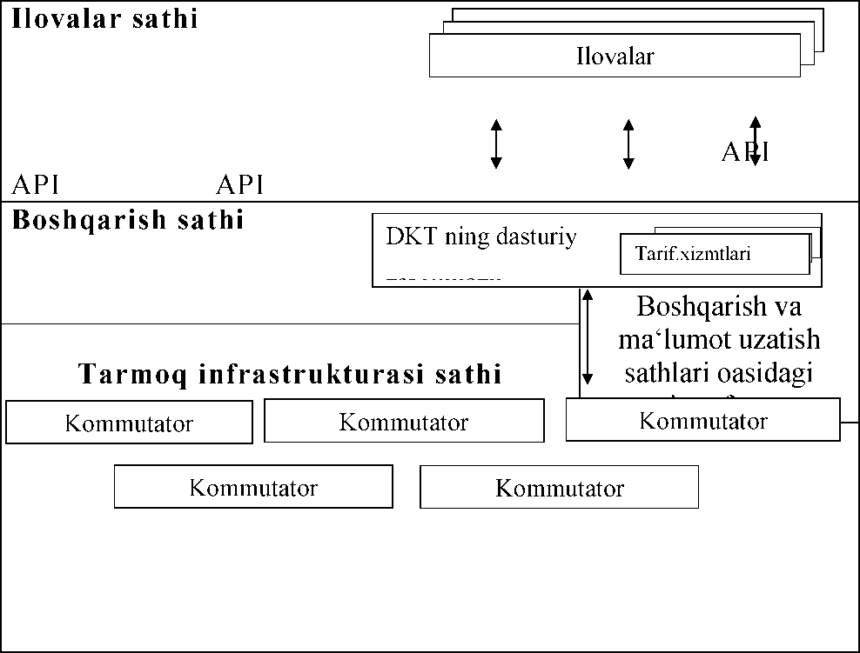
3.3 - picture. Software configurable network architecture.

Protocols installed in each switching center operate based on database information about the status of communication channels. Centrally storing such information in one place (ie, the controller) eliminates cases of non-consensual decision-making in the network.
- Network equipment and structure will be simplified - instead of implementing many standards and protocols, they will execute a command from a single controller;
- By moving the storage and management parts of the switch and network infrastructure to a single controller, their cost is reduced.
The principles of operation of DKT network components are covered in OpenFlow normative documents (specifications).
According to regulatory documents, the main components of the OpenFlow (or DKT) network include the following (Figure 3.4): Controller, which includes: network operating system; network applications; OpenFlow switch; Protected communication channel between controller and switch; OpenFlow protocol. The main protocol of DKT is a protocol called OpenFlow.
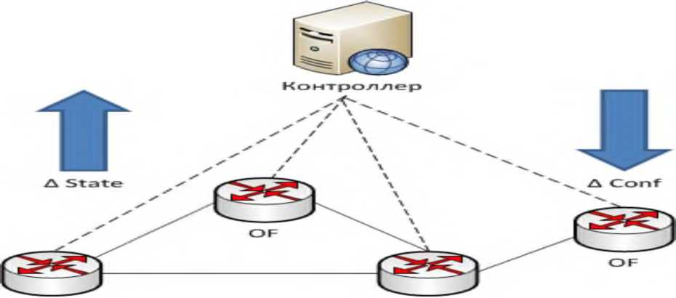
OF OF

3.4 - picture. The main components of the DKT network
schematic diagram.
The general principle of operation of the OpenFlow network is explained as follows: each OpenFlow switch in the network establishes a channel protected by a controller (dashed lines in the picture), and the controller manages the switch operation using this channel. The interaction between the switch and the controller is based on the Open Flow protocol
110
is carried out with the help of information. The controller receives information about changes in the status of network elements and, based on it, configures new network equipment, manages the network infrastructure and information flow. Broadly speaking, a controller is a physical server on which special software is installed.
All routers and switches in the network are connected under the control of the network operating system (TOT). TOT regularly monitors the configuration of network devices and allows applications to manage the network.
The main functions of the OpenFlow switch are:
- Establishing a protected channel with the controller and organizing communication through it;
- Providing the controller with information about the change in the status of the ports;
- Providing the controller with information about the deletion of flow records;
- Notify the controller about a change in status;
- Notify the controller about the presence of an error;
- Contact the controller with a request to set a rule for a new data flow.
Protected communication channel - used for data transfer between the switch and the controller. Each OpenFlow switch must have a separate channel, so a controller manages multiple OpenFlow protected channels
An OpenFlow switch can have a single channel with a single controller or multiple channels with multiple controllers for increased reliability.
An OpenFlow controller remotely manages OpenFlow switches. A protected channel is usually established based on the TSR protocol. There can be several such channels.
The OpenFlow protocol is considered a lower level protocol of the DKT control layer and performs the task of organizing the activity of the switches.
The OpenFlow protocol is implemented on both sides of the network interface, that is, on the switch and controller sides. It works on the concept of flow.
Data management is performed at the packet stream level rather than at the single packet level. In an OpenFlow switch, a rule is set for the first packet in the presence of the controller, all other packets of the flow are routed based on this rule.
The switching operation does not change the payload of the packet, but it can change the header, while the forwarding operation does not change the header and payload.
The packet header consists of several fields. The fields show identifiers of network protocols that perform packet processing and special information used by them. For example, the addresses of senders and receivers and other information for IP, TCP, UDP protocols are given in the header fields.
A set of switching tables (flow tables) is installed on the switch, which form a switching pipeline (pipeline).
A packet arriving at a specific input port buffer (ingress port) is transferred to the switching conveyor, processed on this conveyor and sent to a specific output port buffer (egress port) or control port buffer (control port). This operation is called packet switching.
During switching, an additional field may be added to the header to carry special information within the switch pipeline, which is lost when the packet arrives in the output buffer of the switch.
The size of the special fields and the type of information formed in them are determined based on the technical capabilities of a concrete OpenFlow switch.
Packets arriving at the output port of the current switch are forwarded to the input port buffer of the next switch using the data transfer channel connected to the switch.
Packets arriving at the control port of the switch are transmitted to the controller using a protected channel.
Each port on a switch has a unique sequence number, called a port name. In addition, special names can be used as port names when performing certain actions on packets.
Movement of packets between network switches under the control of DKT controller through OpenFlow protocol interfaces
scheme is shown in figure 3.5.
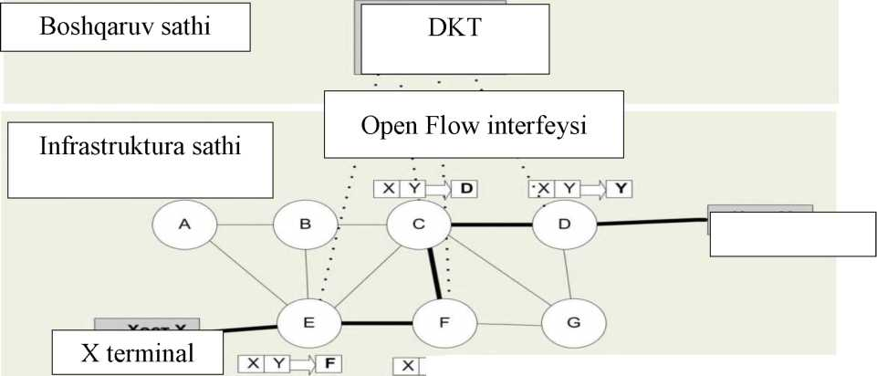

Figure 3.5. Scheme of packet movement according to the defined route between the switches at the infrastructure level under the control of the DKT controller.
The figure shows the process of transferring the X terminal packet to the Y terminal between DKT switches based on the control of the controller.
Due to the introduction of virtualization technology to MQIM, virtual switches appeared in the network. This led to new requirements for the network layer, for example, requirements for the organization of quality data transfer processes between virtual machines.
The adoption of a software-configurable network as such a network creates great opportunities.
In cloud data processing centers, information exchange processes are carried out regularly between virtual and physical servers and data warehouses. At the same time, information is exchanged between user computers and data processing center tools. Today, a network based on IP technology is used as a transport network for this purpose. A transport network is required to transmit large volumes of highly fluctuating traffic in very short intervals without errors. To do this, more and more money is required.
The application of the idea of ​​DKT as a transport network is the operational transfer of large amounts of information based on special software.
is made possible. In practice, the OpenFlow protocol provides control of large volumes of traffic in the cloud environment in both virtual and physical networks. Because in software-configurable network technology, a separate server is used to manage the network, it performs its activities independently of routers and switches. In the Open Flow protocol, the functions of data routing and address change are separated, these two procedures are performed on a single device in IP routers.
Summing up on the basis of the above points, it is worth noting that the use of custom configurable network technology in the transport network of the cloud data processing center eliminates the problems arising in IP technology and leads to an increase in the efficiency of the center.
Virtualization is a method of sharing computer resources.
Virtualization ensures that a real (physical) computing environment is divided into several virtual computing environments. Virtual computing environments are isolated from each other and interact with a high level of computing.
A comparative view of virtualized and non-virtualized environments is presented in Figure 3.6. The figure on the left shows a traditional computing environment, where applications run on top of the operating system using underlying physical hardware. The image on the right shows a virtualized environment, where the virtualization layer allows multiple operating systems to run simultaneously, each with its own application and control access to the physical device.
APPENDICES (I)
I1

3.6 - picture. Virtualized and non-virtualized computer
appearance of environments
Virtualization technology ensures effective use of computing power of server computers. In other words, virtualization technology implements a rational distribution of server computer resources between applications. The application sees only the resources allocated to it and assumes that a separate server has been allocated to it. This creates a situation of "one server - several applications" without reducing the performance, security and ease of use of server applications. In addition, virtualization technology makes it possible to run different operating systems on one computer.
Virtualization technology makes it possible to run multiple virtual computers within a single physical computer.
Virtualization allows computer resources to be distributed across multiple environments so that one computer can do the work of multiple computers. With the help of a virtual server, conditions are created for the location of several operating systems and several applications within one computer.
Virtualization serves to isolate computing processes and computing resources from each other, that is, virtualization is a method that ensures the shared use of computer resources.
Virtualization is implemented in practice as follows:
- First, a special operating system is installed on the server computer. Such an operating system is called a "hypervisor" (Figure 3.7).
- Then one or more "guest" operating systems are installed in the hypervisor. In each of them, appropriate applications can work independently.
A virtual machine has its own proprietary operating system and applications, as well as virtual RAM, hard disk, and network adapters, and functions just like a physical computer.
Virtual machines do not include hardware, they consist only of software components.
A hypervisor isolates guest operating systems from the computer's hardware and ensures that its resources are shared between virtual machines.
A hypervisor controls how virtual machines communicate with computing devices. There are several types of hypervisors.
Applications | Applications
Guest  operational  system | Guest  operational  system |  | Management  system
 | G | Hypervisor
Physical computer hardware
3.7 - picture. Virtual machines on the basis of a physical computer

organizational chart.
Such a structure gives them the following advantages over physical means:
- Being able to relate. Virtual machines can interact with any standard computers. A virtual machine operates under the control of its own "guest" operating system and runs its own applications (issues) just like a physical computer. It has its own motherboard, video card, network controller and other components just like a physical computer. Therefore, any software that runs on physical computers can run on virtual machines.
- Isolation. Virtual machines are completely isolated from each other, just like physical computers. In other words, virtual machines can use the resources of a single physical computer without any communication with each other. In doing so, they function as if they were a separate physical computer. For example, if four virtual machines are set up on one physical server computer, the failure of one of them will not affect the others.
The first type of hypervisor (Fig. 3.8) is created as a control program on the hardware side of the computer. Operating systems of virtual machines are installed one level above.
Because this type of hypervisor works independently of the computer's operating system, it provides high performance, reliability and security. Hypervisors of this type include hypervisors with the following names: Microsoft Hyper - V; VMware ESX Server; Citrix XenServer.
1- virtual computer
- type hypervisor is installed within the computer operating system. Guest operating systems of virtual machines are installed one level higher (Figure 3.9).
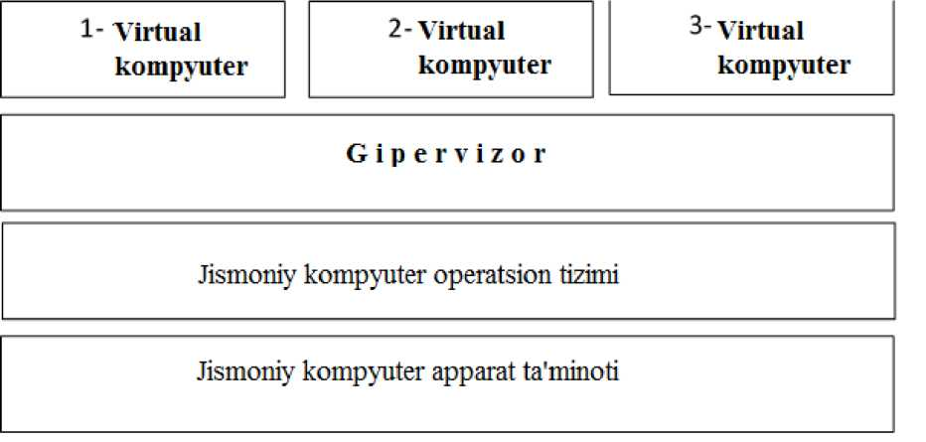
Figure 3.9. The second type of hypervisor.

The next type is a hypervisor with a monolithic scheme (Fig. 3.10). Hardware drivers are included in its composition, and with the help of them, the guest operating systems of virtual machines communicate with the computer hardware.

Figure 3.10. A hypervisor with a monolithic scheme.
Below is the sequence of operations performed when creating a virtual machine inside a physical computer based on the hypervisor program "Oracle VirtualBox". First of all, the Oracle VirtualBox program is installed on the physical computer and its main window is opened (Figure 3.11).
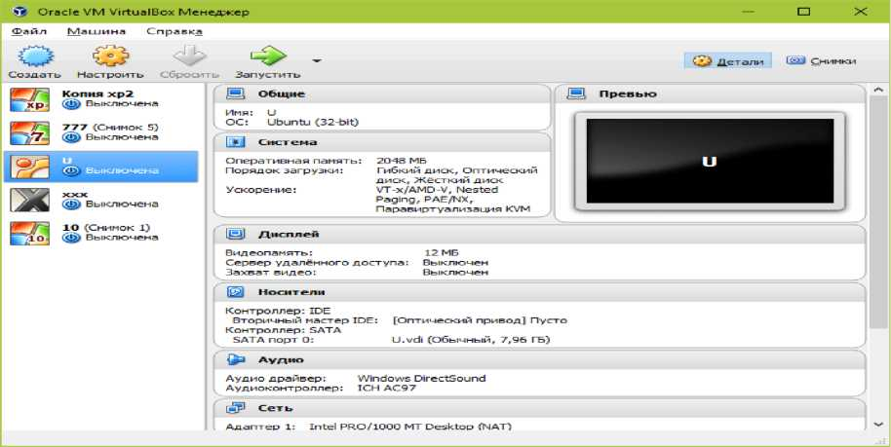
Figure 3.11. Oracle VirtualBox workspace.

The process of creating a new virtual machine (VM) starts by clicking the "Create" button (Figure 3.12).
Oracle VM Vi rtu a 1V ox Men edoker
File | Car | Reference
O | O |  | -
Sozdat | Nastroite | Sbrocyt | Stop

- picture Launch Oracle Virtual Box.
In the window that opens, select the name of the operating system to be installed on the virtual machine. This process is performed by selecting the desired option from the list of operating systems (Windows, Linux, etc.). "Daleye" button is pressed to go to the next step.
In the next window, the size of the RAM of the VM is determined. Usually 1 GB is allocated for the amount of RAM of the VM on which the Windows-type workstation operating system is planned to be installed. This value can be increased. If the RAM (TX) size of the physical computer is relatively large, the TX size of the VM can be chosen to be 2-3 GB, but choosing more than these numbers may cause the physical computer's RAM to decrease and the physical computer's performance to slow down. After selecting the size of the flash memory, you can go to the next window using the "Daleye" button.
It sets the permanent memory size of the VM. In this case, you can choose a field format with a constant field or a dynamically expanding size within the specified limits. In order to save space, it is recommended to choose a dynamic format.
After clicking the "New" button in the last window, a list of new virtual machines will appear. The parameters of the VM are displayed in the frame on the right side of the window.
After the parameters of the VM are set, the operation of installing the pre-selected Windows operating system is performed on it, for which the "Start" button is clicked.
Finally, the desktop of the created virtual machine will be visible on the physical monitor and it will be possible to work with it as if working on a physical computer monitor.
Hypervisors may be written in different languages, but the sequence for creating a virtual machine remains relatively unchanged.
Virtualization technology is also widely used in solving network problems, it ensures efficient use of physical resources of the network.
Network virtualization is a technology for representing the real physical means of a data transmission network in the form of a logical network. There are two types of network virtualization:
- External virtualization (external) - dividing one physical network into several logical networks or vice versa - combining several physical networks into one logical network.
- Internal virtualization (internal) - creating a logical network between virtual machines inside one physical server computer without the participation of a physical data transmission network.
Network virtualization is usually used for the purposes of combining several physical local computer networks located at different "points" into a single logical network.
In this way, remote access to the local network (VPN technology) or division of the physical network into logical networks (VLAN technology) is provided.
- VLAN (that is, logical local network) technology (LAN (local area network) - local network) is a means of dividing a physical local network into logical networks. VLANs are isolated from each other. The traffic (flow) between them is carried out only through the router.
There are several ways to make a logical network a member of a shared network.
- . Port-based identificationmethod. This approach is widespread and supported by many network tools. The division of a physical network into several logical networks depends on the network devices used in the physical network.
In the simplest case, the switch determines which VLAN the traffic belongs to, based on which port it is received from. Therefore, each VLAN logical network will need to be associated with the switch separately.
If it is required to transfer information from different VLAN logical networks through a single port, such a port is called a trunk port or a trunk channel. A trunk is a point-to-point channel between a switch and another network device that can carry traffic from different VLAN logical networks.
The 802.1Q protocol of the IEEE organization is used to determine which VLAN logical network the transmitted information belongs to. Accordingly, a "tag" is placed in the Ethernet frame header. The "Tag" is 4 bytes in size and is placed in the VLAN ID field and identifies which VLAN logical network it belongs to. The protocol based on the VLAN ID field supports the organization of up to 4096 logical networks in one physical network.
When a packet is transmitted through a Trunk switch, it "tags" the packet based on which VLAN logical network it came from. A separate VLAN logical network is allocated for all "Untagged" traffic.
- . MAS is a method of identification by address affiliation(MAC-based).
If the network equipment supports this technology (that is, can work on the basis of this technology), the local network membership sign is assigned using the correlation table (tablitsa sootvetstviya) between the MAS address and the VLAN ID field.
S). Method of identification by belonging to the protocol (proto-col-based). Local network affiliation is determined by which OSI model layer 3-4 protocol is present in the Ethernet frame (that is, in the second layer protocol). For example, a single VLAN logical network can aggregate all IP traffic.
Several virtual networks can be formed on the basis of a physical network. This is done by creating virtual domains based on the physical network.
In virtual networks, router resources processor, memory, hard disk queues and transmission capabilities of communication channels are considered as computing environment of virtualization technology.
Several virtual nodes can be formed in a physical network (Fig. 3.13). Virtual networks can be created, reconfigured, and then terminated as needed.
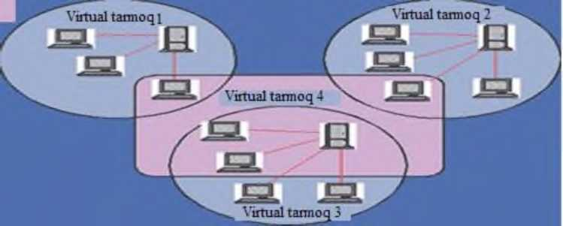

- picture Formation of multiple virtual networks in a physical network
scheme.
- VPN (Virtual Private Network) is a logical network that is built on top of another network, for example, the Internet. Despite the use of common non-secure network protocols in communications in this network, using encryption, closed channels for information exchange are established. A VPN allows you to connect multiple offices of an organization to a single network using unmonitored channels.
A virtual private network extends a private network over a public network and allows users to receive and receive information on shared or public networks if they are directly connected to the private network. A VPN creates a secure, encrypted connection tunneled between the user's computer and the VPN service's servers. VPN applications allow you to manage your network.
A VPN is used to connect geographically non-integrated networks. Individual Internet users can connect to their own proxy servers with a VPN to perform wireless transactions, bypass geo-restrictions and censorship, or protect personal identity and location.
A VPN is created by setting up a virtual port with separate connections, virtual tunnel protocols, or encrypted transport. It provides the benefits of a wide area network (WAN) with a global Internet network. Users can access shared resources remotely within a private network.
A VPN is implemented over a public network, for example, the Internet, covering individual network features (Figure 2.9). Using the tunneling method, a data packet is transmitted over a public network in the same way as a simple two-point connection. Between each "data sender-receiver" pair, a unique tunnel - a secure logical connection - is established, which allows encapsulation of data from one protocol to another.
The following are the main components of the tunnel: router; tunnel switch; one or more tunnel terminators.
The principle of operation of VPN is no different from the main network technologies and protocols. For example, a client sends the standard "PPP (Personal Post Protocol)" protocol when connecting to a server for remote access. In virtual dedicated lines, PPP packets are exchanged between local networks through their routers.
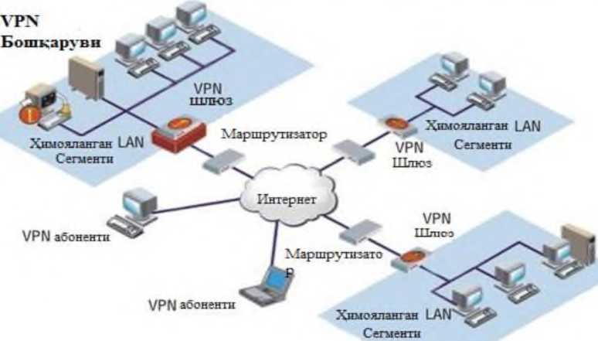

- picture Virtual private network.
Tunneling makes it possible to organize the sending of packets formed in one protocol to another protocol in a logical environment. As a result, it creates an opportunity to solve the problems that arise in the joint operation of several different networks, starting with the importance of ensuring the confidentiality and integrity of the data being sent, ending with the elimination of imbalances of external protocols or addressing schemes.
A corporation's existing network infrastructure can be configured to use VPN using software or hardware. Setting up a virtual private network can be compared to running a cable through a global network. In this network, the connection between the remote user and the end device of the tunnel is established directly according to the PPP protocol.
From the user's point of view, the essence of VPN is a "virtual protected tunnel", or it can be said to create an opportunity to use a database server, FTP and mail servers remotely through open channels of the Internet. VPN includes the ability to protect information traffic in any Internet and extranet systems, audio-video conferences, e-commerce systems and other information systems.
Thus, VPN is: traffic protection based on cryptography;
a guaranteed protective communication tool that allows you to use internal resources from anywhere in the world;
is the development of the corporation's communication system without the use of dedicated line construction equipment.
Virtualization technology makes it possible to use one server computer with up to 70% resource usage instead of 5 or 10 server computers with 5-10% load. Financial costs are reduced - instead of purchasing five or ten servers, one high-quality server is purchased, and its resources are used to solve problems that are performed on 5-10 servers. As a result of virtualization, applications that cannot be combined with each other will be able to work within a single physical computer. Basic literature

1. Cloud technologies. Study guide. TEDelov. -Tashkent: 2020 -217 p.
2. Patrick Niemeyer, Daniel Lake Learning Java / 2014.
3. Cruz Zapata. Android Studio Essentials Belén 2013.
4. Ted Hagos. "Learn Android Studio 3 with Kotlin" 2015.
5. J. Zdziarski. "iPhone SDK Application Development". Saint Petersburg. 2010.

Additional literature

1. Android Programming Tutorials 2013.
2. ManSinicki. Learn Unity for Android Game Development 245 pages
3. MattNeuburg. iOS 12 Programming Fundamentals with Swift

Internet sites

1. https://intuit.ru/studies/courses/493/349/lecture/8337
2. https://www.fandroid.info/
3. https://developer.android.com/
4. https://covde.oksei.ru/user/view.php?id=5&course=167 – Androidfor
5. https://www.w3schools.com/java/default.asp – webon site programming languages
6. https://udacity.com. - onlineplatform

LECTURE 15: Comparative analysis of information threats and methods of combating them in cloud technologies
Plan
15.1 Functional attacks on cloud elements.
15.2 This type of attack is common security with multi-layered cloud
15.3 Protection against functional attacks
15.4 DoS -providing effective protection against attack
Information threats and countermeasures in cloud technologies
comparative analysis of methods of functional attacks on cloud elements. This type of attack depends on the general security principle with multi-layered cloud. Regarding cloud security, the following can be considered as a solution: when protecting against functional attacks, each cloud part has the following
it is necessary to put a source of protection: for the proxy - DoS - providing effective protection against attacks, for the web - server - page integrity control, for server applications - screen-level applications, for MBBT - SQL - injection protection, data for the storage system - providing correct backups (backup), restricting its use. The protection mechanisms listed above have been developed, but they are not yet assembled together to provide comprehensive cloud protection. Therefore, when the cloud is being created, the problem of integrating them into a single system is an incentive to solve.
Client Attacks Many clients use a browser to connect to the cloud. One of the attacks is Cross Site Scripting, "stealing" passwords, web
- session retention and more. The only true and safe defense against such an attack is clear authentication and mutual authentication with SSL encryption. But this method of protection is very inconvenient and time-consuming for cloud developers.
Attacks on the hypervisor The hypervisor is one of the key elements for virtual systems. One of its main functions is to allocate resources to virtual machines. An attack on the hypervisor can cause one of the virtual machines to use the memory resources of another virtual machine. It can also capture network traffic, seize physical resources, and stop a virtual machine from running through the server. It is recommended to use the necessary specialized products in the virtual environment when implementing standard protection methods. Integrating host servers with directory services Active Directory, as well as standardizing the way host server management tools can be used.
Control system attacks. Many virtual machines used in the cloud require separate system management. Tampering with the management system causes virtual machines to crash and make another virtual machine the culprit by blocking one virtual machine.
One of the most effective ways to ensure cloud security is a public report by the Cloud Security Alliance (CSA), which analyzes the following information:
Data storage. Encryption is one of the most effective ways to protect data. The data access provider must encrypt the customer data stored in the data processing center and delete it irretrievably when it is no longer in use.
Data Security in Transmission. Encrypted data transmission can only be done after authentication. Reading or changing data, access to it is done through reliable connections. Such technologies are implemented by the most popular algorithms and reliable protocols AES, TLS, Ipsec.
Authentication. Password protection. Tokens and certificates are focused on providing greater reliability. The provider must act in a transparent manner during the authorization process with the identification system. It uses LDAP (Light Directory Access Protocol) and SAML (Security Assertion Markup Language) protocols.
Isolation of consumers. Individual use of virtual machines and virtual networks. The following technologies should be implemented in virtual networks. VPN (Virtual Private Network), VLAN (Virtual Local Area Network) and VPLS (Virtual Private LAN Service). Providers often isolate consumer data from each other as code changes in a single application environment. This approach is considered dangerous as it can find its way through non-standard code and exploit customer data.
Information protection in the use of cloud technologies If we look at cloud technologies from a technological point of view, the condition of application operation is not much different from the condition of traditional operation. Business systems also run on separate computing power, only in cloud technologies they can be virtual. Data is stored on servers, and they are divided into several computing nodes or placed on a single large server. Many experts believe that information security in cloud technologies should be built on the principle of traditional system protection.
Based on the fact, we can divide the protection of cloud technologies into two:
- prevent equipment safety;
- data security.
In order to ensure the protection of customers, the provider must protect its hardware and software systems from unauthorized access, hacking of IT systems, and code modification. In turn, the client has the opportunity to use encryption technology to protect it from external attacks when entering any necessary or personal information into the system. This includes several advantages of security in "Cloud technology".
The protection of "cloud technology" is determined not only by the operator or the client, but also by the type of methods and where it is used.
Private Cloud. Ensuring information security in a private cloud environment is considered very easy. When working with a private cloud, we can only use computing resources and data storage service model and graph. Then all valuable information remains with the company. In strict measures, the data on the virtual desktop may not be saved when the network goes down. A private cloud will be able to provide maximum types of protection not only in the implementation of full functions of the platform and applications.
The private cloud has an arsenal of administrator-encoded, protected differentiated, cluster-resolved, authenticated, audited operations and secured data.
A modern software solution can do many things, reflecting the ease of personal use of the database system.
In particular, such functions as "Run-Time Privilege Analysis" and "Data Redactions" give organizations the privilege to identify actions accessing and using data stored in "Cloud technologies". But a private cloud requires skilled staff to provide servers with a high level of service, uninterrupted and efficient virtual software.
Likewise, business applications, workloads, and service levels are maintained in the cloud. Must be seasoned and experienced professionals in cloud security. Not all companies have such a situation, so one of the most common types is social cloud technology.
Social Cloud. One of the advantages of the public cloud is that another organization is in charge of your data and at the same time ensures the transfer and storage. As valuable information regularly leaves the network, it requires additional protection. Unfortunately, social and hybrid or traditional, private clouds cannot provide the same level of security built into enterprise systems. Therefore, many service providers have to focus on limited services in order to effectively implement security in the social cloud. However, many organizations prefer to choose providers for cloud security. In recent years, a significant amount of data stored in the cloud has raised fears that it could be vulnerable and monitored by other government users. This is what Steve Rose, director of the Verint Systems consulting department, says.
Defense technology. In the field of IT, the cloud protection strategy allows for a very high level of security while having the highest standards of personal data protection. Cloud computing always allows participants to determine the requirements for each component level. The possibility of implementing such requirements is being found today. The focus should be on reliable deployment and implementation of the program. Ilya Trifalenkov, director of the information security center "R-Style" - it is precisely the level of application software that provides access to information. Only this application software level stands at the front line of maximum risk.
The most common threats in cloud environments are switching virtual machines from their working state, changes in IT infrastructure network topology using only program parameters, IT attacks directly bypassing network protection mechanisms. tooth This risk is reduced due to the protection of all stages of the construction of the virtual environment, namely: virtual infrastructure, within the system management and storage system, hardware, system software graph (hypervisor).
Cloud model security. The three cloud models have very different levels of risk, and the ways to solve security problems also differ depending on the level of interaction. Security requirements remain the same, but different models of SaaS, PaaS, or IaaS have different levels of security management. From a logical point of view, nothing changes, but the possibilities of physical implementation are fundamentally different.
In the SaaS model, the application runs on cloud infrastructure and can be accessed through a web browser. The client does not manage the network, servers, operating systems, data storage, and even some application features. Therefore, in the SaaS model, the main responsibility for security is almost entirely placed on the suppliers.
The first problem is password management. In the SaaS model, the applications are in the cloud, so the main risk is the use of multiple accounts to access the applications. Organizations can solve this problem by consolidating accounts for cloud and on-premises systems. When using a single sign-on system, users have access to workstations and cloud services using a single account. This approach reduces the likelihood of "hanging" accounts in cases of unauthorized use after the dismissal of employees.
According to the PaaS CSA, PaaS customers build applications using software languages ​​and tools supported by the vendor and then deploy them to the cloud infrastructure. As with the SaaS model, the customer does not manage or control the infrastructure—networks, servers, operating systems, or storage systems—but controls the deployment of the software. In the PaaS model, users need to focus on application security as well as API management issues such as authorization, deauthorization, and verification.
The first problem is data encryption. The PaaS model is inherently secure, but there is a risk of system malfunction. This is because it is recommended to use encryption when exchanging data with PaaS providers and this requires additional CPU power. Nevertheless, in any solution, the transmission of confidential user data must be carried out over an encrypted channel.
Iaas Although customers here do not manage the cloud infrastructure, they have control over the location of operating systems, data storage, and applications, and may have limited control over the choice of network components.
This model has several built-in security features without protecting the infrastructure itself. This means that users must manage and secure operating systems, applications, and content, typically through APIs.
If this is translated into the language of protection methods, the provider must ensure that:
Reliable management of the use of the infrastructure itself;
Resilience to infrastructure failures.
At the same time, the cloud consumer has more protection functions
takes:
Firewall within the infrastructure;
Protection from the inside of the network;
Protection of operating systems and databases (access control, vulnerability protection, security settings management);
Protection of the latest programs (antivirus protection, access control).
Thus, most of the protective measures fall on the shoulders of the consumer. The provider can provide custom protection recommendations or ready-made solutions, thereby simplifying the task for end users.
Cloud incident investigation and forensics
Information security measures can be divided into preventive (for example, encryption and other access control mechanisms) and reactive (investigation). The proactive side of cloud security is an area of ​​active research, while the reactive side of cloud security has received little attention.
Incident investigation (including information crime investigation) is a well-known branch of information security. The objectives of such inspections are usually:
Data protection measures can be proactive (problem modification, access management, and other management mechanisms) and reactive (investigation). The active focus of cloud security is the active academic communication field, the reactive side of cloud knowledge and the low importance. Incident investigation (information about it, investigation on the development of communications in the field of information) is a familiar department in the field of information and information. A section consisting of recommendations for the purposes of style-type proposals:
Recover data that may have been deleted Event-related recovery of events inside and outside digital systems
Identification of the user of the digital system
Detection of viruses and other malicious programs
Identifying the presence of illegal materials and programs
Cracking passwords, encryption keys, and passwords
Ideally, computer-technical expertise is the time for the investigator
being a machine, it is at any time to the past of a digital device
can pass and provide the researcher with the following information:
The user actions of people using the device at any given time (for example, opening documents, accessing a website, printing data in a word processor, etc.) are data stored, created and processed by the device at a certain time.
Cloud services that replace standalone digital devices should provide a similar level of forensics. However, pooling these resources requires overcoming the age-old and inflexibility issues of cloud computing infrastructure. The main tool in the investigation of events is the audit sheet.
Audit logs - designed to manage user registration history, administrative tasks and data changes in the system - are an integral part of the security system. In cloud technologies, the audit trail itself is not only a tool for conducting an investigation, but also a tool for calculating the cost of using servers. Although the audit trail does not eliminate the gaps in the protection system, it allows you to look critically at what is happening and formulate suggestions for correcting the situation.
Creating archives and backups is important, but cannot replace an official journal that records who did what, when, and what. An audit trail is one of the primary tools of a security auditor.
The service agreement usually specifies which audit logs are kept and made available to the user.
Threat model
- In , CSA analyzed the main security threats in the cloud. This document describes the attackers for three service models: SaaS, PaaS, and IaaS. 7 main lines of attack have been identified. For the most part, all types of attacks are attacks specific to simple, "non-cloud" servers. Cloud infrastructure imposes certain characteristics on them. So, for example, attacks on vulnerabilities in the software part of servers are complemented by attacks on the hypervisor, which is also their software part.
Security threat #1
Improper and inappropriate use of cloud technologies.
Definition: To get resources from an IaaS cloud provider, a user only needs to have a credit card. Ease of registration and resource allocation allows spammers, virus writers, and others. use the cloud service for their criminal purposes. Previously, such attacks were observed only on PaaS, but recent studies have shown the possibility of using IaaS in DDOS attacks, embedding malicious code, creating botnet networks, and more.
Examples
IaaS services include the creation of a botnet network based on the Zeus Trojan, the storage of the InfoStealer trojan horse code, and MS Office and
Used to post information about various vulnerabilities in AdobePDF.
In addition, botnet networks use IaaS to manage their peers and send spam. Because of this, some IaaS services are blacklisted and their users are completely ignored by mail servers.
Remedy:
Improving the procedure for registering users Improving the procedure for checking credit cards and controlling the use of payment instruments
Comprehensive study of network activity of users of the service
Monitoring the main blacklists for the appearance of the provider network there.
Security threat #2
Secure Programming Interface (API) Definition: Cloud infrastructure providers provide users with programming interfaces to manage resources, virtual machines, or services. The security of the entire system depends on the security of these interfaces. Starting from the authentication and authorization procedure and ending with encryption, the application interface should provide maximum protection against all kinds of attacks by malicious users.
Examples:
The main characteristics of secure software interfaces are anonymous access to the interface and reliable transmission of specific information. Limited monitoring of API usage, lack of a logging system, as well as unknown relationships between different services only increase the risk of hacking.
Remedy:
Conduct an analysis of the cloud provider's security model
Make sure the encryption algorithms are reliable.
Make sure you use valid authentication and authorization methods.
Understand the entire chain of dependencies between different services.
Security threat #3
Intruders
Description:
The problem of unauthorized access to information from the inside is extremely dangerous. Often, the provider's monitoring system is not implemented by the provider, which allows an attacker to gain access to customer information using their service position. Since the provider does not disclose its recruitment policy, the threat may come from amateur hackers and organized crime, which includes the provider's employees.
Examples:
No examples of this type of abuse yet
yes
Remedy:
- Rigorous rules for purchasing equipment and using appropriate systems to detect unauthorized access
- regulating the rules of hiring employees in public contracts with users
- Creating a transparent security system, as well as publishing security audit reports on the provider's internal systems
Security threat #4
Cloud Vulnerabilities Definition: IaaS service providers exploit the abstraction of hardware resources using virtualization systems. However, it is possible to develop equipment without sharing resources. To minimize the impact of this factor, the hypervisor controls access to the virtual machine's hardware, but even hypervisors can have serious vulnerabilities, the use of which can lead to privilege escalation or illegal access to physical hardware.
In order to protect the system from such problems, it is necessary to implement the isolation mechanisms of the virtual environment and isolation violation systems. Virtual machine users should not access shared resources.
Examples:
There are examples of potential vulnerabilities as well as theoretical ways to bypass isolation in virtual environments.
Remedy:
Implement best practices for deploying, configuring, and securing virtual environments
Use of intrusion detection systems Apply strong authentication and authorization rules for administrative work
Time requirements for applying patches and updates Conduct timely scanning and vulnerability detection procedures.
Security Threat #5 Data Loss or Leakage
Definition: Data loss can occur for thousands of reasons. For example, intentionally destroying the encryption key will not recover the encrypted data. Examples include the destruction of data or part of data, illegal access to critical data, alteration of records, or media malfunction. In a complex cloud infrastructure, the probability of each incident increases due to the close interaction of components.
Examples:
Improper application of authentication, authorization, and auditing rules, misuse of encryption rules and methods, and equipment tampering can lead to data loss or leakage.
Remedy:
Using a robust and secure API
Encryption and protection of data provided
Analysis of data protection model at all stages of system activity
Strengthen the encryption key management system
Choose and buy only the most reliable media
get
Ensure timely data backup
Security threat #6
Theft of personal information and unauthorized access to the service
Description:
This type of threat is not new. Millions of users come across it every day. The main goal of attackers is the username (login) and its password. In the case of cloud systems, the theft of passwords and usernames increases the risk of using data stored in the provider's cloud infrastructure. Thus, the attacker can use the victim's reputation for his own activities.
Examples:
Using stolen information to send spam.
Remedy:
Prohibition of transfer of account numbers Use of two-factor authentication method.
Proactive Monitoring of Unauthorized Access Cloud Provider Security Model Description Security Threat #7 Other Vulnerabilities Definition:
Using cloud technologies to run a business allows a company to focus on its business by providing IT infrastructure and services to a cloud provider. By advertising their services, the cloud provider tries to show all the possibilities while disclosing implementation details. This can be a serious risk, as knowledge of the internal infrastructure gives an attacker the opportunity to find an open vulnerability and attack the system.
To prevent such situations, cloud providers may not disclose information about the internal structure of the cloud, but this approach also does not help to increase trust, since potential users cannot assess the level of data security. In addition, such an approach limits the ability to find and eliminate vulnerabilities in time.
Examples:
Amazon EC2 Rejects Cloud Security Audit Vulnerability in Software Processing Leads to Security Breach at Heartland Data Center
Remedy:
Open the journal
Full or partial disclosure of system architecture information and installed application details
Use of vulnerability monitoring systems.

LECTURE 16: Features of cloud technology
Plan
16.1 Cloud technology models and the process of emergence
16.2 Cloud technologies.
16.3 The importance of "virtualization" technologies in the emergence of cloud computing
Features of cloud technology
Cloud technology models and the process of creation Cloud technologies - this model presents IT as a service to the consumer over the Internet. The importance of "virtualization" technologies in the emergence of cloud computing is very great. Virtualization technology was first proposed by IBM in the 1960s, but the term virtualization was long forgotten after the transition from expensive mainframe computer technology to inexpensive x86 processor computer servers. From 2000, the situation started to change, until these years, WMware won the monopoly in x86 discharge virtualization. In 2005, WMware made virtual machines available for free using DT. In 2006, Microsoft launched the Windows version of Microsoft Virtual PC.
Cloud is an innovative model (concept) of IT-infrastructure organizations, which consists of separately separated and distributed configured hardware and network resources, software, and they lie in the data center of remote providers.

The model provides a convenient and concurrent use of configured computing resources (for example, networks, servers, databases, applications, and services) from a single currency network, while providing operational and free operation with minimal management. This model of the cloud
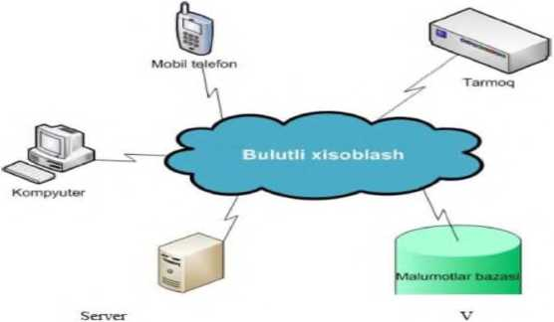

Figure 3.15. Cloud computing
Distinguish them from other types of computing (from Internet resources).
It consists of 5 main characteristics, 3 service models and 4 presentation models.
Self-service on demand. The user can determine and change the server time, the size of the data storage, automatically, if necessary, without interaction with the service provider, and the computing power independently.
Broad access to the network. Computational power capabilities can be accessed over large distances through standard mechanisms on the network. It allows to widely use various types (thin - thick) client platform (terminal devices).
Pooling of resources. By combining the computing resources of a configured provider into a single pool, a large number of users will have the opportunity to share resources.
Rapid elasticity of resources. Cloud services can be expanded, quickly provided, or reduced depending on user demand
Cloud computing in business processes
Cloud computing consists of thousands of servers located in data centers that run tens of thousands of applications running on millions of users at the same time. The most important way to effectively manage such a large-scale infrastructure is the most complete automation. In addition, cloud infrastructure provides self-management and delegation of authority to provide different users to ensure secure use of computing resources - cloud operators, service providers, vendors, IT administrators, application users need
The concept of cloud computing has significantly changed the traditional approach to application delivery, management and integration. Compared to the traditional approach, cloud computing means you have to manage large infrastructures, serve different groups of users within the same cloud, and are completely dependent on the cloud service provider. However, this dependence seems only theoretical, because if the provider company allows at least one data theft, it will be a big blow to the entire industry that provides remote objects.
Cloud computing is an effective means of expanding sales channels and expanding sales channels for independent software vendors (telecom operators), telecom operators and VAR intermediaries (SaaS). This approach allows users to make real-time payments and organize dynamic services that regulate the amount of their resources at the level of real needs without long-term commitments. IT managers have so far avoided cloud technologies. // CNews April 21, 2010
Cloud computing for hosting provides huge growth potential. The cloud computing industry is growing rapidly, and according to analysts, it will account for 9% of IT spending by 2012. Additionally, the industry is increasingly shifting from emphasis to cloud computing and SaaS, and your customers expect you to move in that direction.
The main advantage of using clouds is the absence of the need to have a powerful system for the end user, which leads to a significant reduction in costs for the user. The second advantage is that you cannot use pirated content because all incoming traffic comes from certified providers. Thus, the modernity of the computer can solve one of the most global problems of piracy.
According to Parallels, the majority of IT will move to five different clouds in the next 5-10 years. Different platform services like IBM, Apple, HP and Amazon - Google (type 1), Microsoft (type 2) and other big IT players (type 3).
Cloud services (4 types) are expected to offer a wide range of services from thousands of solar providers. For example, web hosting and software hosting, vertically integrated organizations (government, healthcare, etc.), independent software vendors (strategic business development, customer support systems, etc.), telecommunications services (voice mail) VOIP). Finally, there are enterprise managed clouds (type 5), which provide services for internal use and for use by employees and partners.
Cloudy clouds
- Type 1: Google Cloud
- Type 2: Microsoft Cloud
- Type3: Other Clouds (eg IBM and Apple - Amazon, Facebook, Adobe, etc.)
Service clouds
- Type4: Service provider clouds - telecom operators, web hosts, ISVs, SaaS
- Category 5: Internal Clouds of Large Companies (Fortune 1000)
Succeeding in today's competitive IT market
- moving to the fifth type of clouds or engaging third-party resources to move to the fourth type. To solve this problem, Parallels creates solutions, ecosystems and collaborates with service providers and companies to create an effective infrastructure for providing cloud services. Besides,
The SaaS provider takes care of the program's health, provides technical support to users, and installs updates independently. Thus, the user thinks less about the technical side of the problem and focuses on their business goals.
Key benefits of SaaS over traditional software include:
- Low cost of ownership.
- Short implementation time.
- Low entry threshold (you can quickly and test).
- The task of maintaining and updating the system falls entirely on the shoulders of the SaaS provider.
- Full user movement is limited only by "Internet coverage".
Support for companies and remote workers
Low power requirements of the user's computer.
Disadvantages of a SaaS company include security, low frequency and unreliability of transferring commercial data to a third-party provider due to interruptions for Internet Chernyak L. Integration is the foundation of the cloud. // Open systems. DBMS September 16, 2011
There are alternative technologies to SaaS. They are intermediate transitions from traditional software to SaaS and may soon disappear.
S + S is an alternative brand promoted by Microsoft, different from SaaS, because it is a software client, not a browser, on the customer's computer.
Hosting programs. This option differs from SaaS only in the server-side architecture and is not noticeable to the user. Therefore, most of the applicants turn to SaaS services. The difference is that classic SaaS services have a multitenant architecture, i.e. One application serves many clients, and application hosting involves installing a separate copy for each client. The second option provides more customization options, but at the same time makes it more complicated to manage and update, so it costs more.
The practice of using cloud technologies
- In , WINDOWS AZURE was announced as a commercial system. Like a traditional OS, WINDOWS AZURE allows you to run programs and store data, but not on the user's computer, but in the cloud.
The WINDOWS AZURE operating system is part of the Windows Azure Platform for software development, which includes the following elements:
- WINDOWS AZURE software provides a Windows environment for running and storing data in Microsoft data centers
- SQL Azure provides support for SQL Server-based Rails databases. Data can be stored in the cloud and on-premises, but work with WINDOWS AZURE applications
- AppFabric, the Windows Azure platform, enables the secure transfer of applications running in cloud and traditional environments.
Despite the similarity of the names, the concepts of fabric and AppFabric are not the same. The first is the integration of the physical machine in the cloud operating system, and the second is related to the connection with applications running in different environments.
Straight awayoperating systemWINDOWS AZURE also consists of interrelated components: Compute Service, Storage Service, and Fabric.
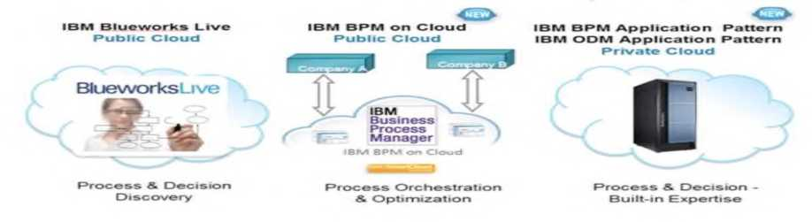

- picture Business process management in the cloud Compute Service is suitable for computing. The main purpose of a cloud platform is to support an application that runs on a large number of users at the same time. WINDOWS AZURE supports multiple copies of the same code on different physical servers. In turn, the program can run on several virtual machines at the same time in several versions
possible, each of them is provided with a hypervisor based on Hyper-V used for clouds.
There are two different job versions of the cloud application: web role (web role) and worker role (Worker role). The first can handle HTTP or HTTPS requests and the Internet Information Services (IIS) server is running in a virtual machine (VM). A developer is able to create a version of the web server using ASP.NET or Windows Communication Foundation (WCF), as well as any other .NET technology that works with IIS. The program can be created in Makarov SV programming language. For Cloud Computing // Creative Economics .- M:, No. 8, 2010.
In contrast, the worker role does not indicate that IIS is running. Performs tasks in the background. For example, a web role can be used to receive a request from a user. But its processing starts later using the version of the worker role.
A storage service provides data storage. OS WINDOWS AZURE uses three methods of working with data. The simplest of them is a BLOB containing binary data with a simple hierarchy. This type of information organization is designed to store images, audio and videos. to use large volumes. When it is necessary to organize data of the same type, they refer to a table where there is a row number and a column number for each data. A table in a storage service is not relational. A simple organization allows access to data through ADO.NET methods. In this form, the cloud operating system distributes data storage to several physical computers, which is more efficient than using a relational database.
The studied methods provide storage and access to data, and a third method called "queue" is required for their communication. The principle of organizing data includes: "First in, first out." This method helps different versions of the application to exchange messages with each other. Because synchronization is possible in the cloud environment, this web role and the worker role are related to each other. Let a user be presented with a task that requires significant computing power through a web interface. The web role writes the received request to the queue. A worker, this queue entry, receives and executes the request. The results of the implementation (answer) are sent in the next rule, in the queue. M regardless of the way information is organized, In WINDOWS, data is replicated three times in AZURE Storage, which ensures the stability of the system: the loss of data in one of the copies is not fatal. There are also archived copies stored in another Microsoft data center. This means that even if the entire data center is lost, the data will be retrieved and restored from another data center's archive.
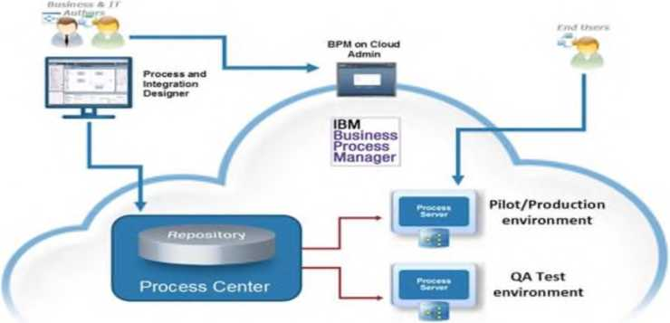

- picture From cloud technology in business process management
use
OS -The newest component of the text allows you to organize WINDOWS AZURE and a series of computers that store your data. The control of such a "computer fabric" is done by fabric control software. Fabric monitors all running applications, manages interactions with the OS in different VMs, and selects a physical server to run the application, while optimizing hardware utilization. Applications are managed using configuration files that contain an XML description of everything the application needs, such as the required number of virtual machines with web roles and job roles.
WINDOWS AZURE components allow you to create a variety of applications. That is, to create a scalable Internet application, the programmer needs to store data in a table using the required number of Web sites. A parallel computing application requires a web host, a queue to store requests, the necessary worker roles, and a table (or BLOB) to store the data. In turn, SQL Azure and AppFabric enable WINDOWS AZURE solutions to work with software and databases.local networkor with cloud systems of other providers Makarov SV Download effect // Creative Economics. - M:, No. 9, 2010.
Applications built on WINDOWS AZURE are offered simultaneously as a service to individuals, corporate users, or both. Here are some examples of the prices of some Microsoft cloud services:
- Computing power - $0.12 per hour
- Monthly data storage - $0.15/GB
- Data transfer - $ 0.01 / 10 Kb
- Download Data - $0.15/GB Includedusing windowsAZURE Independent Software Developers can build applications for business users by applying software-as-a-service principles.
For example, the American company Alinean, Inc. may be a solution developed by . Its field of activity is sales analysis and provision of analytical tools required in the field of marketing. Alinean systems allow you to assess the needs and opportunities of your business in the future, offer solutions for potential development and calculate when the investment will pay off. Alinan users are corporate customers located in different parts of the world. Among them are IBM, HP, Microsoft, Intel, AT & T, VMware, Oracle, Siemens, Symantec and others. 20 servers on demand in Alinean data center located in Orlando (Florida, USA), One day a week. The volume of business increased and the opportunity was not enough,
Therefore, it was decided to transfer the pre-developed program to the roof of WINDOWS AZURE. As a result, he turned 28 years oldvirtual serversWorks with Azure and 20 SQL Azure (10 gigabytes). Alinean was able to reduce the cost of maintenance by 60% by paying after the service. Compared to the previous, traditional model. In addition, management is about 160%. In WINDOWS AZURE, the ratio of the average increase in revenue to the volume of investments (ROI - Return on Investment) compared to the previous configuration (100%).
Due to the scalability of WINDOWS AZURE, it allows to store records of many users. By creating cloud solutions, the development company can rely not only on corporations, but also on individuals. This program is implemented by TicketDirect International, a New Zealand company that operates online, accounting for 45% of all ticket sales for cultural and sporting events in New Zealand. The previous, traditional ticketing system based on Microsoft SQL Server 7 and SQL Server 2000 was written in Visual Basic 6. The program easily sold several hundred in an hour. However, on sales days, when discounts were announced for visiting the public event, thousands of people tried to "pass" at once.
WINDOWS AZURE has provided TicketDirect with scalable infrastructure as a service with true payment capabilities. As a result, during trading, the application starts using additional features. No longer does TicketDirect require the purchase of equipment just to cover temporary bursts of activity. There are almost no restrictions. In the cloud, the company serves several popular events, while sales begin at the same time. WINDOWS AZURE provides as many features as business needs.
In a WINDOWS AZURE environment, internal applications can be created where the users are employees of the enterprise. In this case, olgeability is probably not very important. However, there are also explosions in the company's activity - then it is difficult to overestimate the advantages of cloud computing within the walls of the enterprise. As an example, let it be Microsoft itself, or vice versa, its information technology department, as it found the program of WINDOWS AZURE. As part of the annual charity campaign, the IT department is holding an online auction for the charity "United Way". In the past, hardware and software were supported only once a year during this period, but it was supported throughout the year. Besides, At the end of the auction, there were other problems faced by the technicians. Each time this time, the activity increased and the system was overloaded.
The IT department has decided to move to cloud computing. WINDOWS AZURE and Microsoft SQL Azure were used for data storage. Now, in the final days of the auction, the IT team is programming the system to use more resources to serve the greater flow of requests. Once the auction ends, the odds will drop. The cloud model is ready to serve as many users as needed. Within the larger Microsoft company, the system now allows you to collect additional funds for charitable giving.
These examples talk about the construction of required buildings. But to work in WINDOWS AZURE environment, you don't need to program your own application. Let's all test Microsoft's cloud operating system. Based on WINDOWS AZURE, Office applications "Live" are available on demand within Windows Live. Windows Live allows you to create documents in Word, Excel and PowerPoint format and store them on a virtual disk, in the clouds. Interestingly, the system allows you to open an online document on a computer using a traditional Microsoft program. In the future, WINDOWS AZURE will go beyond the data centers of its developers and will be installed on the walls of other corporations. Microsoft has announced future partnerships with companies such as Dell, HP and eBay.

LECTURE 17: Characteristics and capabilities of Google-drive
PLAN
17.1 (Google Drive —cloud hosting where files can be stored
17.2 Dropboxview of the app
Features and capabilities of Google Drive
Google Drive is a cloud hosting where files can be stored. The service has been provided by Google since April 24, 2012. In 2014, the number of monthly active visitors of the service reached 240 million[1]. Main functions: saving files on the Internet, editing and copying them. Google Drive includes files in various formats created in Google Docs, Sheets, Presentations, and other office programs. The service offers 15 GB of free space. Active users can purchase more space for additional money.
Technical progress does not stop yet. A technology that eventually becomes ineffective will die out and another, more advanced one will come to replace it. A clear example of this is the evolution of data storage methods. If earlier in the course were discs and DVDs, today most people prefer to store data on compact flash drives of larger size and they can accommodate a lot of data. Any user who creates an account in such a service o can upload their files to the server and access them from any computer or other supported device (tablet, smartphone, etc.) under their account. Agree, very practical: you can save time and money. One disadvantage is that you need to access the Internet. Lack of connection will deprive you of access to downloaded data. Fortunately, almost everyone has access to the network.
For working users, the amount of disk space for large files is the main criterion. If the service cannot provide the necessary space, it will not be appropriate to use them.
Dropbox cloud technologies, which was once one of the founders, can now be safely called an outsider who cannot compete with other participants comparing disk space with other aspects. Only 2 gigabytes for registration, 1 gigabyte for normal work and 13 gigabytes for attracting programs to the user program (500 megabytes for each user, registered and installed by the client). Only 15 gigabytes are provided for free on the server. And if you consider that the same area is used to store Google Docs documents, e-mail Users should have a small content. . For example, now the price of 100 GB is $ 2, 1 TB is $ 10. You will get several tens of terabytes (I think who might need it).
Cloud Mail.ru - What Mail.ru says about cloud storage, they, and users have enough free space on the servers. Anyone connecting to the service can use up to 100 gigabytes of free space, where unlimited files can be uploaded.
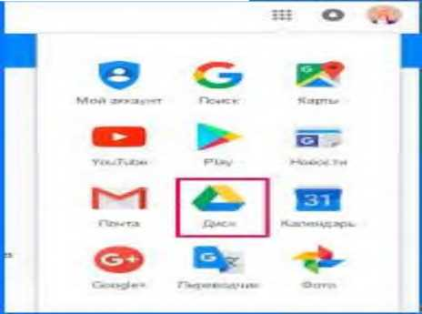

- picture Cloud Mail.ru desktop
MediaFire - In the MediaFire cloud, you can get 50 gigabytes of space, but the conditions for getting it are more complicated. The initial size on the disk is only 10 gigabytes. Another 8 gigabytes can be obtained by installing certain applications and extensions, and offering the remaining 32 services to the customer. 1 gigabyte extra per user.
Yandex Disk - cloud storage Yandex local company initially offers 3 GB free space, using simple manipulation
- Can easily change to GB. Additional space is opened by attracting active referrals (500 megabytes per person). In addition, it makes sense to follow various stocks on the Yandex website. For example, now any subscriber of the "OnLime" tariff plan from "Rostelecom" can open an additional 100 GB and buy a Kingston card with the Yandex logo - this is how many gigabytes can be obtained as the volume of a flash drive.
Microsoft OneDrive allows the use of 15 gigabytes of data for each registered user, and if he is also the owner of the computer with Windows 8 installed, then the size increases by 10 gigabytes.
Mega gives new users 50 gigabytes of free space for any file. It's a little bit, but unlike many other competitors, you don't need to cheat in addition.
Copy.com is another cloud service with a referral program. Initially, it provides 15 gigabytes of free space, but no monstrous gigabytes are counted for each participant, but up to 5 gigabytes. If you want to remove all the limitations of the free version and get 1 terabyte of free space from 250 gigabytes, you need to pay $ 5 per month and subscribe.
Apple iCloud - unlike other Apple services, storage can be used by computer owners as well as mobile devices from other manufacturers. Provides 5 gigabytes of free space in iCloud. To expand 20 gigabytes, 39 Russian rubles are spent per month, 200 gigabytes - 140 rubles per month. Maximum 1 terabyte and 749 rubles per month.
Google Drive Security and Privacy
Many people do not want to use cloud services because they are afraid of theft or losing some information. Let's see what the creators of such services have done to prevent such situations.
Dropbox uses modern data protection methods: SSL and 256-bit AES, which guarantee safe transfer and storage of all files uploaded to the server. All applications and service extensions are checked for vulnerabilities and updated periodically. 2-step verification can be connected.

Dropbox
- picture The appearance of the Dropbox application is not in the context of protecting the technology competition in Google Drive. . Of course, this does not negate the need to follow certain security rules - setting confidentiality in settings, disconnecting from a shared computer after completing work.
All files uploaded to the Mail.ru cloud are tested with the help of Kaspersky for the presence of viruses and other malicious codes. As the auxiliary databases are updated, the test is reprocessed. As with other services, files are encrypted. As for the shortcomings, it is necessary to mention the terms of the license agreement service, removing all responsibility of Mail.ru for any negative situations related to unauthorized use, technical problems.
Microsoft OneDrive creates multiple copies of your files at the same time, placing them on different servers. If one of them fails, you won't lose the saved data. Protection against access by third parties is also at a good level - two-step verification allows you to restore the account using additional information. Operational service available technical support.
Yandex Disk. Encrypted communication prevents your personal data from being intercepted by attackers, the ability to set a strong password - access to third-party accounts. If you unexpectedly lose your device (when you go to the store), it can be blocked by a special option to access it.
MediaFire has 2-step verification and encrypted communication. This is enough for those who do not want to store really important information in the cloud.
Mega - all the files you upload to the mega server are automatically encrypted on your device, and the encrypted version is already on the cassette, even the management of this service cannot access it. To be honest, with the last statement, we will probably be deceived, but additional confidence in security will appear.
Copy.com not only protects user files from malicious users, but also from your own discretion.
Apple iCloud - All data downloaded to Apple iCloud is encrypted with AES technology 128-bit keys. Not only the server where files are stored is protected, but also the process of uploading files to the server. If desired, you can connect two-step verification, which allows the user to identify the user with the connected device. On the other hand, everyone remembers the scandal of a large number of famous photos stolen from iCloud. The security flaw was quickly remedied, but was it the only one?
Functionality and additional capabilities of Google-drive The ability to store files on the server is not the only thing that modern cloud storage services are capable of. Almost any service has additional functions that can be useful for users.
Dropbox also works well through a browser interface, and it's a built-in app. All tools for creating and editing files are fully supported. What is important is that variable files load very quickly. This effect is achieved by partial editing (only the modified part of the edited file, previously compressed) is transferred to the server.
Google Drive is characterized by a convenient and functional interface, intuitive even for novice users. There are built-in tools for viewing and editing text documents and images in various formats. Work supported with mobile devices and there are additional functions specially developed for them.
Cloud Mail.ru - many complain about the inconvenience of working with the warehouse through the browser, periodic errors and all mental aspects. The problem is solved by installing software to work with the service. In the rest, there is nothing special - integration with the mobile client, mail and other standard functions.
Microsoft OneDrive - OneDrive has a lot of good news. The most important of them is the ability to create and edit Microsoft Office documents (Word, Excel, etc.) to save and send files directly through Hotmail.
Yandex Disk has advanced features and a wide range of supported systems, including mobile phones, Windows Phone, and Linux. Yandex Disk is integrated with several other Yandex services, which greatly simplifies the work.
MediaFire, in addition to the main function of saving files, allows you to share them on the Internet. Supports more than 200 file formats.
Mega works well on iOS and Android devices, and recently they bought an official client application (previously, work was done only through the browser).
Copy.com is very similar to the functionality of Dropbox mentioned above, but its beautiful and intuitive interface is also useful for a wide range of platforms. Apple iCloud can only be fully evaluated by owners of Apple devices. Automatic cloud synchronization makes it much easier to save data (photos, contacts, documents, etc.) and there is no need to install additional software. Windows owners who want to use iCloud must install iTunes, which is a bit inconvenient.
Which of the following services can be called the best? It is very difficult to define. Each warehouse has advantages and disadvantages. If you choose the most suitable (average) option, it will be liked by many, then Google Drive will have a choice.
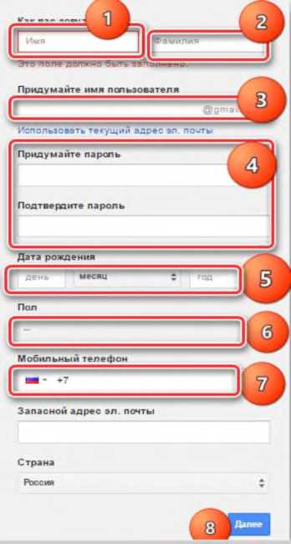
Figure 3.20 Google Drive workspace
Although it does not boast of a large free disk space, it has the ability to meet the needs of the average user. To save important files on this service, you can safely maintain the highest level of protection. Technical problems and intruders will not harm you. If you need to quickly transfer files from one device to another, many people have encountered problems. For example, your on your phone pictures
can be quickly edited on your computer.
Using flash drives for these purposes is inconvenient, because you have to perform local access to the computer and remove the flash card from your smart card every time.
Cloud storage easily solves this problem. When using Google Drive, the user is given 15 GB of free space, which can be used to store and reproduce important information.
How to use the online version To start using Google Drive, you must first create an account. If the user is using an Android device or Gmail mail, then you only need to remember the login information.
Go to this page to save a new account. All necessary information (name, surname, year of birth, gender, phone number) should be entered in it.
After the registration is completed, you need to confirm the phone, for this a message with a code will come to the number. You will need to enter a special field. After that, you can start working with cloud storage.
To use the online version, go to the site of the service.
Before you have a nice interface where you can add and change files in memory to the user. Through the browser version, you can:
- download and create folders and files;
- create documents, tables and presentations;
- processing photos;
- view the changed documents through the browser.
The online version allows you to do most of the same things as on a computer. Google has a full-fledged cloud office for users to work with different types of files. A large part of the window is occupied by the workspace, which contains all the repositories and folders.

LECTURE 18: Mobile teaching. M-learning
PLAN
18.1 In M-learningorganization of independent education
18.2 Effective organization of independent education.
Mobile training. M-learning
Effective organization of independent education in M-learning
Various means of information and communication technologies can be used for effective organization of independent education. Including e-courses, e-learning systems, video lectures, webinars, e-tests, etc. In addition to these tools, there are also modern and compact mobile technologies. When organizing independent education of students on the basis of mobile technologies, first of all, educational materials are studied independently of a specific time and place. This will allow you to get the information you need to study.
Education based on mobile technology is widely used in the educational systems of foreign countries today. It can be noted that in the United States of America, Canada, and European countries, mobile educational technologies have been introduced in the teaching of various subjects by using a single platform that combines mobile educational resources and their development methods.
Today, many companies producing computer, communication and computing equipment are producing modern computers with compact sensors on a new platform. These include tablets, smartphones and mobile devices. According to the statistics of developed countries, mobile devices in most cases are smart phones or tablets.
A touch screen is used to control the tablet. Work with it is done with fingers, without using a physical keyboard and mouse device. Typing on a touch screen is generally not as fast as typing on a keyboard.
- In the 70s of the century, Alan Key, an American scientist in the field of computing systems theory, proposed the idea of ​​a "book-sized computer"3. The 1990s saw the rise of mobile learning projects and the use of mobile learning for students with the advent of pocket computers. Learning from the network on the basis of mobile technology has been thoroughly studied in the scientific research works of VAKuklev. In the research work, information on the use of distance education in WiMAX wireless network based on mobile devices and working on Intel Classmate type computers for children is reflected. Also, in the research works of MAGrigoreva, teaching computer science in mobile computer systems5, Saville-Smith, G.Stead and G. In Colley's projects, the issues of organizing mathematics and linguistics education on the basis of mobile systems were studied6. Australia, Great Britain, Italy, Canada, Cyprus, Mexico, New
In Zealand, Poland, the USA, Turkey, Chile, Sweden and South African countries, educational technologies based on internal information and telecommunication tools (mobile computer systems: telephone, tablet and smartphone) are widely used.
About M-learning opportunities
As the capabilities of mobile devices continue to advance, their widespread use as an educational tool is taking center stage in both traditional and non-traditional education. One of the modern methods of education is education based on mobile technology, which is developing day by day. According to the analytical forecast of the Infonetics Research company, the use of the global network based on mobile communication in the world in the last five years is about 6 million1. Currently, the term mobile learning can be used in three ways:
M-learning is a technology for acquiring and exchanging knowledge using mobile devices (phone or pocket computer) with WAP, GPRS or 3G technologies (mainly Internet access);

- raasm Overview of cloud-based M-learning M-learning is a technology used to organize the educational process with the help of mobile communication tools (mobile phones and communicators);
M-learning is an educational process that involves the use of personal learning devices (laptop, pocket computer or mobile phone) in distance education.
Many conferences and exhibitions are being held on mobile learning. A number of international conferences were held, including mLearn, WMUTE and IADIS Mobile, ISML in Jordan, Mobile Learning in Malaysia, Working with Portable Devices in London, and Mobile Learning in the USA. A key issue at the conference is how mobile learning is impacting student learning. The importance of mobile learning is as follows:
- allows to attract new technologies to education;
- mobile devices are compact and smaller compared to books, computers and other devices;
- can be evaluated for use by students participating in learning.
The capability of mobile devices is not only for calling or messaging, but also for a wider range of tasks. Today, these devices provide opportunities for many users to receive information, build knowledge, and exchange ideas. Indeed, today there are many definitions of mobile learning or m-learning. These tools continue to be one of the primary tools for students to acquire information. Students want to always have access to educational resources on smartphones or tablets.
Today, the number of connections in mobile technologies has increased several times, compared to personal and portable computers, when most students connect to the Internet. According to experts, when analyzing the services provided by mobile communication companies, it is noted that while earlier mobile communication was used only for communication, now the demand for using internet communication instead of talking is increasing. It is proven in practice that students' attempts to use mobile devices and the Internet for independent education outside of class have a positive effect on improving their knowledge. They want to always have access to educational resources.
Mobile learning has many advantages: when students try to use mobile access to educational information and systems, this technology can greatly improve and enrich the learning process itself.
Mobile users use mobile apps to satisfy their information needs by reading news on various topics, watching videos, live broadcasts and exclusive shows, and information on commercial areas. For this, first of all, it is necessary to install mobile applications on the device through the Internet.
Currently, we can divide the organization of the educational process into traditional, technological, multimedia levels. At the traditional level, teacher-student communication is always provided. Therefore, it is necessary to constantly monitor the level of knowledge acquisition and form practical skills, immediately identify and correct errors. The technological level of the quality of education determines the presence of many channels of information in education, which significantly accelerates its development and strengthening. More attention is paid to teaching in the educational process. It involves the use of oral education and the use of television, personal computer, technical tools, the whole complex of teaching.
Moodle is an abbreviation of the words Modular Object - Oriented Dynamic Learning Environment (object-oriented modular dynamic learning environment) and is a powerful pedagogical software package that organizes teaching and online classes in the web environment. Martin Dugiamas is the founder and developer of the Moodle electronic course management system, and since 1999 he has completed a number of system development projects. Version 1.0 of the system was developed on August 20, 2002. Today, version 3.0 of the system is widely available.
Today, the Moodle system is used not only in universities, but also in colleges, schools, non-profit organizations and various companies. The Moodle system is viewed as a specially designed learning activity that helps students develop their knowledge. The Moodle system creates an opportunity for students to independently receive continuous education and develop their creativity. This system is determined by the exchange of messages between students through correspondence, the provision of independent work of students, the introduction of modern teaching methods and the provision of various educational services.
Given the popularity of mobile technologies among students, we need to analyze how these types of communication contribute to the use of independent learning to serve the development of intellectual knowledge. There are a number of ways to use mobile devices in independent learning:
- to develop multimedia educational web resources (audio files, videos, podcasts, graphics, maps, pictures);
- providing quick access to educational sites, resources, catalogs, dictionaries;
- ensuring the development of educational materials adapted for mobile communication platforms as a real educational tool (SMS-tests, training manuals and instructions based on mobile applications).
Today, mobile learning provides students with new means of communication and collaboration. From a pedagogical point of view, in acquiring knowledge, students use mobile learning as a means of self-education.
Therefore, a number of steps should be taken to develop mobile education. These are as follows:
- organization of education in a non-traditional way, encouraging self-awareness of students using mobile learning tools in an informal or everyday environment;
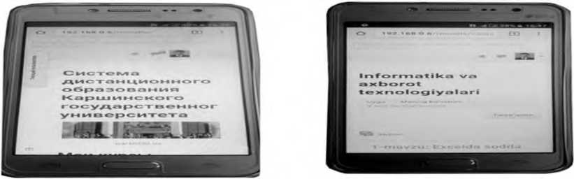

- picture The process of accessing the Moodle system and using educational resources through a mobile device.
- use of mobile technologies for students to share knowledge and experience;
- creation of administrative and legal standards together with educational institutions for the introduction of mobile education;
- encouraging teachers to regularly improve their teaching methods with personal mobile devices;
- discussing the possibility of reducing the cost of mobile internet for mobile education with telecommunications companies.
In order to use mobile education, it is necessary to increase the motivation of students for independent activity. For this purpose, the teacher in the virtual environment, for example, using the LMS Moodle platform, creates educational resources related to the subject in the "Informatics and Information Technologies" course and presents them to students for independent work.
Its advantages are that through mobile devices, the student can study the subject taught in class in his free time.
The student enters the Moodle system using a smartphone or tablet using a Wi-Fi wireless network on the territory of the educational institution using a browser program or the Moodle Mobile apk mobile application. By entering the login and password to the Moodle system, the student will see relevant educational resources from the subject of "Informatics and Information Technologies" (Fig. 3.23).
Teacher of "Informatics and Information Technologies" in the "Moodle" system.
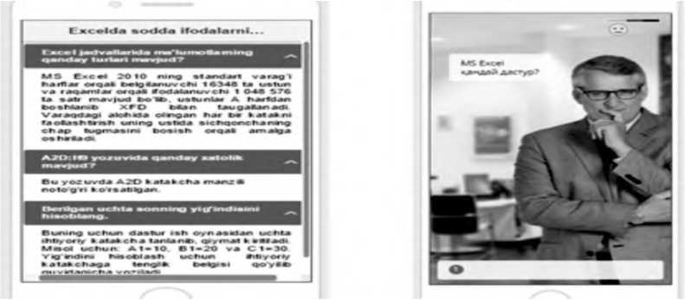

- picture A resource in the form of questions and answers on the screen of a mobile device. Students use electronic learning resources based on relevant topics given by In this system, you will get acquainted with the educational resources given in the course "Informatics and IT" on the topic "Calculation of simple expressions in Excel". These learning resources show how to work with items or resources such as questionnaires, chat, forums, glossaries, databases, quizzes, quizzes, and assignments.
For example, the student uses a question-and-answer resource on the topic "Calculation of simple expressions in Excel" using mobile technology. For this, the student chooses an educational resource and tests his knowledge as follows.
- What are the parts of Excel spreadsheets?
- A standard sheet of MS Excel 2010 has 16,348 columns designated by letters and 1,048,576 rows designated by numbers, with columns beginning with the letter A and ending with XFD. Each individual cell on the sheet can be activated by left-clicking on it.
- What is wrong with A2D recording?
- The A2D cell address is incorrect in this entry.
- Calculate the sum of the three given numbers.
- To do this, select three optional cells from the program window and enter a value. For example: A1=10, B1=20 and C1=30. To calculate the sum, put an equal sign in an optional cell and write as follows: =A1+B1+C1 or =10+20+30 is entered using the keyboard keys and the Enter key is pressed.
Also, on the basis of mobile education, students can effectively use publications in the form of "Dialog" for independent education in "Informatics and information technologies". To do this, you can learn by loading the dialogue included in the Moodle system on the topic "Calculation of simple expressions in Excel". The dialogue is interactive, the reader is asked a relevant question about the topic, and when the answer is given, the character's emotion changes. At the end of the dialogue, the student's answer is taken into account and the knowledge grade is announced.
Introduction of independent education of students in vocational colleges on the basis of the proposed mobile technology, full mastery of the science of "Informatics and information technologies" in the educational process and the integration of various organizational forms in education will improve the quality of education. increases, provides continuous learning.
- Examples of Distance Education in Developed Countries Understanding Distance Education
Basic concepts: distance education, subject, object, educational-material, financial-economic, regulatory and legal frameworks, marketing, Internet, methodological tools, textbooks, electronic library, electronic textbook, video conference, websites, texts and others.
In modern education system, distance learning is introduced as a convenient type of education.
Distance education is a form of obtaining information in which, in addition to full-time and part-time education, the preferred traditional and innovative methods, tools and forms of education based on computer and telecommunication technologies are widely used.
The components of distance education are as follows:
Teacher, student and communication.
In the distance education tool, a controlled educational process aimed at one goal is organized with the help of special opportunities, telephone, electronic communication and other educational tools based on an individual schedule in a place convenient for the student.
In distance education, on the basis of a certain goal, the interaction between the subject and the object of education is carried out with the help of educational tools.
The information process includes elements of a unique pedagogical system, such as: educational goals, educational content, educational methods and tools, organizational forms of education, control, educational material, financial and economic, regulatory and legal bases, marketing, etc.
The distance education system is based on the humanitarian principle. That is, no one should be deprived of the right to education due to poverty, geographical problems, social protection and other reasons.
In distance education, the teacher sends the educational material to the student through the "Internet" system. Students who want to study this course will access the website, get theoretical knowledge, complete practical tasks and send the answer to the teacher by e-mail. The teacher checks the assignment completed by the student and sends the file back to the student by e-mail. Gives necessary instructions if necessary.
During the learning process, the student uses textbooks, e-library and e-textbooks, video conferences.
Distance learning is independent study. In the period of independent study, the student develops independent thinking, self-control and management skills.
In distance learning, the faster the student mastered the given program, the faster he completed his studies and received a certificate of completion.
Methodological tools of distance education are:
- textbook,
- audio and video tutorials,
C) websites,
G) electronic libraries,
D) texts,
Ye) electronic textbooks.
Of course, the user must have a multimedia computer, modem and telephone for distance learning.
In the 21st century, distance education is entering the educational system as the most promising form of humanitarian education and education.
- century is also characterized by the introduction of global technology into the educational process. Because the requirements of the market economy require the improvement of the educational process at the level of world standards.
Nowadays, distance learning is developing as a widespread and convenient form of education in many developed countries of the world. For example, in the University of Oulu in Finland, London Metropolitan University in the United Kingdom, Fontis University in the Netherlands, and the Republic of South Korea, distance learning technology has been widely implemented, where it is effectively used in the field of improving the skills of students and other professionals. is getting married.
It goes without saying that this type of education is not a distant future for Uzbekistan, which is facing the world. That is why it is necessary to implement some reforms in educational institutions of Uzbekistan.
Modern technologies in education and distance education.
Information technology in teaching is a set of electronic tools used in teaching activities and methods of their use. Electronic tools include hardware, software and informational components. Instructions for their use are given in the methodological (methodological) support of information technology in teaching. .
Distance education is a humanistic form of teaching, based on the use of traditional, new pedagogical and information technologies. In this, technical tools serve for independent learning of educational material, communication between the teacher and the student. . Accordingly, distance education should rely on new technical means of communication and information processing and basic methods of correspondence education. This, in turn, gives an opportunity to talk about the organization of a distance education system. A distance education system is a complex complex of hardware, software and methodological tools, including servers and workstations, personal computers, communication tools, general system and network software support, management systems of local and centralized knowledge and information banks,
Methodological foundations of distance education system.
Openness and individual approach in organizing the educational process.
A centralized structure of the distance learning system, consisting of a center based on leading universities and a remote learning-consulting point.
Organization of a distance learning process with alternating contact and non-contact study periods. Connecting a teacher-consultant (tutor) with the qualities of a teacher, consultant and manager to a student.
Organization of remote and face-to-face communication of students with each other and with the teacher using modern technical tools, information technologies and traditional mail. We will consider the main principles of distance education system organization.
Humanistic principle of education. This principle is of decisive importance in the system of continuous intensive education, and its importance increases even more in the system of distance education.
Such training is aimed at satisfying people's need for education. Distance, health of people or other social reasons also create conditions that do not prevent them from getting knowledge.
The principle of the priority of pedagogical approaches in the organization of the educational process in the distance education system. In distance education, the priority of the pedagogical approach is ensured in the organization of the educational process, as in traditional education. Experience shows that the pedagogical approach of the system the efficiency of the system increases when the side is prioritized.
The principle of feasibility of using new information technologies from a pedagogical point of view. This principle requires a pedagogical evaluation of the effectiveness of each step in the organization and design of a distance education system. Therefore, it is not necessary to introduce technology, but to enrich educational courses with appropriate content, it is necessary to convey it to the student through new information technologies.
The principle of choosing the content of education: the content of distance education must meet the regulatory requirements of the state educational standards. Also, it is necessary to create alternative programs that create the opportunity to choose the content of education.
The principle of choosing information security: the principle of the initial level of education: In order to improve the effectiveness of education, certain basic knowledge and skills are necessary. The principle of appropriateness of the teaching technology. The teaching technology should be adequate for the distance education model. The distance education system should not have a feature contrary to the traditional education system. Distance education also preserves the educational content of the traditional education system. But its difference is in the creation of convenience for students.
Peculiarities of distance education process.
- Flexibility. The student is free regarding the time, size, etc. of the lesson.
- Modularity.
- Parallelism. Without separation from production.
4. Interaction.
- Didactic system of distance education.
Until now, the educational process in the existing didactic system included 7 elements: the goal of education, the content of education, teachers, students, the form, means and methods of education.
The didactic system of distance education includes 12 elements.
Table 3.1
the goal |  | Educational material
content | teachers | Control
Methods |  | Regulatory and legal
tools | students | economic
forms |  | marketing

Additional elements, i.e. educational material, control, normative-legal, economic, marketing, etc., are inconspicuously involved in the traditional didactic system, but for the pedagogical process it does not have the same principle importance as in distance education. .
Methods and tools of distance education.
Distance learning technology (DLT) is a special method, tool and system of organizational forms of teaching, aimed at multidisciplinary implementation of educational content.
Many teachers of higher educational institutions (except for teachers of pedagogy and didactics) are not very interested in the concept of "teaching method". Because most of the teachers study the teaching activity empirically. They mainly use teaching methods imitating department heads or leading professors. But they don't know or don't care which educational methods these methods are included in the system. Knowing the educational method is one of the important conditions for improving education. The educational method determines how to implement the teaching of various educational subjects. is a didactic category that provides a theoretical understanding of distance learning. Distance learning is carried out through various educational methods and several methods are used in it. Each method consists of specific actions aimed at achieving a specific goal with the help of various didactic teaching tools. When using distance learning methods, the following methods can be used: demonstration, illustration, explanation, story, conversation, exercise, problem solving, memorization of material, written work and repetition.
Distance learning, which includes pedagogically processed educational content, educational tools in the hands of the teacher and students perform the task of presenting educational content, checking and controlling the learning activities of students. . A particular learning material can be provided with a number of teaching aids (printed materials, audio-video, etc.). Each of the tools has its own didactic potential. The teacher should be aware of these possibilities and should be able to divide the educational material according to various tools, create a complex of educational tools from the educational materials as a system that carries educational information aimed at the implementation of didactic tasks. Distance learning system tools can include:
- Textbooks (traditional textbooks, electronic textbooks, manuals,
spravochniks, etc.).
- (computer) training manuals on the network;
3. Computer training in conventional and multimedia options
systems;
- Audio and educational information materials;
- Video educational materials;
- Remote laboratory practicums;
- Remote trainers;
- Remote information and knowledge base;
- Remote electronic libraries;
10. Educational tools based on teacher expert systems;
- Geo-informed systems-based learning tools;
- Virtual reality-based learning tools.
Teaching tools in the distance education system are implemented using new information technologies. We present the characteristics of the mentioned tools.
Textbooks. In the preparation of didactic printed materials, it should be based on the above. Study guides should be structured in such a way that the student can refer to additional educational information only in necessary cases. The module principle should be used in the organization of the structure of the educational material. Read more about independent mastering of the material and independent work. instructions should be given. The training manual should contain control tasks, questions and answers to check knowledge, and exercises. In general, educational materials should be based on the following structure (invariant according to the educational subject):
Introduction (historical subject of the program and specialty, relevance and place of connection with other subjects);
Course curriculum;
Purpose and objectives of the course;
Methodological instructions for independent mastering of the course; Contents;
The main material is organized by sections (modules); Tests, questions and problems with answers for studying by sections;
Final test;
Practical assignments for independent work;
Thematics for small scientific investigations;
Glossary of Terms;
List of abbreviations;
The final part;
list of references (main, additional, optional);
Hrestomatiya (textbooks on the subject of the course, scientific articles, examples of methods);
Brief creative biography of the author of the manual.
Information given in the literature should be colored;
Introduction - orange, dictionary of unfamiliar words - pink, text - black and white, keys to exercises - dark blue, self-check exercises - light yellow, assignments (tests) - green .
Internet technology in distance education This type of distance education is based on the effective use of global and local computer networks. Students will have the opportunity to use information and educational resources through this network.
In the introduction of Internet technologies in education, it is necessary to solve a number of organizational, technical, methodological and programmatic issues, as well as the management of the educational process. .
Teaching can be done autonomously. In this teaching technology, it is possible to organize interactive consultations between students and teachers by e-mail and exchange information with other information related to the educational process. Internet technologies in education include electronic textbooks, virtual stands, electronic based on the use of encyclopedias, animated multimedia complexes, as well as the introduction of a test method of controlling the knowledge of subjects. Telecommunication technologies - modern technical and informational means of telecommunications in the educational process to use based.Telecommunications
technology-based teaching requires the use of relatively expensive technical and software tools. In particular, the broadcasting of audio and video lectures to different audiences or computers at the same time through a satellite communication tool or telecommunication system creates opportunities for two-way real communication.
Table 3.2
Method of information transmission | Recovery ability
 | After 3 hours | After 3 days
Oral | 25% | 10-20%
Visual | 72% | 10%
Visual + verbal | 80% | 65%
Activation | 90% | 70%

Interactive whiteboard. Another achievement of modern computer technologies is the free use of the Internet system, and the ability to connect video conferences with information on simple whiteboards with interactive whiteboards. Interactive whiteboards produced on the basis of SMART technology provide users with convenience. That is, two
169
which can display high-resolution images with a layered grid on a large screen, the number of dots across the screen is 2000*2000, which allows you to display all the possibilities of the displayed image.
Interactive whiteboards, in turn, are produced in two forms: direct and reverse projection. The latest version of interactive whiteboards is designed in the form of a projection TV, where the projectors are located on the back of the board, which prevents light from falling into the eyes of the person conducting explanatory work.
Based on special programs, files are deleted, and then the information is saved in the form of an album.
There is also a feature to preview user-generated content or images. By pressing one of the buttons located at the bottom of the board, it will be possible to call up the necessary images using the keyboard, and it is also possible to write texts using the buttons located in the virtual state.
It should be noted that the computer must know the operation system of the interactive whiteboard in advance, the reason for this is that the image is directed to a place on the board and from this point it transmits the image using a multi-projector. Interactive whiteboards are mainly designed to work with three types of colors. lib, the board will display images in that color as soon as the user sets one of the color markers at the point where the beam is coming from.
Use of multimedia in the creation of training manuals. The most popular topic today is creating a multimedia project. Here, everyone can show their creativity, intelligence, knowledge, and fine taste. Unfortunately, it is impossible to prepare a multimedia project without the knowledge of presentation preparation and database creation, however, there are special software tools that can be used to learn the technology of their operation and have multifunctional tools. We'll teach you how to do just that with sample software tools.
It is not how you master the tools, but the technology of creating a multimedia product that is important. What is a multimedia product? It's a product that's very similar to a documentary, only available on PC. There is music, color effects, movement (animation), sound. What is the main thing in a multimedia product?
As with every movie, it's a script. You have to be a screenwriter, a director, an artist, and a cameraman at the same time. It is necessary to learn not only to come up with your topic, but also to present it in parts that fit the computer screen area. As a director and artist, you have to come up with every frame decoration and how they interact. A lot of preliminary work is required to create individual slides, fragments, databases. Only after that, you can begin to merge all the previously prepared fragments. When it comes to computer encyclopedias, e-textbooks, recreational and educational programs, etc., the main emphasis is now on the creation of multimedia products. What is a multimedia product? First, it is a software product that definitely provides interactivity to the user, that is, it provides an exchange of commands and answers between a person and a computer, and creates a dialogue environment. Second, it is an environment where various video and audio effects are used. It is very reminiscent of a video film that allows the viewer to choose one or another scenario. A multimedia product is an interactive, computer-generated product that can include streaming music, video clips, animation, picture and slide galleries, various databases, etc. Multimedia products can be divided into: Second, the environment in which various video and audio effects are used. It is very reminiscent of a video film that allows the viewer to choose one or another scenario. A multimedia product is an interactive, computer-generated product that can include streaming music, video clips, animation, picture and slide galleries, various databases, etc. Multimedia products can be divided into: Second, the environment in which various video and audio effects are used. It is very reminiscent of a video film that allows the viewer to choose one or another scenario. A multimedia product is an interactive, computer-generated product that can include streaming music, video clips, animation, picture and slide galleries, various databases, etc. Multimedia products can be divided into:
- encyclopedias;
- educational programs;
- mind development programs;
- programs for children;
-games.
In recent years, multimedia products have reached a level that can be purchased by a wide range of consumers. Their use is not always the same. When buying various multimedia equipment, you should pay attention to the following indicators:
- the quality and reliability of the given material;
- the quality of the given graphic material;
- sound accompaniment (text, music, etc.);
- availability of video material and their quality;
- interactivity possibilities (viewing in different directions, in-depth study of the material, possibility of printing, etc.);
-friendly interface.
Not every ready-made multimedia product meets these requirements, moreover, your personal interests may differ from the direction suggested by the authors. In this case, you can develop your own software product and create your own interface that exposes your chosen theme.
Despite the fact that the development of a multimedia product is a difficult and expensive process, not only programmers, but also many artists and designers are engaged in this fascinating work.
To create a multimedia product, the following can be involved:
- A demanding program to work with a team of skilled programmers.
- Instrumental tools ie Macromedia Director, Formula Graphics
Multimedia System, Multimedia Creator, Asymetrix ToolBook, AuthorWare Professional and other such special software products. Projects created in this form are somewhat cheap, therefore not universal, although the capabilities of the used instruments are limited, skilled users can work with such instruments. For educational purposes, multimedia products can be developed on the basis of Microsoft Office programs, preparation of material and additional programs such as PhotoShop (photo processing), Adobe Premier or Vstudio2 (video clip processing), Stoik Software (image processing and morphing), Phonograph Windows 95 (for sound recording and processing) are used for this.
A multimedia software product often finds content from accessible databases, such as Access or Works. Presentation of pictures or clips is done using PowerPoint. Hyper-references are used to create an interactivity mode, which helps to refer to a more complete explanation. First of all, you can create an educational multimedia project and develop lessons or thematic encyclopedias on the basis of it (music trends, favorite singers, famous artists, movie news, etc.). To do this, you need to have two types of software:
- preparation of material to be added to the multimedia product;
-creating the product itself.
General overview of software products for material preparation. The material added to the multimedia product can be provided in the form of images, audio and video recordings, and texts. These are different forms of information that have their own software tools that have the appropriate tools to work with. Below are relatively popular software products for various forms of information.
When working with graphic objects, two forms of activity should be distinguished: scanning and image creation (editing).
Scanning means the process of automatic reading of information from paper data carriers with the help of a special device - a scanner and entering it into the computer. The following software products are used to scan images.
- PhotoEditor is a program included in Microsoft Office that supports image scanning and performs some operations for preparing graphic materials (changing contrast, brightness, color, and image orientation).
- PhotoPaint is a program that allows you to scan an image and pre-process the material (correction, change color, change orientation, scale, saturation with gamma rays, etc.).
You are familiar with image creation and editing. Here is a brief description of the most common software tools:
- PhotoShop is a software product that allows you to process graphic files. This editing program works with many file formats (JPG, GIF, PSD, TIF, etc.), in addition to the standard processing of images, they can be modified with various filters (rotation, embossing, graininess, brightness level, etc.) allows to transfer.
- Stoik ArtMen is part of Stoik Software's software products and helps to process like drawings by various artists, for example, in watercolor, watercolor, engraving, enamel, etc.
- Paint is a standard graphic editor that allows you to change the image orientation, clean, cut the selected area. Only BMP and PCX files are recognized. Video processing.
Working with video recordings requires the pre-digitalization of the recorded image using a VCR. Converting an image to a digital form means changing the material from an analog form to a digital form that can be entered into a computer. To convert the image to digital form, the computer must be equipped with a special video card, a TV tuner and accompanying software. Digital video recording does not require a TV tuner, it is enough to have the following software products:
- Vstudio2 - used to convert video recordings from a VCR to digital; allows you to edit videos in different ways.
- Adobe Premier is a more complex software product that digitizes fragments and assembles them with many transitions between them. Adobe Premier can change the size of frames and their orientation (rotation, trajectory of frame movement).
- MorphMan is a program from Stoik Software that allows editing and morphing video footage. Morphing is the step-by-step transformation of one image into another.
This program can create morphing between individual video fragments along with static morphing. As a result of such processing, a video file with the AVI extension is created. Sound processing. Phonograph is a standard program of Windows 95 that allows you to record sound (from CDs, microphone and line) and to edit it (volume up/down, speed up/down, create an echo effect).
Text processing.
When working with text, some part of it can be entered into the computer directly using the keyboard, it is convenient to enter large unchanging texts using a scanner with the purpose of further processing using special software products. FineReader is a program that converts scanned materials into text for later editing in text editors. Review of programs for creating multimedia products - Macromedia Director - serves to create presentations and multimedia products. This program works with MMX technologies and allows you to work with buttons, slides, clips and animations. - Formula Graphics Multimedia System - provides interactive multimedia programs. The listed programs are expensive, therefore, they are rarely used among users. What needs to be done to develop multimedia projects at school, it is enough to use Microsoft Office programs, which have a wide range of capabilities. If you want to add a database to your project, you'll need Access, and if you want to create a presentation with animation effects, you'll need PowerPoint.
When developing a multimedia project, it is necessary to pay attention to some criteria in order to distinguish an excellent product from an average product. The first thing to consider is the topic of the project. It should be interesting to the majority of users, only then will this product become known. When choosing a topic, its relevance, acuteness of the issues under consideration, opportunities for creative and cultural development, and the degree of broadening of the worldview are considered very important. The second important thing in creating a project is its practical purpose, which will consist of:
- when displaying some information (for example, choosing your favorite singers);
- teaching some skills (for example, how to comb hair or cook);
- imparting knowledge in a certain area (for example, multimedia lessons on educational subjects or creating a reference book).
The third thing to pay attention to when creating a project is a well-written script and the quality of services provided during the work process. The demand for your project depends on the ease of working with the information you provide. The quality of graphics and video materials is the fourth important thing. The presence of video materials improves the assimilation of any information, and the high quality of graphics allows you to enjoy pictures and slides, the low quality causes discomfort and interferes with the assimilation of the material. This quality also applies to the texts involved in the project. Hyech is free of any spelling or stylistic errors. Timeliness, completeness and accuracy of information are also important.
- visual presentation of information;
- ease of entering information;
- ease of searching, viewing and selecting information;
- the possibility of using information from other software products; - possibility to edit the project (add or delete new information);
- nice interface that provides interactive mode.
When developing a multimedia project, it is necessary to maintain a certain sequence of work stages.
- stage. Choosing a topic and setting a problem.
After the topic is determined, it is necessary to write specific tasks for creating a multimedia product, where the goals and tasks should be specified.
- stage. Object analysis.
At this stage, it is considered what objects the project consists of, as well as by what parameters these objects are distinguished. If you are creating a multimedia encyclopedia of biology, you can consider a separate software product for each animal species as an object. When preparing a multimedia lesson, it is necessary to take into account the structural elements such as the explanatory part, working with materials, and the control part. After preparing a multimedia project, it is necessary to consider the individual characteristics of each object. This information can be placed in the form of separate records and tables.
- stage. Scenario development and model synthesis.
The sequence of working with the product in the development of the scenario,
it will be necessary to consider the possibility of changing the job and leaving it (terminating the job). In order to prevent accidents, it is important to calculate them, as well as check the degree of multivariability of the work, that is, the possibilities of achieving the same result in different ways. In the script, the workflow should include sound accompaniment, for example, the text on the screen should be accompanied by music or any sound. In this case, it is necessary to take into account that neither this nor this interferes with the work and does not tire. If the program's capabilities allow, you can also consider turning off the sound. Using the results of the second stage analysis, it is necessary to choose a specific model of the future project.
- stage. The form of information presentation and the choice of software products. After the scenario is developed and the model is created, it is necessary to determine the software product for the realization of the project. At this stage, two different software products should be provided:
- project organizer: for graphic objects, audio and video recordings, preparation of texts and processing of materials;
-to create a multimedia product, that is, direct work tools.
After the selection of software tools, it is necessary to choose the form of information presentation and the instruments for its implementation. If your project includes a database prepared in the Access application, the information can be presented in the form of a table or form. Panel instruments or masters for creating shapes and buttons can serve as instruments. In PowerPoint, information is presented as individual slides or objects (text or graphics). PowerPoint uses animations, drawing, or the formatting panel as instruments.
- stage. Synthesis of the computer model of the object.
After selecting all the considered options, you can start implementing your project on the computer. When creating a computer model, you have to go through two more steps.
- stage. Preparation of materials for work. At this stage, graphic, text, audio, video materials are prepared using software products of your choice. When working with graphic information, pay attention to the fact that the higher the quality of the images you choose, the more space they will take up on the Winchester and computer memory, and the slower your product will work. When creating video clips, pay attention to frame sizes and data compression. When creating video clips with a frame size of the screen size, the file size is several megabytes. When the frame sizes are large and the compression is low, the display speed of the clip drops dramatically. The choice of this or that parameter depends on the capabilities of your computer.
Work on the preparation of materials requires a high level of skill that emerges through experience.
- stage. Multimediacreating a product. At this stage, a computer model of your multimedia project is created with the help of prepared materials and selected software tools. The next topic will be devoted to the review of the complete technology of these processes. VI stage. Working with multimedia products.
Now it is possible to work with your created multimedia product, that is, to view, search, select information.
The use of digital multimedia and new information technologies in the creation of electronic interactive educational guides and presentations is a powerful auxiliary tool in the educational process. The architecture of e-learning tools can vary depending on the teaching style.
A presentation or a film can fulfill the functions of providing information, knowledge, and demonstration as desired. Computer technologies make it possible to create virtual models similar to the real situation.
Computer graphics has gone from being a novelty to a necessity, but multimedia technologies are especially important in the design of various Web-presentations, including lectures, textbooks, and training manuals. They help to focus on a creative approach to creating a project. A teacher or course designer can offer visual materials of varying complexity when creating presentations. In addition, it is necessary to take into account the level of mental development of the participants, psychological stability and similar factors that affect the final product. And finally, perhaps the decisive factor - visual graphic animations and interactive developments give scope and charm to the work process.
Summarizing the approaches considered above, it can be noted that creating an electronic educational publication at a high scientific and methodological level is one of the ways to improve educational methods. The following main stages of designing an electronic educational publication can be distinguished:
-weaving the content model of educational materials;
- script development for the manual;
-creating scripts and algorithms for the training package.
Thus, in modern conditions, the information educational environment of an electronic educational publication can be a set of teaching tools. Its task is to strengthen a certain amount of new knowledge, to form skills and competencies.
Trends in the development of the distance education system in Uzbekistan The introduction of modern information and communication technologies into the educational process has led to the creation of a new form of education - distance education, in addition to traditional teaching methods. Modern technologies create a basis for the new organization of distance higher pedagogical education. In such education, pedagogues will need to create new training courses with the help of computer programmers and specialists. The modern education system requires the teacher to be ready for the distance education system, that is, to master advanced teaching technologies (Internet, Case, TV technologies, etc.). Automation of higher education institution management, introduction of information and communication technologies (ICT) into the educational process is one of the main directions of the "Program for the Comprehensive Development of the Higher Education System in 2017 - 2021" approved by the President of the Republic of Uzbekistan. At the same time, we can see that information systems have been introduced only in some activities of higher education institutions due to the lack of conceptual views in this direction that are compatible with the requirements of the 21st century. The complete informatization of the activities of the higher education institution was complicated due to the new reforms in the higher education system, which did not require the introduction of appropriate changes to some regulatory legal documents. For this, the first task of informatization will be the reengineering of existing processes. In this direction, South Korea, When studying the experience of countries such as Great Britain, Denmark, and Russia, the main goal of informatization is primarily aimed at improving the quality of education, and in the next place, by automating processes, improving the activities of employees and professors of higher education institutions. It aims to save time spent on repetitive tasks. In improving the quality of education, the main focus is on creating educational content and organizing their open use. Distance education (D) uses different educational models, but they all have one thing in common, which is that all students and teachers are separated by distance. Like all types of education, there are different models of MT. These are the following main components of the educational process: description of the content of the subject; direct and indirect communication with teachers; execution of practical assignments; will consist of monitoring and evaluating student knowledge. Each model uses similar content and technologies that implement it. Different models of MT differ not only in the technologies used, but also in the level of management, teacher and student responsibilities. In some models, the teachers and the educational institution completely retain the function of managing the educational process, just as it is taught in the classrooms of the traditional education system. In other types, the control of the learning is transferred to the learners. A historical analytical study of scientific sources has shown that many authors have focused on the creation of distance learning models, including
- The team led by S. Polat presented the following 6 models in their monographs.
Currently, these six models of distance learning are being used in educational institutions of developed countries around the world:
Externship type teaching. Teaching in this form has the following advantages: firstly, it allows efficient use of time for talented students; secondly, specialists who feel the need to improve their skills and are working in this direction directly in practice will be given the opportunity to improve their skills for a short period of time. As an example of a higher education institution providing education in the form of an externship in the distance method, it is possible to highlight the University of London.
University MT model. Subjects in the curriculum of the educational fields available in this university are taught through the technical means of MT organized on the basis of ICT. In this case, the e-books prepared by the relevant departments for each subject and continuously enriched are delivered to students through various types of information carriers, and students' learning is monitored by these departments. The priority of this form is that electronic books created on the basis of advanced technologies are widely used for full-time and other forms of education at this university. The use of e-books prepared on the basis of a single program in various forms of such education leads to the deepening of students' knowledge and gives great economic benefits. As an example,
MT model based on cooperation of several higher education institutions. E-books and manuals created in cooperation with several educational institutions are, on the one hand, scientifically perfect and of better quality, and on the other hand, they cost a little less economically. MT in this form was developed by the English-speaking countries of the European continent under the program "Cooperation in education" (Commonwealth of education - 1997) in cooperation with Great Britain. As a result, citizens of English-speaking countries in Europe have the opportunity to study at universities and colleges of these countries through a specially organized MT telecommunication system.
MT models organized in cooperation with specialized educational institutions. Such specially organized systems are intended for correspondence and distance learners and operate as a result of extensive use of new educational technologies. In this form, in addition to the telecommunication system, multimedia courses are widely used, and as a result, in addition to teaching students, the opportunities for evaluating and certifying their knowledge are expanded.
The advantages of this form from the economic point of view are as follows: electronic textbooks prepared on the basis of a single program are used in several cooperative educational institutions; allows students studying in different forms of education (full-time, part-time, distance) on the basis of a single program to use electronic books prepared in the relevant subjects; the generalization of assessment and certification of student knowledge in the program saves training hours and additional costs; The costs of creating MT programs and e-books are shared among several educational institutions operating in cooperation; this aspect, of course, serves to reduce the value of distance learning contracts.
Autonomous training model. Training programs of this form are organized on the principle of independent learning and are based on television and radio broadcasting. Radio and telelections broadcast via satellite are the main teaching aids in teaching students. In this case, facilities are created for specialists to improve their skills and acquire additional specialties without being separated from production. An example of such a system is the American television project. The main disadvantages of this model are the high cost of the information transmitted by satellite and the need for students to be at the center in their place of residence at a certain time. In other words, this method of imparting knowledge depends on a specific time and specific place.
An informal, integrated teaching model based on multimedia programs. The MT system in this form is mainly one of the programs that do not require the need to contact teachers or educational institutions for independent professional development, acquisition of additional specialization and language learning. consists of, is a means of learning through computer and teleradio systems and is rarely used in the higher education system. R. Taning and I. Seinon studied the models developed in foreign educational institutions using MO' technologies and distinguished the following three MT models. Advice model. Model of official correspondence (correspondence). Guided independent learning model. In the monograph of TPVoronina, VPKashitsin, OPMolchanova, four models of MT are considered: traditional surface,
All of the models below assume that potential consumers of educational services, media, radio and television, or other educational institutions have been selected, screened, and have all necessary documentation. These are: external education, education on the basis of one university, models of autonomous educational institutions established for the purpose of special distance education, MT models recognized by UNESCO:
Below are three models of MT. Of course, they do not represent all approaches to MT. But they represent two extreme cases and a middle case, representing a shift in educational management from teacher to student.
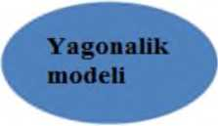

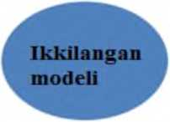

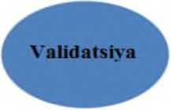
MT
niodaellari

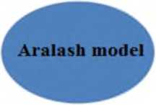
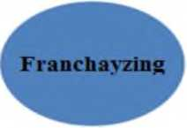
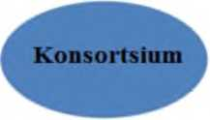

- picture autonomous education organized for the purpose of distance learning
models of institutions
Distributed audience model. This model focuses on the delivery of a course designed for a class, group, composed of students living in different locations, using interactive telecommunication technologies. As a result, a mixed class is formed, combining traditional learners and MT learners. Specifications of this model:
- classes require synchronous communication, that is, students and teachers must be at a certain time, in a certain place (for example, at least twice a week);
- the number of participants varies from one to five and more, the more the number of participants, the more technical, logical and educational complexity increases;
- study places for students can be arranged not at the school, but at home or at the workplace;
- educational institutions adapted to serve students living in remote areas;
Independent learning model. In this model, students are not held responsible for being in a specific place at a specific time. Students with a set of materials representing the detailed program and content of the course
they are provided and have the opportunity to contact the teacher who evaluates the work by answering the supervisor's questions. Communication between the student and the teacher is carried out using the telephone, computer conferences, e-mail and regular mail. Specifications of this model:
- classes are not held in the auditorium, students study subjects (courses) independently based on detailed instructions in the program;
- students communicate with the teacher only at certain specified times, and with other students at desired and specified times;
- all course materials are provided in the form of printed publications, computer disks or video recordings, and students will be able to use them at any time and in any place;
- course materials are used for several years. These materials will be created with the participation of course organizers, experts and specialists and will be used by all teachers in a common way.
V. Open education +Classroom model. This model focuses on the use of printed course text and other media (such as videotapes or computer disks). This gives the student the opportunity to study the course using interactive telecommunication technologies that facilitate the organization of student communication within a distance group. Specifications of this model:
- all course materials are provided in the form of printed publications, computer discs or video recordings, and students can use them individually or in groups at their discretion;
- course materials are used in more than one semester and differ for each teacher (for example, his video lecture);
- the students and the teacher gather from time to time to practice. It uses interactive technologies (according to the distributed class model);
- classroom activities are organized for students to clarify basic concepts, develop problem-solving skills, work in groups and perform other tasks.
A video conference system based on optical communication networks has been launched, connecting the branches of Tashkent Medical Academy and Tashkent State Pedagogical University in Termiz, as well as branches of Termiz State University in Denov.
"Uzbektelecom" JSC has developed a set of necessary software and organizational resources for a fast and high-quality internet-based videoconferencing system. This system, covering six facilities, consists of 24 special computers, 24 web cameras and microphones, and 48 speakers of a special model, and 48 wide-format screens. The leading professors and teachers of the university had the opportunity to learn from experts. Also, the current system provides rapid delivery of new knowledge and experiences, connection and exchange of experience with other universities, increasing the economic efficiency of education, audio-video in the educational process. , animation, extensive use of graphics,
Through the distance education system, it is possible to improve the quality of personnel training, create opportunities for distance training for students, and bring different interactive forms of education closer to each other.
Control questions:
- What is the importance of hardware and software when using cloud data center resources?
- What are the advantages of a software-configurable network-based architecture of a cloud data center?
- Explain the importance of virtualization technology in cloud computing systems?
- What do you mean by Virtual Private Network?
- Explain about hypervisor with monolithic scheme?
- What are the cloud technology models and the process of creation?
- Cloud computing in business processes
- The practice of using cloud technologies
- Working on Google Drive
- Google Drive Security and Privacy
- What are Dropbox's state-of-the-art data protection methods?
- Functionality of Google Drive
- What are the methods of effective organization of independent education in M-learning?
- About M-learning opportunities
- Give an insight into the Moodle system?
- An understanding of distance learning
- Internet technology in distance education
- Development trends of distance education system in Uzbekistan
- Give an insight into autonomous learning model?

PRACTICAL
EXERCISES

REPUBLIC OF UZBEKISTAN
MINISTRY OF HIGHER AND SECONDARY SPECIAL EDUCATION

ANDIJAN INSTITUTE OF MECHANICAL ENGINEERING

"TECHNOLOGICAL PROCESS MANAGEMENT AND
FACULTY OF COMPUTER SYSTEMS

"INFORMATION TECHNOLOGY"
department

"Cloud technologies and database"
from science

Methodical instructions for practical training

5330200 – Information systems and technologies (by industries and sectors)

Andijan 2022

ON TOPICS OF PRACTICAL TRAINING IN SCIENCETABLE OF CONTENTS

1 | Subject area analysis. Defining requirements in services.
2 | MBi creation processes.
3 | Development of a comparative table of cloud services.
4 | MB models.
5 | Moving data from one place to another in the "Cloud".
6 | Choosing a virtualization solution.
7 | File-server and Client-server technologies.
8 | Connecting "Cloud" with mobile devices.
9 | The concept of developing a new service based on cloud computing.
10 | Development of new cloud computing based service using IBM Cloud, Windows Azure, Amazon Cloud and other platforms.
11 | Designing an MB
12 | Searching for on-demand online Cloud computing services.
13 | stages.
14 | Implementation of cloud services.
15 | Relational models of MB, basics of relational models.
16 | Classes of databases.

APPLICATIONS

REPUBLIC OF UZBEKISTAN
MINISTRY OF HIGHER AND SECONDARY SPECIAL EDUCATION

ANDIJAN INSTITUTE OF MECHANICAL ENGINEERING

"I APPROVE"

Rector of the Institute

___________ UMTurdialiyev

2022 "___" ____________

CLOUD TECHNOLOGIES AND DATABASES
SCIENCE CURRICULUM

Field of knowledge: | 300000 | - Production technical field
Field of study: | 330000 | - Computer technologies and  informatics
Course of Study: | 5330200 | - Information systems and technologies (by networks and sectors)

Andijan - 2022

The science curriculum was approved by the report of the Scientific Council of the Andijan Mechanical Engineering Institute dated "___"_________, 2022 and approvedby the Rector of the Andijan Mechanical Engineering Institute on"___"_________, 2022.

Developers:
1. Kh. Sarimsakov - Associate Professor of the "Information Technologies" Department of AndMI, Candidate of Economic Sciences
2. MM Yuldashev - trainee teacher of the "Information Technologies" department of AndMI.

Reviewers:
- M. Yusupov - head of the "Information Technologies" department of the AndMI, technical department Doctor of Philosophy
- Mirzakarimov.B. - Professor of the "" department of Fergana branch of TATU, doctor of economic sciences.

I._ Relevance of educational science and its role in higher professional education

One of the main subjects of the information technology field is Cloud technologies and database science. The main goal of cloud technologies and database science is to form students' knowledge about cloud technologies and database-based services. In the near future, cloud technologies and database-based services will be the most acceptable alternative to installing hardware and software. At the end of the course, students study current cloud technologies and database-based services and their differences from previous services, make a comparative conclusion, and develop a new cloud-based technology and database service.

II. The purpose and tasks of educational science

The purpose of teaching scienceis to introduce students to cloud technologies and database services and teach them how to use them in the modern world. During the training course, computer techniques, modern techniques for decision-making (in some cases optimal) in several different information systems: industrial, social, financial, robotics, etc. are considered. cloud technology and database science include society and various fields. The subject also studies search engines, intelligent systems, and service-oriented systems from a practical and theoretical perspective.
The tasks of the subjectare to teach students the theoretical foundations of cloud technologies and databases, the basic concepts and categories of cloud technologies and databases, economic laws and principles, and to develop the ability to apply them in practice.
The following requirements are set for the knowledge, skills and qualifications of students in science:
The student should know:
- cloud technologies and database able to understand the basic concepts of the theory;
- cloud technologies and database understand the basic concepts used in their applications;
- b they can use the knowledge of cloud computing to analyze the problem, formulate a solution and find its solution in the processes of computing the national technologies and database;
- cloud technologies and database they can learn how concepts appear in their theory and applications;

III. The main theoretical part (lecture sessions)

Topic 1. Organization of cloud technologies
Development of cloud technologies in Uzbekistan. Services provided by cloud infrastructure. The process of emergence of cloud technologies.
Topic 2. Creation and models of cloud technology
enables management of services in the field of IT services and Internet products. The introduction of a single platform for providing all types of cloud service services with advanced technologies opens the new data processing center to the possibilities of diversification of the product portfolio and wide opportunities that ensure the unquestionable superiority of the Uzbektelecom company in the market.
3rd topic. Cloud computing
Cloud computing. The development of cloud computing on a global scale.
4 - topic. Principles of cloud computing ecosystem development
A cloud ecosystem. SLA-based cloud computing organization features. Cloudy pyramid.
5. Advantages and disadvantages of cloud technologies
Advantages of using cloud technologies. Disadvantages of using cloud technologies
Topic 6. Cloud service provision
Private cloud. Community cloud. Public cloud. Learning to organize a cloud education system
7th topic. Effective organization and management of cloud infrastructure components
These include data storage, Amazon S3, virtual server rental, provision of computing resources, Amazon EC2. Amazon S3 online web service
8 subjects. Cloud infrastructure modeling
Cloud infrastructure modeling. Imitation approaches
Simulation models in the study of complex systems
9 - topic. Implementation of effective configuration of resources within SLA
SLA (Service Level Agreement), Service Quality The loss of organizational control is mainly due to human factors that create barriers to cloud computing.
10 - topic. A method of effective organization of network resources in cloud infrastructure
Load balancing (load balancer) located in the cloud system. In computers, load balancing is the distribution of the load among several computing resources, such as computers, networks, CPUs, or disks.
11 - topic. Oracle VM VirtualBox software
Concept of virtuality. The current reality in the world is new urgent issues and the need to solve them effectively
1 2 topics. Service models and key delivery providers
(SaaS) – software as a service.
SaaS-type provider - manages software placed in the cloud infrastructure, reliable operation
1 3 topics. Analysis of existing threats in cloud technologies and mechanisms to combat them
Cloud management and control - the main security issues All resources, virtual machines in cloud technologies.
1 4 topics. Hardware and software tools in cloud technologies, their application and application
Basic confirmation of hardware downtime, processing of confidential information in corporate networks, advantages of using hardware, quality assurance, reliability and endurance in the work process
15 topics. Comparative analysis of information threats and methods of combating them in cloud technologies
Functional attacks on cloud elements. This type of attack is common security with multi-layered cloud. Protection against functional attacks, DoS - providing effective protection against attacks,
1 6 topics. Features of cloud technology
Cloud technology models and the process of emergence
Cloud technologies. The importance of "virtualization" technologies in the emergence of cloud computing.
17 subjects. Features and capabilities of Google Drive
(Google Drive is a cloud hosting where files can be stored.
An overview of the Dropbox application
18 subjects. Mobile training. M-learning
Organization of independent education in M-learning. Effective organization of independent education.

19 topics. of "Database management systems".
goals and objectives
and tasks of science. Understanding of data bank. Database components. The database is the core of the data bank.
20 - topic. Informational aspects of the management system
The information aspects of the organization's management system, the process of information movement and re-formation, a set of blocks that make up the work structure of the management system. The control system in which the HIGH-level control unit and the external environment unit are described.
21 - topic. The methodology of constructing an informational model
Structure of processes and their composition in MBs. Database and its structure. MBiniz design stages. MBi creation processes.
22 - topic. Methodology of constructing an informational model
Information is a general understanding of the logical model. Sample MAMM. Information object of the subject field. Information objects. Information object structure. Functional dependencies of props.
23 - topic. Organizational work in creating a database
Organization of data in the machine environment has two stages - logical and physical. A method of placing data directly on the machine carrier. Organization of data using modern application programs. In applications and universal software tools, the user, as a rule, organizes data logically.
24 - topic.MB structure and classes
Classes of databases. Structure of centralized databases. Learning distributed databases. File-server and Client-server technologies.
25 - topic.A general definition of relational MBBT
Relational model data structures. Relational tables. Domain and tuples. Definition and basic concepts. Relational table - relationship. The schedule is the key to the relationship.
26 - topic.Database design in MBBT environment
Independent information array. Database. A database that is used by one person and many people. Tools for organizing and maintaining the information base inside the machine. Software tools for organizing and maintaining an information base.
27. In an MBBT environment based on inventoried files
database design
should have structured and semantic information. Structured information depends on the appearance of relationships. Semantic information is a set of functional connections between the relational attributes expressed in the schema.
28 - topic.Database in MBBT using hierarchical model design
Network and hierarchical data model. Data structure in models. Relationship of objects in models. Features of the models. Comparison of models.
29 - topic. Creating a MB using a relational model
Work with tables. Identify key fields. Database normalization. Normal forms. 1,2,3 -normal forms. Defining data types. Connecting tables to each other
30. Basics of SQL query language
SQL Query Language Concept, SQL Query Language Basics, SQL Query Structure, Basic Concepts of SQL Query Language. Basic command categories in the SQL query language.
31. Implementation of relational model in MS ACCESS MBBT environment
Access data type. Work with tables. Constructor tables window. Identify key fields. Select and sort records using queries. Sample request. Creation of queries using "Master" and constructor.
32. Implementation of relational model in MS ACCESS MBBT environment
Determining the areas to be counted. Creating complex queries. Creating forms for data entry. Automated creation of forms using a table or query.
IV. Instructions and recommendations for practical training
The following topics are recommended for practical training:
- Subject area analysis. Defining requirements in services.
- MBi creation processes.
- Development of a comparative table of cloud services.
- MB models.
- Moving data from one place to another in the "Cloud".
- Choosing a virtualization solution.
- File-server and Client-server technologies.
- "Cloud" with mobile devices.
- The concept of developing a new service based on cloud computing.
- Development of new cloud computing based service using IBM Cloud, Windows Azure, Amazon Cloud and other platforms.
- Designing an MB
- Searching for on-demand online Cloud computing services.
stages.
- Implementation of cloud services.
- Relational models of MB, basics of relational models.
- Classes of databases.
- Structure of centralized databases.
- Learning distributed databases.
- Developing a security policy in the Cloud
- MBBT Basic Concepts.
- Principles of operation of MBBT.
- Types of MBBT.

Practical training should be conducted by one professor-teacher per academic group in an auditorium equipped with multimedia devices. It is desirable that the classes are conducted using interactive methods and the necessary pedagogical and information technologies are used.

V._On laboratory works instructions and recommendations.
Advantages and Disadvantages of MBBTs
VI.On the course work (project). instructions and recommendations.
The coursework (project) in science is not indicated in the curriculum

V II. Independent education and independent work

Recommended topics for independent study:
1. Google Cloud system
2. iCloud system
3. Mail.ru cloud
4. Microsoft One Drive system
5. AWS cloud service
6. MEGA cloud service
7. Cloud.uz service
8. Microsoft Azure
9. Yahoo service
10. Amazon cloud service.
11. Organizational work in creating a database.
- A general definition of relational MBBT. Language tools.
- Database design in MBBT environment.
- Database design in MBBT environment based on inventory files.
- Database Design in Hierarchical MBBT.
- Implementation of relational model in MS ACCESS MBBT environment.
Students prepare and defend a Power Point presentation on independent study topics.

VIII. Basic and additional educational literature and information sources

Basic literature

1. Decision No. PK-1730 dated March 21, 2012 of the President of the Republic of Uzbekistan on "Further development of measures to support modern information and communication technologies".
2. Cloud computing - Chris Jamsa - Jones & Bartlett Publishers - 2011 - 322p.
3. Cloud computing: Principles and Paradigms - Raj Kumar Buyya, James Bromberg, Andrzej M. Goscinski - John Wiley & Sons - 2010 - 664p.
4. Cloud computing – Velte – McGraw-Hill Education (India) Pvt Limited – 2009.
5. Cloud computing: Technologies and Strategies of the Ubiquitous Data Center - Brian JS Chee, Curtis Franklin Jr. – CRC Press – 2010 – 288 p.
6. Cloud computing: Principles, Systems and Applications - Lee Gillam - Springer - 2010 - 400p.
7. Online Cloud Computing Education -http://cloud.cit.ie/
8. Cloud computing Blog –http://cloudcomputing.blogspot.com/
9. Cloud computing bibl e - Barry e Sosinsky, Wil ey Publishing, Inc., Indianapolis, Indiana, USA, 2011.
10.Cloud computing - Chris Jamsa - John es & Bartl e tt Publish e rs - 2011 - 322p.
11. Cloud computing: Principles and Paradigms - Rajkumar Buyya, Jam es Bro e rg, Andrz ej M. Goscinski - John Wil ey & Sons - 2010 - 664p.
12. Cloud computing – World – McGraw -Hill Education (India) Pvt Limited ed - 2009
Additional literature
1. Constitution of the Republic of Uzbekistan - T.: Uzbekistan, 2014. - 46 p.
2. "Infrastructural information and communication technology management" (ICT Infrastructure Management) - Publication 2002. _ _ _ _ _ _ _ (OG C )
3. Cloud computing: Technologies and Strategies of the Ubiquitous Data Center - Brian JS Chee, Curtis Franklin Jr. – CRC Press – 2010 – 288 p
4. Cloud computing: Principles, Systems and Applications - Lee Gillam - Springer - 2010 - 400p.
5. Professor Charles Fine Massachusetts Institute of Technology Sloan School of Management Cambridge, Massachusetts 02142, September 2010, Service Operations 6. Outline scope of services for the role of information management, CIC/INF MAN/S ﬁrst edition 2013.
Internet site
1. www.ziyonet.uz
2. www.library.tuit.uz
3. www.intuit.ru
4. http://www.searchengines.ru
5. http://e-tuit.uz
6. www.ibm.com/cloud-computing/us/en/
7. www.windowsazure.com
8. http://cloud.cit.ie/
9. http://cloudcomputing.blogspot.com/
10. http://gov.uz – the government portal of the Republic of Uzbekistan.

REPUBLIC OF UZBEKISTAN
MINISTRY OF HIGHER AND SECONDARY SPECIAL EDUCATION

ANDIJAN INSTITUTE OF MECHANICAL ENGINEERING

Registered:  No. _  2022 years "_____" ________ | "I CONFIRM"  On academic work vice rector of the university ___________S. Aliyev  2022 years "__" _________

CLOUD TECHNOLOGIES AND DATABASES
WORKER OF SCIENCE TRAINING PROGRAM

Field of knowledge: | 300,000 – Production and technical sector
Field of study : | 330000 – Computer technologies and informatics
Field of study : | 5330200 – Information systems and technologies  (by networks)

General education _ hours |  | 248 hours | 5th semester _ | 6th semester _
That's it including :
Lecture | – | 64 hours | 32 hours | 32 hours
Practical training | – | 64 hours | 32 hours | 32 hours
Laboratory exercises _ | – | - | - | -
Independent education hour | – | 120 hours | 60 hours | 60 hours

Andijan - 2022
curriculum of science wasreviewedand approved in the minutes of the meeting of the Scientific Council of the Andijan Institute of Mechanical Engineering dated "____" _____________ , 2022.

The working curriculum of the Andijan Institute of Mechanical Engineering is educational and methodological. It was approved by the statement of the Council of Ministers No. "___" dated "___" ___________, 2022.

Developers:
1. Kh. Sarimsakov - Associate Professor of the "Information Technologies" Department of AndMI, Candidate of Economic Sciences
2. MM Yuldashev - trainee teacher of the "Information Technologies" department of AndMI.

Reviewers:
1. M. Yusupov - head of the department of "Information Technologies" of AndMI, technical department Doctor of Philosophy
2. U. Sobirov - AndMI "Automation of mechanical engineering production"
associate professor of the department, candidate of economic sciences.

Educational - methodical department _ boss : _
202 2 years "____"_____________ _______________________ A. Akhmedov
(signature)

AndMI « Management of technological processes and computer
systems » faculty dean:
202 2 years "____"___________ _______________________ M. Sherboyev
(signature)

Head of the "Information Technologies" department:
202 2 years "____"_____________ _______________________ M . Yusupov
(signature)

I._ Relevance of educational science and its role in higher professional education
One of the main subjects of the information technology field is Cloud technologies and database science. The main goal of cloud technologies and database science is to form students' knowledge about cloud technologies and database-based services. In the near future, cloud technologies and database-based services will be the most acceptable alternative to installing hardware and software. At the end of the course, students study current cloud technologies and database-based services and their differences from previous services, make a comparative conclusion, and develop a new cloud-based technology and database service.
II. The purpose and tasks of educational science i
The purpose of teaching the subjectis to install and configure the existing instruments and applications for students to create programs for mobile devices in creating different from services use and setting, abstract and anonymous from classes use, mobile in applications program work efficiency increase, knowledge, skill and skill formation.
The task of the subjectis to teach students the theoretical foundations of cloud technologies and databases, the basic concepts and categories of cloud technologies and databases, economic laws and principles, and to create the ability to apply them in practice.
The following requirements are set for the knowledge, skills and qualifications of students in science:
The student should know:
- able to understand the basic concepts of cloud technologies and database theory;
- understand the basic concepts used in cloud technologies and database applications;
- they can use cloud computing knowledge to analyze the problem, formulate a solution and find its solution in cloud technologies and database computing processes;
- they can learn how concepts appear in the theory and applications of cloud technologies and databases;

III. M lecture classes
Table 1
No | M lecture topics | Size of lesson hours
5th semester
1 | Organization of cloud technologies | 2
1.1. | Development of cloud technologies in Uzbekistan.
1.2. | Services provided by cloud infrastructure.
1.3 | The process of emergence of cloud technologies.
2 | Creation and models of cloud technology | 2
2.1. | ActivePlatfom innovative design IT services and service management in the field of Internet products
2.2 | Introduction of a single platform for providing all cloud service services
3 | Cloud computing | 2
3.1. | Cloud computing
3.2. | The development of cloud computing on a global scale
4 | Principles of cloud computing ecosystem development | 2
4.1. | A cloud ecosystem
4.2. | SLA-based cloud computing organization features
4.3 | Cloudy pyramid
5 | Advantages and disadvantages of cloud technologies | 2
5.1. | Advantages of using cloud technologies
5.2. | Disadvantages of using cloud technologies
6 | Cloud service provision | 2
6.1. | Private cloud
6.2. | Community cloud. Public cloud. Learning to organize a cloud education system
7 | Effective organization and management of cloud infrastructure components | 2
7.1. | Storage of information from cloud infrastructure components
7.2. | Amazon S3, rental of virtual servers, provision of computing resources
7.3. | Amazon EC2. Amazon S3 online web service
8 | Cloud infrastructure modeling | 2
8.1. | Cloud infrastructure modeling
8.2. | Imitation approaches
8.3. | Simulation models in the study of complex systems
9 | Implementation of effective configuration of resources within SLA | 2
9.1. | SLA (Service Level Agreement)
9. 2. | Quality of service Organizational control
10 | A method of effective organization of network resources in cloud infrastructure | 2
10.1. | Load balancing (load balancer) located in the cloud system.
10.2. | Load balancing a number of computing resources on computers
10.3. | load sharing between computers, networks, central processors or disks
11 | Oracle VM VirtualBox software | 2
11.1. | Concept of virtuality
11.2. | Current reality in the world
11.3. | Dolzarb issues and the need to effectively solve them
12 | Service models and key delivery providers | 2
12.1. | (SaaS) – software as a service
12.2. | SaaS type provider
13 | Cloudy in technologies there are threats and against them to fight mechanisms analysis | 2
13.1. | Cloud management and control are key security concerns
13.2. | All resources in cloud technologies
14 | Hardware and software tools in cloud technologies, their application and application | 2
14.1 | Basic confirmation of hardware interruptions
14.2 | Processing of confidential information in corporate networks
14.3 | Advantages of using hardware
15 | Comparative analysis of information threats and methods of combating them in cloud technologies | 2
15.1 | Functional attacks on cloud elements.
15.2 | This type of attack is common security with multi-layered cloud
15.3 | Protection against functional attacks
15.4 | DoS - providing effective protection against attack
16 | Features of cloud technology | 2
16.1 | Cloud technology models and the process of emergence
16.2 | Cloud technologies.
16.3 | The importance of "virtualization" technologies in the emergence of cloud computing
17 | Features and capabilities of Google Drive | 2
17.1 | (Google Drive is a cloud hosting where files can be stored
17.2 | An overview of the Dropbox application
18 | Mobile training. M-learning | 2
18.1 | Organization of independent education in M-learning
18.2 | Effective organization of independent education.
19 | The purpose and tasks of the science "Database management systems". | 2
19.1 | The purpose and tasks of science.
19.2 | Understanding of data bank.
19.3 | Database components
19.4 | The database is the core of the data bank.
20 | Informational aspects of the management system | 2
20.1 | Information aspects of the management system of the organization
20.2 | The process of information movement and re-formation
20.3 | The work structure of the management system
21 | The methodology of constructing an informational model | 2
21.1 | Structure of processes and their composition in MBs
21.2 | Database and its structure.
21.3 | MBiniz design stages
22.4 | MBi creation processes.
22 | Methodology of constructing an informational model | 2
22.1 | Information is a general understanding of the logical model
22.2 | Sample MAMM. Information object of the subject area.
22.3 | Information objects
22.4 | Information object structure.
23 | Organizational work in creating a database
23.1 | Organization of data in the machine environment has two stages - logical and physical
23.2 | A method of placing data directly on the machine carrier
23.3 | Organization of data using modern application programs
24 | MB structure and classes | 2
24.1 | Classes of databases
24.2 | Structure of centralized databases
24.3 | Learning distributed databases
24.4 | File-server and Client-server technologies.
25 | A general definition of relational MBBT | 2
25.1 | Relational model data structures
25.2 | Relational tables
25.3 | Domain and tuples
25.4 | Definition and basic concepts
26 | Database design in MBBT environment | 2
26.1 | Independent information array
26.2 | Database
26.3 | A database that is used by one person and many people
26.4 | Tools for organizing and maintaining the information base inside the machine
27 | Database design in MBBT environment based on inventory files | 2
27.1 | In the relational database of the data, the scheme should also be structured
27.2 | Structured information depends on the appearance of relationships
27.3 | Semantic information is the relationship expressed in the schema
28 | Database in MBBT using hierarchical model design | 2
28.1 | Network and hierarchical data model.
28.2 | Data structure in models
28.3 | Relationship of objects in models
29 | Creating a MB using a relational model | 2
29.1 | Work with tables
29.2 | Identify key fields
29.3 | Database normalization
30 | Basics of SQL query language | 2
30.1 | SQL query language concept
30.2 | Basics of SQL query language
30.3 | Structure of SQL queries
31 | Implementation of relational model in MS ACCESS MBBT environment | 2
31.1 | Access data type
31.2 | Work with tables
31.3 | Constructor tables window
32 | Implementation of relational model in MS ACCESS MBBT environment | 2
32.1 | Determining the areas to be counted
32.2 | Creating complex queries
32.3 | Creating forms for data entry
32.4 | Automated creation of forms using a table or query
Total: |  | 64

M lecture sessions are held in an auditorium equipped with multimedia installations for a stream of academic groups.

IV. Practical training
Table 2
T/r | Topics of practical training | Size of lesson hours
5th semester
1 | Subject area analysis. Defining requirements in services. | 4
2 | MBi creation processes. | 4
3 | Development of a comparative table of cloud services. | 4
4 | MB models. | 4
5 | Moving data from one place to another in the "Cloud". | 4
6 | Choosing a virtualization solution. | 4
7 | File-server and Client-server technologies. | 4
8 | "Cloud" with mobile devices. | 4
6th semester
9 | The concept of developing a new service based on cloud computing. | 4
10 | Development of new cloud computing based service using IBM Cloud, Windows Azure, Amazon Cloud and other platforms. | 4
11 | Designing an MB | 4
12 | Searching for on-demand online Cloud computing services. | 4
13 | stages. | 4
14 | Implementation of cloud services. | 4
15 | Relational models of MB, basics of relational models. | 4
16 | Classes of databases. | 4
 | Total: | 64

Practical classes are held separately for each academic group in an auditorium equipped with multimedia facilities. Classes are conducted using active and interactive methods, "Case-study" technology is used, the content of the cases is determined by the teacher. Visual materials and information are transmitted using multimedia structures.

V. Laboratory exercises
Laboratory training in this subject is not provided

VI. Independent education
Table 3
No | Independent study topics | Size of lesson hours
5th semester
1 | Google Cloud system | 4
2 | iCloud system | 4
3 | Mail.ru cloud | 4
4 | Microsoft One Drive system | 4
5 | AWS cloud service | 4
6 | MEGA cloud service | 4
7 | Cloud.uz service | 4
8 | Microsoft Azure | 4
9 | Yahoo service | 4
10 | Amazon cloud service. | 4
11 | Organizational work in creating a database. | 4
12 | A general definition of relational MBBT. Language tools. | 4
13 | Database design in MBBT environment. | 4
14 | Database design in MBBT environment based on inventory files. | 4
15 | Database Design in Hierarchical MBBT. | 4
16 | Implementation of relational model in MS ACCESS MBBT environment | 4
Total: |  | 64

It is recommended to prepare abstracts and present them by students on subjects to be mastered independently.

Coursework in this subject is not provided for in the curriculum of the field of study

VII. Criteria for monitoring and evaluating student knowledge in science
Monitoring and evaluation of students' knowledge of subjects at the Andijan Institute of Mechanical Engineering in accordance with the Decree of the President of the Republic of Uzbekistan dated June 5, 2018 No. in accordance with the decision of the Minister of Higher and Secondary Special Education of the Republic of Uzbekistan dated August 9, 2018 No. 19-2018 It is carried out on the basis of the "Regulation on the control and evaluation system of students' knowledge in higher education institutions", approved and registered by the Ministry of Justice of the Republic of Uzbekistan on September 26, 2018 with No . 3069.

Evaluation methods | Oral survey, test, interview, control work, homework check, written work, presentations and other similar forms.
B populationcriteria | 5 - "Excellent" grade  - The student makes independent conclusions and decisions;  - can think creatively;  - conducts independent observation;  - can apply the acquired knowledge in practice;  essence of science (topic) andwhen it is considered that he has an idea about science (topic) - he is evaluated with 5 (excellent) grade.  4 - "Good" grade  - The student observes independently;  soulapplythe acquired knowledge in practice;  essenceof science (topic) and when it is considered that he has an idea about science (topic) - he is evaluated with 4 (good) grade.  3 - "Satisfactory" grade  soulapplythe acquired knowledge in practice;  - understands, knows, can express, tell the essence of science (topic) and when it is considered that he has an idea about science (topic)-he is evaluated with 3 (satisfactory) grade.  2 - "Unsatisfactory" grade  - When it is consideredthat the student has not masteredthe science program, does not understand the essence of the science (topic) and does not have an idea about the science (topic) - he is evaluated with a grade of 2 (unsatisfactory).
 | Types of assessment | Max. price | Transfer and q ti _
 | Intermediate control  Intermediate control (conducting the ON type and evaluating the student's knowledge according to this type of control is carried out by the professor-teacher who conducted the training in the subject).  - termcontrol is held during the semester after the completion of the relevant section of the work science program in order to assess the student's knowledge and practical skills. Depending on the nature of the subject, the type of midterm examination can be conducted up to 2 times, and the form and duration of the examination are determined by the department based on the nature of the subject and the hours allocated to the subject. When evaluating a student according to the type of interim control, the grades he received during the training sessions are taken into account.  wasevaluated with a "2" (unsatisfactory) grade for this control type will not be included in the final control type. | 5 | 9-16 _ week
 | Final control  Conducting the final control typeand evaluating the student'sknowledge on this type ofcontrol is carried out by a professor-teacher who did not conduct the training.  The form of conducting the final inspection is determined based on the nature of the subject, hours allocated to the subject. | 5 | 18-19 weeks
 | Written work, oral, test, etc | 5

VIII. Basic and additional educational literature and information sources

Basic literature

- Cloud technologies. Study guide. TEDelov. -Tashkent: 2020 -217 p.
2. Patrick Niemeyer, Daniel Lake Learning Java / 2014.
3. Cruz Zapata. Android Studio Essentials Belén 2013.
4. Ted Hagos. "Learn Android Studio 3 with Kotlin" 2015.
5. J. Zdziarski. "iPhone SDK Application Development". Saint Petersburg. 2010.

Additional literature

- Android Programming Tutorials 2013.
- Adam Sinicki. Learn Unity for Android Game Development 245 pages
- Matt Neuburg. iOS 12 Programming Fundamentals with Swift

Internet site

1.https://intuit.ru/studies/courses/493/349/lecture/8337
2. https://www.fandroid.info/
3.https://developer.android.com/
- https://covde.oksei.ru/user/view.php?id=5&course=167 – for Android
- https://www.w3schools.com/java/default.asp– website about programming languages
- https://udacity.com. - online platform

GLOSSARY

Amazon web services- (AWS) is a cloud-based web services infrastructure provided by Amazon.
AnyLogic- a simulation program developed by anyLogic.
Authentication -Password protection, tokens and certificates are the focus for greater reliability.
An administrator is a specialist who has extensive rights to adapt and manage electronic information-educational resources.
Animation is a method of organizing graphic information that gives the opportunity to express dynamic and sound processes.
Asynchronous communication - means of communication (forum, e-mail) that provide the opportunity to exchange information with a delay in time.
cloud-When used by information technologies, it is a technology, infrastructure that provides services through the Internet.
Cloud configuration is the process of setting up the hardware and software information for the elements of the cloud environment so that they can work and communicate with each other.
Cloud Consumer Account -that the provider automatically executes the report of used resources.
Cloud Ecosystem -is a term used to describe a complex system of interrelated components that work together and enable a cloud service.
Cloud computing- Provides easy access to servers, storage, databases, and a wide range of software services on the Internet, and is a distributed computing technology in which computer resources are made available to the user as an Internet service.
Cloud Pyramid Infrastructure -it is a set of physical devices (servers, hard drives, etc.). In addition, a "platform" is a collection of services and advanced software at the request of users.
Cloud technologies- as a model, presents IT as a service to the consumer via the Internet.
Community cloud- cloud computing in the infrastructure can be used only by a separate team, (department) of the organization.
Dropbox -today's widely used Internet system for organizing cloud services.
Hypervisor is one of the key elements for virtual systems.
Infrastructure-as-a-Service- Infrastructure service includes equipment used to support operations, including storage, hardware, servers, and network components.
Load balancer- Load balancer distributes the load between computing resources.
Information storage and processing center -(English data center) is considered a specialized architecture, consisting of servers (hosting) and network facilities, to which users connect using Internet channels.
Distance learning- is independent study. In the period of independent study, the student develops independent thinking, self-control and management skills.
M-learning- mobile equipment (phone or pocket computer) with WAP, GPRS or 3G technologies (the main one is access to the Internet) technology of knowledge acquisition and exchange;
Paint- a standard graphic editor that allows you to change the orientation of the image, clean it, cut the selected area. Only BMP and PCX files are recognized. Video processing.
PhotoEditor- a program included in Microsoft Office that supports image scanning and performs some operations for preparing graphic material (changing contrast, brightness, color and image orientation).
PhotoPaint- a program that allows you to scan the image and pre-process the material (correction, change color, change orientation, scale, saturation with gamma rays, etc.).
Platform as a service- platform as a service model, platforms for developers can include operating systems, programming languages, application testing environments, databases, and web servers. Configuration and management of all elements is the responsibility of the providers.
Public cloud (public cloud) - the infrastructure has the possibility of wide public use of cloud computing services.
Quality of Service-Quality of service has been considered one of the most important topics in the entire development of the telecommunications industry.
Self service on demand - the consumer determines and changes the billing requirements as needed without contacting the provider.
Service Level Agreement- an agreement that defines the level of services provided by the cloud provider.
Software as a service -In the software-as-a-service distribution model, applications are hosted by vendors or service providers and made available to customers over the Internet. Allowing software configuration users.
Stoic ArtMen- Stoik Software belongs to the range of software products and helps to process like drawings by various artists, for example, in watercolor, watercolor, engraving, enamel, etc.
Network virtualization is a technology for representing the real physical means of the data transmission network in the form of a logical network. There are two types of network virtualization:
Virtual reality- is an artificially generated information environment, which is aimed at replacing the usual perception of the environment with information generated on the basis of various technical means.
VirtualBox is a free program for creating virtual machines. Virtualization is a way to share computer resources
Virtuality- the term is derived from the Latin word "virtualis", which means "a process that happens or can happen under certain conditions", or does not exist, but has the possibility of happening. means names.
Virtual laboratory- a software package with the possibility of remote access and presentation of the processes occurring in real objects under study through computer simulation.
Virtual audience- to connect students living in different geographical places with the help of network technology to get the advice of the teacher and manager of the educational process.
Infrastructure as a service is a corporate solution for a wide range of enterprises. The infrastructure can be located in the data processing center, and in the external data center.
Private cloud- the infrastructure is used within a single organization to implement cloud computing.
1. Diagram of Figure 10.
Now that it's a little more clear, I think the profit scheme is pretty simple. However, in general, the cloud is a type of mash that performs calculations without the direct participation of your computer's resources, servers and other units. Maybe we all have a screen with only one microprocessor, and all the calculations and power allocation are done, that is, first, talking and computers close to the power, going back and doing so.
GLOSSARY
Amazon web services- (AWS) is a cloud-based web services infrastructure provided by Amazon.
AnyLogic- a simulation program developed by anyLogic.
Authentication -Password protection, tokens and certificates are the focus for greater reliability.
An administrator is a specialist who has extensive rights to adapt and manage electronic information-educational resources.
Animation is a method of organizing graphic information that gives the opportunity to express dynamic and sound processes.
Asynchronous communication - means of communication (forum, e-mail) that provide the opportunity to exchange information with a delay in time.
cloud-When used by information technologies, it is a technology, infrastructure that provides services through the Internet.
Cloud configuration is the process of setting up the hardware and software information for the elements of the cloud environment so that they can work and communicate with each other.
Cloud Consumer Account -that the provider automatically executes the report of used resources.
Cloud Ecosystem -is a term used to describe a complex system of interrelated components that work together and enable a cloud service.
Cloud computing- Provides easy access to servers, storage, databases, and a wide range of software services on the Internet, and is a distributed computing technology in which computer resources are made available to the user as an Internet service.
Cloud Pyramid Infrastructure -it is a set of physical devices (servers, hard drives, etc.). In addition, a "platform" is a collection of services and advanced software at the request of users.
Cloud technologies- as a model, presents IT as a service to the consumer via the Internet.
Community cloud- cloud computing in the infrastructure can be used only by a separate team, (department) of the organization.
Dropbox -today's widely used Internet system for organizing cloud services.
Hypervisor is one of the key elements for virtual systems.
Infrastructure-as-a-Service- Infrastructure service includes equipment used to support operations, including storage, hardware, servers, and network components.
Load balancer- Load balancer distributes the load between computing resources.
Information storage and processing center -(English data center) is considered a specialized architecture, consisting of servers (hosting) and network facilities, to which users connect using Internet channels.
Distance learning- is independent study. In the period of independent study, the student develops independent thinking, self-control and management skills.
M-learning- mobile equipment (phone or pocket computer) with WAP, GPRS or 3G technologies (the main one is access to the Internet) technology of knowledge acquisition and exchange;
Paint- a standard graphic editor that allows you to change the orientation of the image, clean it, cut the selected area. Only BMP and PCX files are recognized. Video processing.
PhotoEditor- a program included in Microsoft Office that supports image scanning and performs some operations for preparing graphic material (changing contrast, brightness, color and image orientation).
PhotoPaint- a program that allows you to scan the image and pre-process the material (correction, change color, change orientation, scale, saturation with gamma rays, etc.).
Platform as a service- platform as a service model, platforms for developers can include operating systems, programming languages, application testing environments, databases, and web servers. Configuration and management of all elements is the responsibility of the providers.
Public cloud (public cloud) - the infrastructure has the possibility of wide public use of cloud computing services.
Quality of Service-Quality of service has been considered one of the most important topics in the entire development of the telecommunications industry.
Self service on demand - the consumer determines and changes the billing requirements as needed without contacting the provider.
Service Level Agreement- an agreement that defines the level of services provided by the cloud provider.
Software as a service -In the software-as-a-service distribution model, applications are hosted by vendors or service providers and made available to customers over the Internet. Allowing software configuration users.
Stoic ArtMen- Stoik Software belongs to the range of software products and helps to process like drawings by various artists, for example, in watercolor, watercolor, engraving, enamel, etc.
Network virtualization is a technology for representing the real physical means of the data transmission network in the form of a logical network. There are two types of network virtualization:
Virtual reality- is an artificially generated information environment, which is aimed at replacing the usual perception of the environment with information generated on the basis of various technical means.
VirtualBox is a free program for creating virtual machines. Virtualization is a way to share computer resources
Virtuality- the term is derived from the Latin word "virtualis", which means "a process that happens or can happen under certain conditions", or does not exist, but has the possibility of happening. means names.
Virtual laboratory- a software package with the possibility of remote access and presentation of the processes occurring in real objects under study through computer simulation.
Virtual audience- to connect students living in different geographical places with the help of network technology to get the advice of the teacher and manager of the educational process.
Infrastructure as a service is a corporate solution for a wide range of enterprises. The infrastructure can be located in the data processing center, and in the external data center.
Private cloud- the infrastructure is used within a single organization to implement cloud computing.
1. Diagram of Figure 10.
Now that it's a little more clear, I think the profit scheme is pretty simple. However, in general, the cloud is a type of mash that performs calculations without the direct participation of your computer's resources, servers and other units. Maybe we all have a screen with only one microprocessor, and all the calculations and power allocation are done, that is, first, talking and computers close to the power, going back and doing so.
GLOSSARY
Amazon web services- (AWS) is a cloud-based web services infrastructure provided by Amazon.
AnyLogic- a simulation program developed by anyLogic.
Authentication -Password protection, tokens and certificates are the focus for greater reliability.
An administrator is a specialist who has extensive rights to adapt and manage electronic information-educational resources.
Animation is a method of organizing graphic information that gives the opportunity to express dynamic and sound processes.
Asynchronous communication - means of communication (forum, e-mail) that provide the opportunity to exchange information with a delay in time.
cloud-When used by information technologies, it is a technology, infrastructure that provides services through the Internet.
Cloud configuration is the process of setting up the hardware and software information for the elements of the cloud environment so that they can work and communicate with each other.
Cloud Consumer Account -that the provider automatically executes the report of used resources.
Cloud Ecosystem -is a term used to describe a complex system of interrelated components that work together and enable a cloud service.
Cloud computing- Provides easy access to servers, storage, databases, and a wide range of software services on the Internet, and is a distributed computing technology in which computer resources are made available to the user as an Internet service.
Cloud Pyramid Infrastructure -it is a set of physical devices (servers, hard drives, etc.). In addition, a "platform" is a collection of services and advanced software at the request of users.
Cloud technologies- as a model, presents IT as a service to the consumer via the Internet.
Community cloud- cloud computing in the infrastructure can be used only by a separate team, (department) of the organization.
Dropbox -today's widely used Internet system for organizing cloud services.
Hypervisor is one of the key elements for virtual systems.
Infrastructure-as-a-Service- Infrastructure service includes equipment used to support operations, including storage, hardware, servers, and network components.
Load balancer- Load balancer distributes the load between computing resources.
Information storage and processing center -(English data center) is considered a specialized architecture, consisting of servers (hosting) and network facilities, to which users connect using Internet channels.
Distance learning- is independent study. In the period of independent study, the student develops independent thinking, self-control and management skills.
M-learning- mobile equipment (phone or pocket computer) with WAP, GPRS or 3G technologies (the main one is access to the Internet) technology of knowledge acquisition and exchange;
Paint- a standard graphic editor that allows you to change the orientation of the image, clean it, cut the selected area. Only BMP and PCX files are recognized. Video processing.
PhotoEditor- a program included in Microsoft Office that supports image scanning and performs some operations for preparing graphic material (changing contrast, brightness, color and image orientation).
PhotoPaint- a program that allows you to scan the image and pre-process the material (correction, change color, change orientation, scale, saturation with gamma rays, etc.).
Platform as a service- platform as a service model, platforms for developers can include operating systems, programming languages, application testing environments, databases, and web servers. Configuration and management of all elements is the responsibility of the providers.
Public cloud (public cloud) - the infrastructure has the possibility of wide public use of cloud computing services.
Quality of Service-Quality of service has been considered one of the most important topics in the entire development of the telecommunications industry.
Self service on demand - the consumer determines and changes the billing requirements as needed without contacting the provider.
Service Level Agreement- an agreement that defines the level of services provided by the cloud provider.
Software as a service -In the software-as-a-service distribution model, applications are hosted by vendors or service providers and made available to customers over the Internet. Allowing software configuration users.
Stoic ArtMen- Stoik Software belongs to the range of software products and helps to process like drawings by various artists, for example, in watercolor, watercolor, engraving, enamel, etc.
Network virtualization is a technology for representing the real physical means of the data transmission network in the form of a logical network. There are two types of network virtualization:
Virtual reality- is an artificially generated information environment, which is aimed at replacing the usual perception of the environment with information generated on the basis of various technical means.
VirtualBox is a free program for creating virtual machines. Virtualization is a way to share computer resources
Virtuality- the term is derived from the Latin word "virtualis", which means "a process that happens or can happen under certain conditions", or does not exist, but has the possibility of happening. means names.
Virtual laboratory- a software package with the possibility of remote access and presentation of the processes occurring in real objects under study through computer simulation.
Virtual audience- to connect students living in different geographical places with the help of network technology to get the advice of the teacher and manager of the educational process.
Infrastructure as a service is a corporate solution for a wide range of enterprises. The infrastructure can be located in the data processing center, and in the external data center.
Private cloud- the infrastructure is used within a single organization to implement cloud computing.
1. Diagram of Figure 10.
Now that it's a little more clear, I think the profit scheme is pretty simple. However, in general, the cloud is a type of mash that performs calculations without the direct participation of your computer's resources, servers and other units. Maybe we all have a screen with only one microprocessor, and all the calculations and power allocation are done, that is, first, talking and computers close to the power, going back and doing so.
GLOSSARY
Amazon web services- (AWS) is a cloud-based web services infrastructure provided by Amazon.
AnyLogic- a simulation program developed by anyLogic.
Authentication -Password protection, tokens and certificates are the focus for greater reliability.
An administrator is a specialist who has extensive rights to adapt and manage electronic information-educational resources.
Animation is a method of organizing graphic information that gives the opportunity to express dynamic and sound processes.
Asynchronous communication - means of communication (forum, e-mail) that provide the opportunity to exchange information with a delay in time.
cloud-When used by information technologies, it is a technology, infrastructure that provides services through the Internet.
Cloud configuration is the process of setting up the hardware and software information for the elements of the cloud environment so that they can work and communicate with each other.
Cloud Consumer Account -that the provider automatically executes the report of used resources.
Cloud Ecosystem -is a term used to describe a complex system of interrelated components that work together and enable a cloud service.
Cloud computing- Provides easy access to servers, storage, databases, and a wide range of software services on the Internet, and is a distributed computing technology in which computer resources are made available to the user as an Internet service.
Cloud Pyramid Infrastructure -it is a set of physical devices (servers, hard drives, etc.). In addition, a "platform" is a collection of services and advanced software at the request of users.
Cloud technologies- as a model, presents IT as a service to the consumer via the Internet.
Community cloud- cloud computing in the infrastructure can be used only by a separate team, (department) of the organization.
Dropbox -today's widely used Internet system for organizing cloud services.
Hypervisor is one of the key elements for virtual systems.
Infrastructure-as-a-Service- Infrastructure service includes equipment used to support operations, including storage, hardware, servers, and network components.
Load balancer- Load balancer distributes the load between computing resources.
Information storage and processing center -(English data center) is considered a specialized architecture, consisting of servers (hosting) and network facilities, to which users connect using Internet channels.
Distance learning- is independent study. In the period of independent study, the student develops independent thinking, self-control and management skills.
M-learning- mobile equipment (phone or pocket computer) with WAP, GPRS or 3G technologies (the main one is access to the Internet) technology of knowledge acquisition and exchange;
Paint- a standard graphic editor that allows you to change the orientation of the image, clean it, cut the selected area. Only BMP and PCX files are recognized. Video processing.
PhotoEditor- a program included in Microsoft Office that supports image scanning and performs some operations for preparing graphic material (changing contrast, brightness, color and image orientation).
PhotoPaint- a program that allows you to scan the image and pre-process the material (correction, change color, change orientation, scale, saturation with gamma rays, etc.).
Platform as a service- platform as a service model, platforms for developers can include operating systems, programming languages, application testing environments, databases, and web servers. Configuration and management of all elements is the responsibility of the providers.

DISTRIBUTION MATERIALS

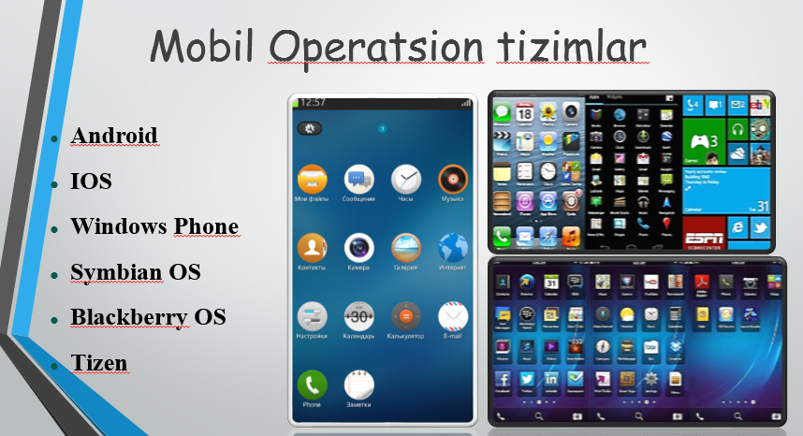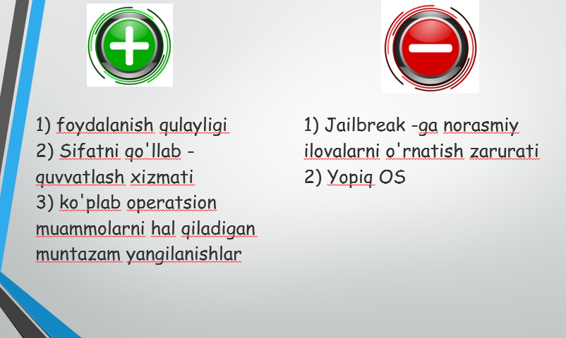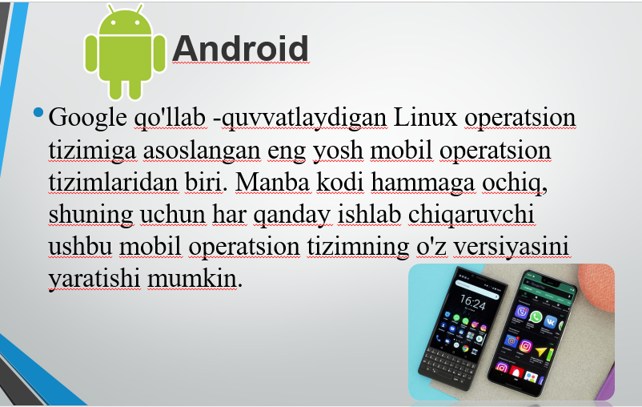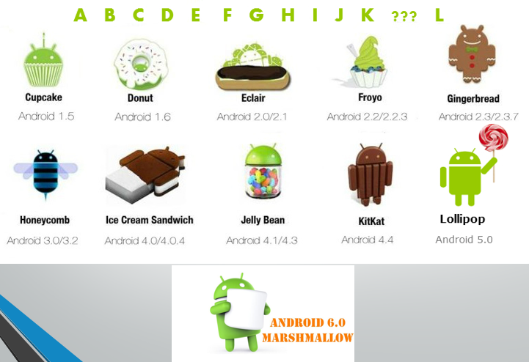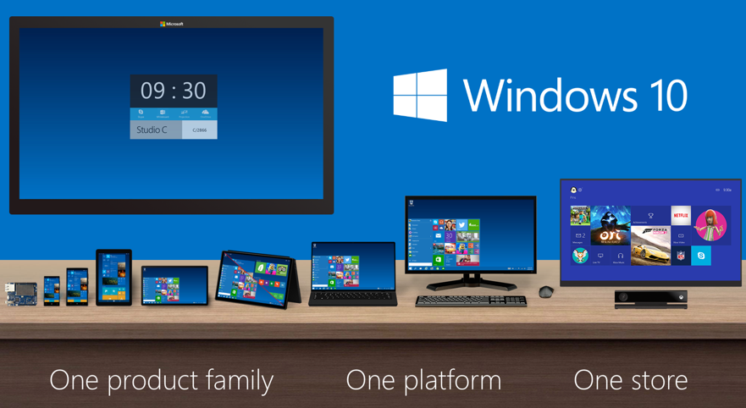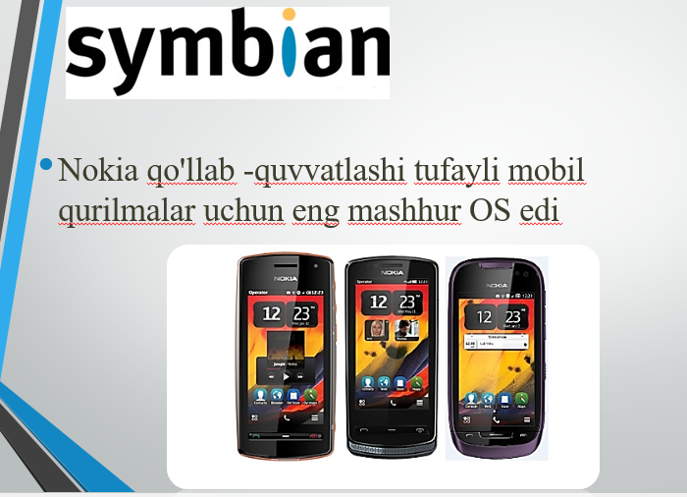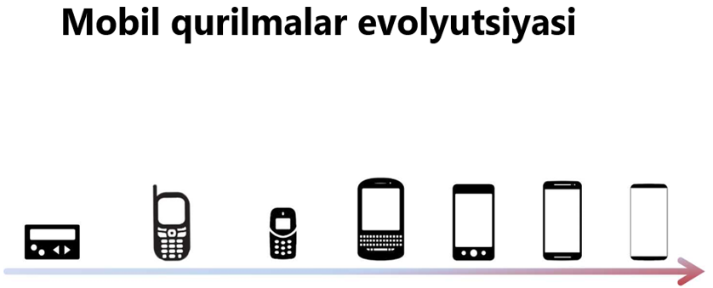

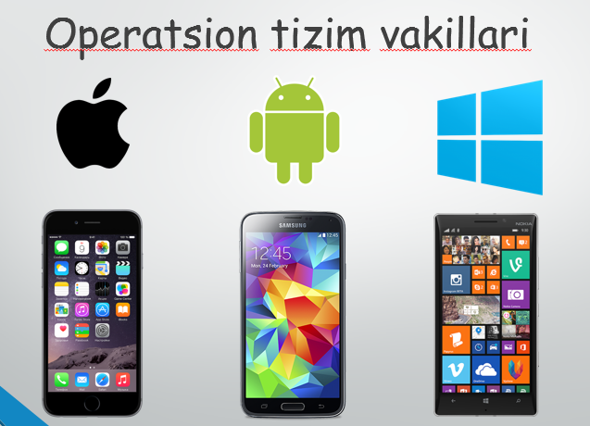
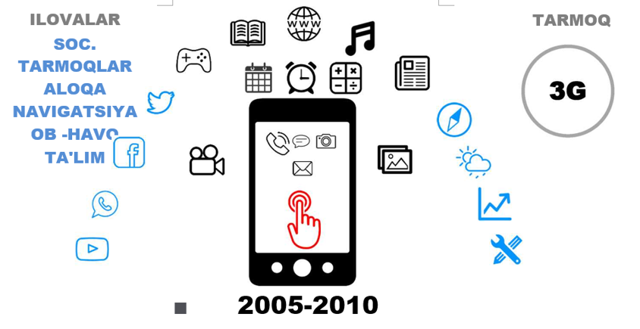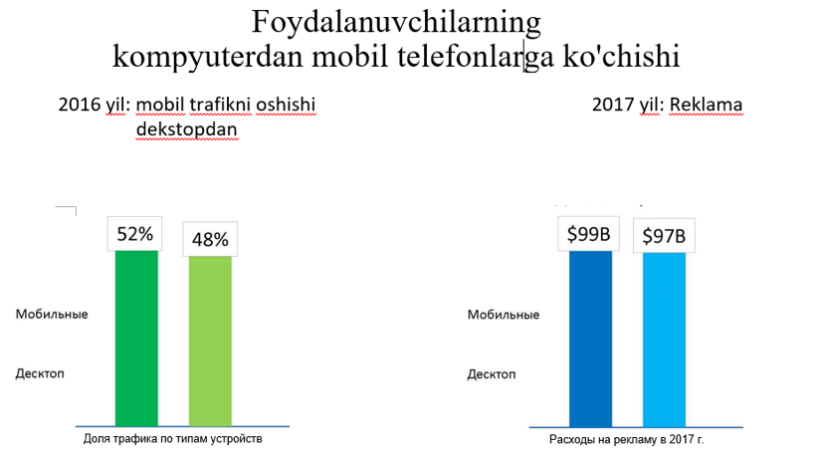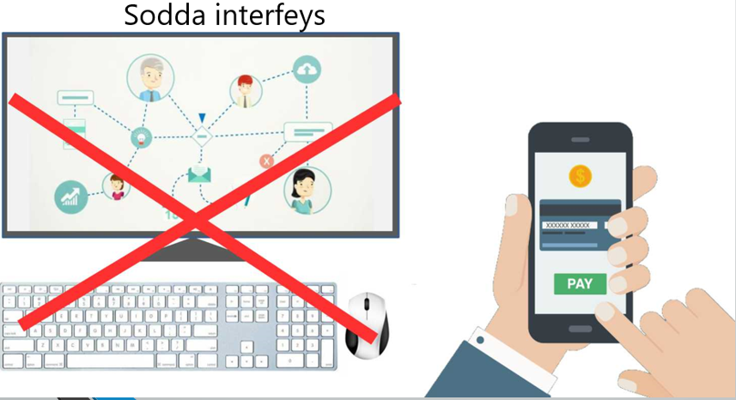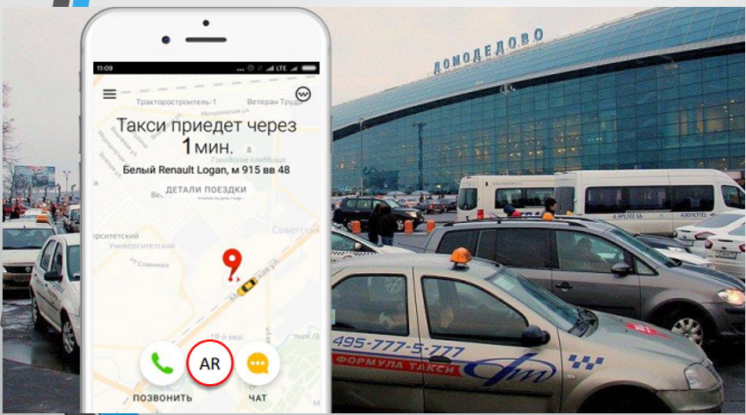
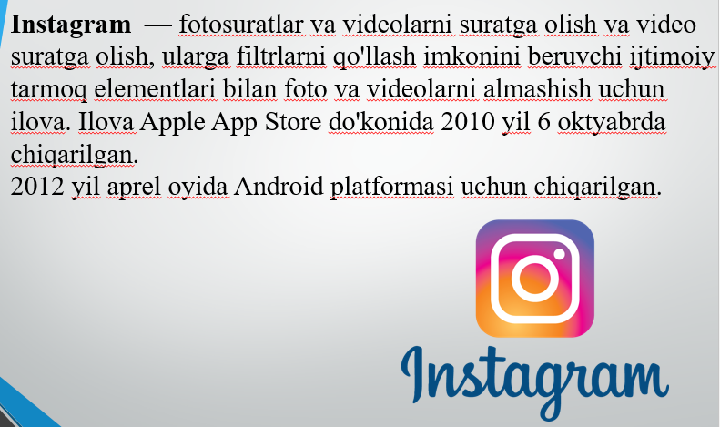 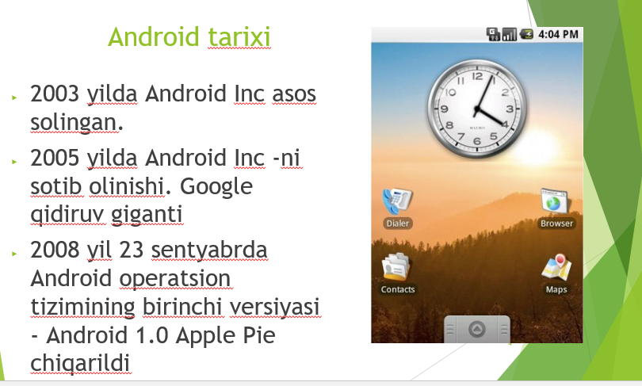 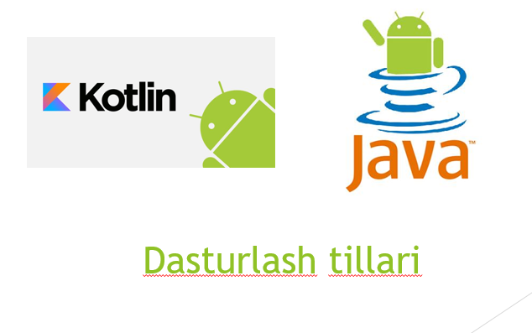 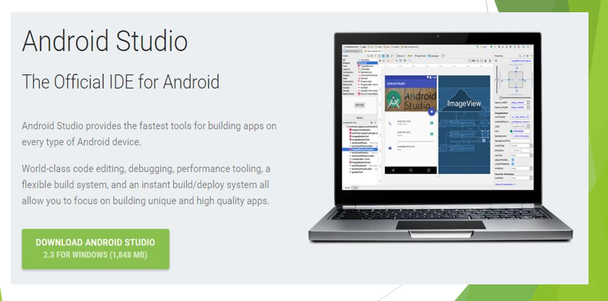 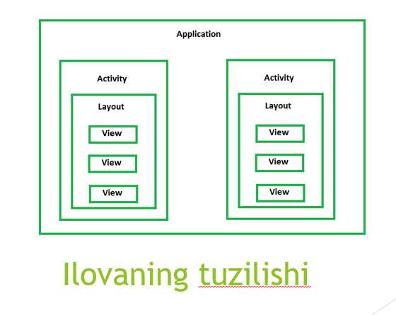 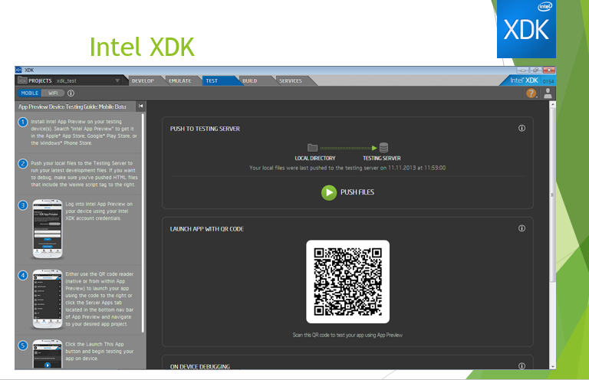 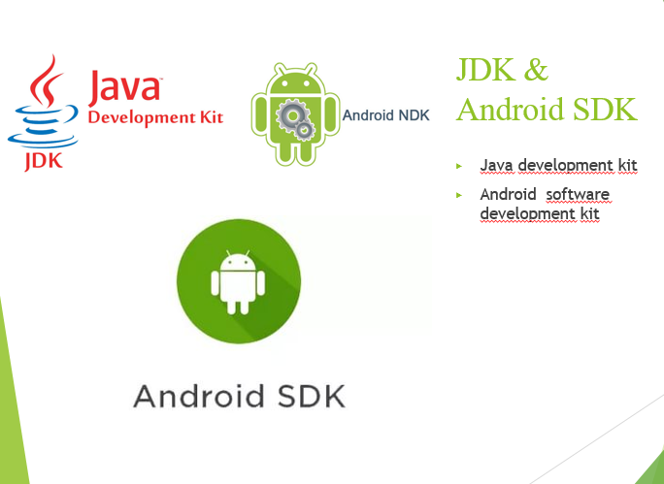 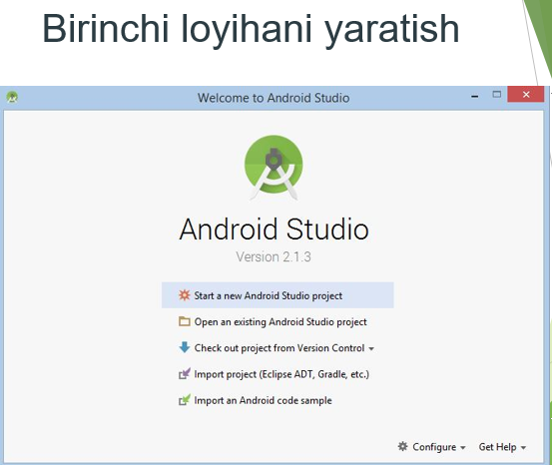 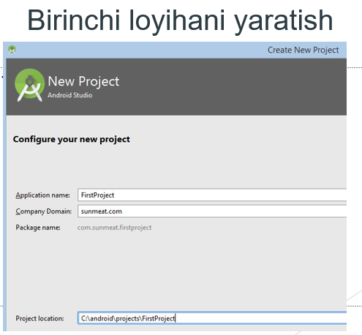 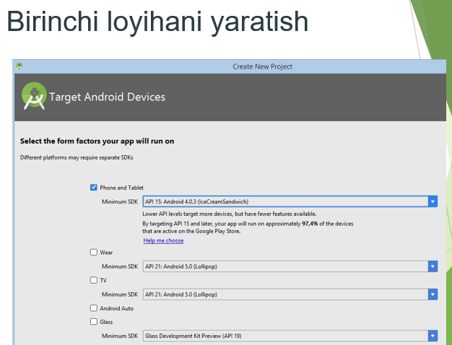 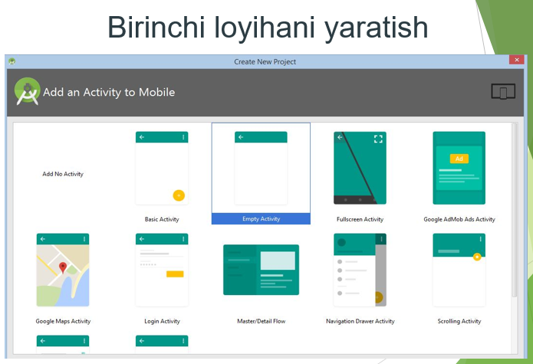 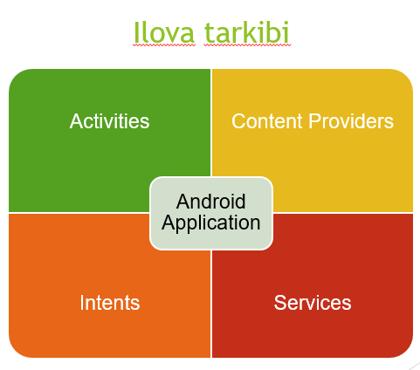 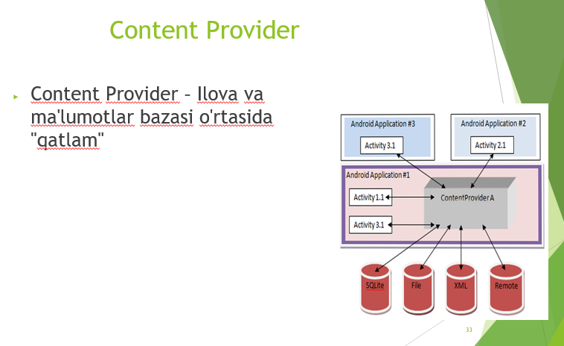 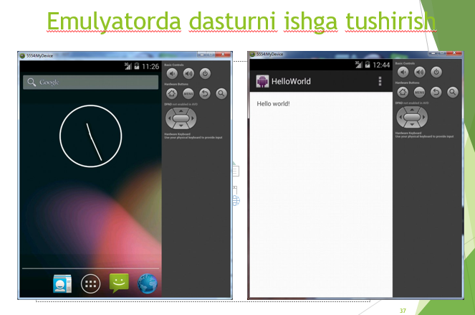 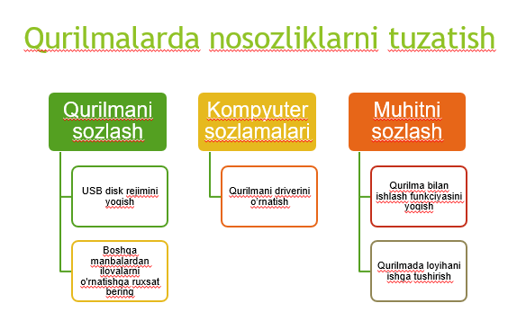 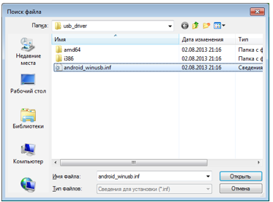 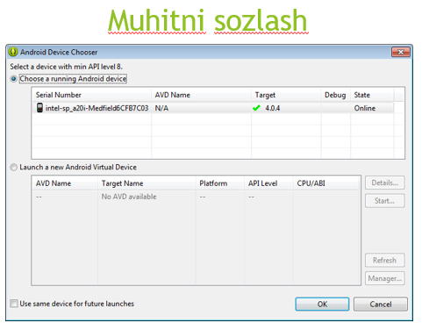p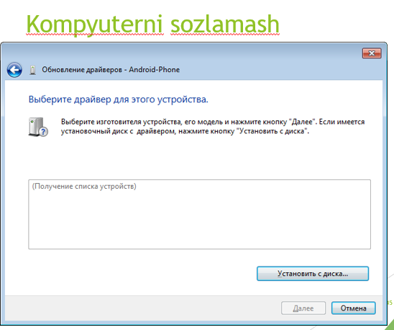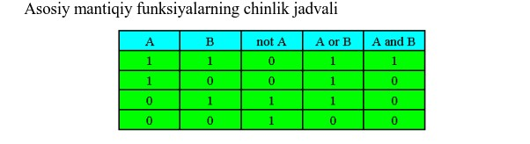

TEST and QUESTIONS

Questions from the subject "Creating software tools for mobile communication devices".

1) A set of programming tools that includes the tools needed to create, compile, and assemble a mobile application is called:
a) Android SDK
b) JDK
c) ADT plug-in
d) Android NDK

2) Unity-
a) It is a cross-platform environment for the development of computer games
b) It is a cross-platform software development environment
c) It is a cross-platform development environment of computer records
d) Computer presentations are cross-platform development environments

3) ProgressDialog is—?
a) A dialog box containing an execution bar for performing an action
b) a dialog box with a predefined interface that allows you to select a date or time
c) A dialog box containing a title, three buttons, a list of selectable values, or custom content
d) to allow developers to efficiently parallelize C++ mobile applications

4) Which language is used for Android applications?
A) Java
B) JavaScript
C) C++
D) Python

5) What company made the dart?
A) Google
B) Yandex
C) Opera
D) Apple

5) What programs are required to work with Android?
A) JDK, Android Studio
B) JDK only
C) JDK, Android Studio and Visual Studio
D) Only Android Studio

6) What property extends the element to the full width of the screen?
A) match_parent
B) fill_parent
C) wrap_parent
D) parent_wrap

7) Web Applications are—?
A) optional programs running over the network
B) Programs that we install on Linux, Mac or Windows and use daily
C) these programs have a large weight and are usually used in large areas
D) Applications suitable for mobile devices can also be written in Java

8) Which class is the basic building block for user interface (UI) components, defines the rectangular area of ​​the screen, and is responsible for drawing and handling events?
A) VIEW
B) GUI
C) UIC component
D) widget

9) What allows you to test a mobile app without downloading it to a real device?
A) Android virtual device (AVD)
B) Dalvik virtual machine (DVM)
C) Java virtual machine (JVM)
D) Android virtual machine (AVM)

10) In which folder should all program resources be located?
A) res
B) images
B) import
D) src

11) What markup language is used to describe the hierarchy of GUI components of an Android application?
A) xml
B) etc
C) xhtml
D) html

12) BlueStacks is—?
A) Allows you to use Android applications on Windows and Mac
B) Can run iOS on Mac and Windows.
C) is a browser emulator that allows you to use iOS programs on any computer
D) Runs Windows programs on the Linux operating system

13) Choose the correct definition given about Intent-Object.
A) Makes a transition from one window to another
B) is used to transmit user messages
C) is used to receive user instructions
D) works only on one page

14) What does Nestopia do?
A) Can play Nintendo games on Linux.
B) it is a browser emulator that allows you to use iOS programs on any computer
B) Can run iOS on Mac and Windows.
D) Allows you to use Android applications on Windows and Mac

15) A dialog box containing a line of processes to perform the action
A) ProgressDialog
B) DatePickerDialog
C) AlertDialog
D) DialogFragment

16) Which method starts a new activity?
A) startActivity()
B) beginActivity()
C) intentActivity()
D) newActivity()

17) AlertDialog is—?
A) A dialog box that contains a title, three buttons, a list of selectable values, or custom content
B) a container for creating your own dialog boxes
C) a dialog containing an execution string to perform an action
D) a dialog box with a predefined interface that allows you to select a date or time

18) About voice assistants. Do you know whose voice "Alice" speaks in?
A) Tatyana Shitova
B) Natalya Bochkareva
C) Marina Golub
D) Yana Troyanova

19) Which file is required to add information when creating a new Activity in an application?
A) AndroidManifest.xml
B) main.java
C) layout.xml
D) activity.xml

20) Show a suitable source for safe download of Android applications.
A) Google play
B) iTunes
C) sites with free software
D) Apple App Store

21) What order determines the table order of GUI components in Android applications?
A) TableLayout
B) RowLayout
C) GridBagLayout
D) GridLayout

22) In which file are the line resources of the application?
A) activityfullscreen.xml
B) AndroidManifest.xml
C) strings.xml
D) text.xml

23) What method finds an object by id?
A) findViewById
B) FindViewID
B) findViewId
D) findById

24) There are the following categories of screen density for Android devices:
A) LDPI, MDPI, HDPI, XHDPI, XXHDPI and XXXHDPI
B) HDPI, XHDPI, XXHDPI and XXXHDPI
B) there is no correct answer
D) LDPI, MDPI, HDPI

25) A MOOC is:
A) a training course with massive interactive participation using open education and e-learning technologies via the Internet, which is one of the forms of distance education.
B) the type of distance electronic education, which is characterized by the use of mobile devices (tablets, smartphones, game consoles, multimedia guides).
C) remote interaction of teachers and students with each other, reflecting all the components inherent in the educational process and carried out using Internet technologies or other means.
D) if the objects are similar, they must perform the same actions

26) Why do you need ListActivity class?
A) To create an activity whose main element is a list
B) To create a new page
C) To create a permanent activity
D) To create an activity whose main element is a table

27) ListView is—?
A) rotating list of elements.
B) Creating tables
C) Placing a picture
D) Allows you to enter text

28) Context is-?
A) current context
B) text
C) schedule
D) Image placement command

29) GridView component is-?
A) is a flat table
B) is a text
C) is a picture
D) connects the text and the table

30) is a flat table
A) GridView component
B) ListView component
C) Relativelayout
D) Linearlayout

31) The function of numColumns is-?
A) determines the number of columns
B) places a picture in the text
C) places text in the table
D) determines the number of lines

32) What operating system kernel was used as the basis of the Android operating system?
A) Linux
B) Mac OS
C) Windows

33) function of verticalSpacing
A) determines the amount of space between table cells
B) determines the number of columns
C) determines the number of lines
D) places a picture in the text

34) android:columnWidth is-?
A) sets the column width
B) sets the line width
C) sets the schedule
D) enters the text

35) What is the name of Android 4.4 version?
A) Whale cat
B) Lollipop
C) cream-caramel
D) Marshmallow

36) RelativeLayout is—?
A) determines how other elements are stacked or displayed on the screen.
B) element is used to display text
C) Similar to the TextView control, the only difference is that users can edit the text
D) responds to user commands

37) TextView is—?
A) element is used to display text
B) Similar to the TextView control, the only difference is that users can edit the text
C) responds to user commands
D) determines how other elements are stacked or displayed on the screen

38) Universal Image Loader for Android library lets you:
A) Analysis of HTML pages
B) making graphs and charts
C) loading, caching and displaying images
D) Use of animation available in previous versions of the Android platform only from version 3.x

39) Facebook SDK for Android is a library that allows:
A) obtaining any user data
B) sending advertising messages on behalf of the user
C) write messages on the wall, read and change statuses, watch friends' feed
D) analysis of user pages

40) Which of the following is NOT a security rule for linking libraries?

A) Use libraries from dubious sources with caution
B) familiarization with forums and sites where libraries can be discussed
C) get to know the library developers personally
D) use broken libraries

41) The MapNavigator library is designed for:
A) work with any cards
B) Working with Yandex.Maps
B) marine navigation
D) Working with Google Maps

42) jsup library does not allow:
A) Finding and retrieving data using DOM and CSS selectors
B) Manage HTML elements, attributes and text
C) write messages on the wall, read and change statuses, watch friends' feed
D) Accept a URL, file or string as a parameter

43) When configuring backward compatibility, the following information should be added to the manifest file:
A) only the minimum version of the Android SDK
B) Minimum and basic (target) versions of the Android SDK
C) information about the linked library
D) only the main (target) version of the Android SDK

44) Is there any library that makes it easy to upload images?
A) Yandex.Metrica for applications;
B) Universal image downloader for Android
C) ActionBarSherlock
D) NineOldAndroids

45) For compatibility libraries
A) collection of statistical data
B) drawing a graph
C) use of features that appeared in some versions of the Android operating system in previous versions of the platform
D) connecting non-standard control elements

46) Which library is designed to use animation?
A) Universal image downloader for Android
B) NineOldAndroids
C) Yandex.Metrica for applications
D) ActionBarSherlock

47) What is the res / anim / folder of the project for?
A) this folder contains files with a set of images intended for frame animation
B) this folder contains files with animated videos to play in the application
C) this folder contains XML files that define the implementation of animation properties
D) this folder contains XML files that define the sequence of instructions for animating transformations

48) Which file is needed to add information when creating a new Activity in the application?
A) AndroidManifest.xml
B) main.java
B) layout.xml
D) activity.xml

49) What type of activity does the system call before the activity appears on the screen?
A) onVisible()
B) open ()
C) onResume()
D) onCreate()

50) What is the purpose of SurfaceHolder.lockCanvas() method?
A) Block to redraw the Canvas
B) Ignoring further interaction with the canvas
C) Hide canvas
D) To prevent the canvas from collapsing

Evaluation criteria

Evaluation methods | Express tests, written works, oral survey, presentations.
Evaluation criteria | 90-100 points "excellent"  - the student always prepares for classes, is very active, knows program materials well, can make conclusions and decisions, thinks creatively, can apply knowledge in practice;  - the student is able to choose the scope of application of relevant knowledge in accordance with the purpose, find new methods and directions that serve to find a solution, understands the essence of the educational material;  - the student looks for ways to solve the presented educational problems; - knows and can tell the materials in the program and has an imagination.  70-89 points "good"  - the student is able to know the relationship between the phenomena being studied and to be able to describe the object, and can solve the problems by revealing the causal relationship, can connect the studied theoretical knowledge with practice, and can do independent observation;  - the ability to apply the content of knowledge and skills, to solve one type of problems, to record and remember, to apply knowledge in practice;  - the student is prepared for training, knows the program materials, understands the essence and has imagination.  60-69 points "satisfactory"  - the student is able to perform assignments based on what he heard, the examples given to him, the presented algorithm and instructions, he understands the essence;  - the student can distinguish a certain object based on a number of signs, define it, and explain the educational material, and has an imagination.  0-59 points "unsatisfied"  - the student has no imagination;  - the student does not know software materials.
 | Types of rating assessment | Max. score - 50 | Transfer time
 | Current control (completion of tasks) | 30 | 2-15 weeks  14 weeks  14 weeks
 | Independent work evaluation. | 10
 | Intermediate control | 10
 | Final control | 50 | 15 weeks
 | TOTAL | 100

USED
BOOKS

Basic and additional educational literature and information sources
References

Main literature:

1. Reto Meier, "Professional Android 4 Application Development", Published by John Wiley & Sons- 2013 - 816 p.
2. Wei-Meng Lee, Android™ Application development cookbook - John Wiley & Sons -2013 - 410 p.
3. GoloshchapovA. JI. Google Android: programming for mobile devices. — SPb.: BXV-Peterburg, 2011. — 448 p.
4. Anthony Gray, Swift pocket reference, Programming for IOS and OS X., Shroff Publishers &Distr., 2016
5. Doshchanova M.Yu. "Programming means for mobile devices". Uchebnoe posobie. — TWEET Communicator. 2016

Additional literature:

- "Introduction to Android Application Development Fourth edition" Developer's library by Joseph Annuzzi, Jr. Lauren Darcey Shane Conder, November 2013.
- "Android Wireless Application Development Volume 1: Android Essentials, 3rd Edition", Published Feb 23, 2012 by Addison-Wesley Professional.
- Professional Android Sensor Programming, Greg Millette, Adam Stroud 2012.
- John Gallagher, Matthew Mathias, Swift Programming: The Big Nerd Ranch Guide, Big Nerd Ranch Guides, 2015
- Neil Smyth, iOS 11 App Development Essentials: Learn to Develop iOS 11 Apps with Xcode 9 and Swift 4, eBookFrcnzy, 2018
- "Programming Android second edition" by Zigurd Mednieks, Laird Dornin, G. Blake Meike and Masumi Nakamura, September 2012.

Websites:

  - www.gov.uz. - Government portal of the Republic of Uzbekistan.
  - www.tutorialspoint.com/Android/index.htm

www.tutorialspoint.com/java/index.htm

www.tuit.uz

www.ziyonet.uz

www.edu.uz

http://dl.e-book-free.com

http://moodle.tuit.uz/my/

https://ru.unesco.org/themes/ikt-v-oblasti-obrazovaniya

